|  |  |
| --- | --- |
|  | **FPT ACADEMY INTERNATIONAL**  **FPT – APTECH COMPUTER EDUCATION** |

**Centre Name: ACE-HCMC-2-FPT.**

**Address: 590 Cach Mang Thang 8, District 3, Ho Chi Minh City, Viet Nam.**

Cinestar

Project Report Semester 4

|  |  |  |
| --- | --- | --- |
| **Supervisor** | Ngo Phuoc Nguyen | |
| **Batch** | T1.1910.M1 | |
| **Group** | 3 | |
| **Serial No.** | **Student Name** | **Enrollment Number** |
| 1. | Trần Kim Đạt | Student1215622 |
| 2. | Nguyễn Doãn Đại | Student1226493 |
| 3. | Nguyễn Thanh Huy | Student1218317 |

**Aug – 2021**

**This is to certify that**

**Mr./Ms.:**

TRAN KIM DAT

NGUYEN DOAN DAI

NGUYEN THANH HUY

**Has successful design & developed:** Project: CINESTAR

**Submitted by:** TRAN KIM DAT

**Date of issue:** Aug– 2021

**Authorized Signature:**

**_______________________________________**

# **ACKNOWLEDGEMENT**

Our group would like to devote this chapter to express our deepest appreciation to all those who offered us valuable assistance during in carrying out this eProject.

First and foremost, we owe a debt of gratitude to our dedicated instructor, Mr. Ngo Phuoc Nguyen, whose suggestions and encouragement helped us to overcome not only technological challenges but also psychological tension. Without her, our work could not have been completed successfully.

Secondly, we highly appreciate the eProject Team at the Head Office which has provided us a golden opportunity to apply what we learned into practice. We are certain that the experiences we gained from this project will facilitate our future career greatly. Besides, we would also like to express my gratitude to all the staff members of my center for not only providing me with the opportunity to work with them on this project, but also for their support and encouragement throughout the process.

Finally, we wish to say a personal thank you to all our dear classmates and team members who are always willing to support us openly and enthusiastically.

# **REVIEW 1**

# **INTRODUCTION**

During the period of information technology and computer development people can search and find anything at home vie internet connection and use online services. Therefore, we are developing a service “Book movie tickets at any place to get the best experience” named CINESTAR.

CINESTAR is a group of people who want to develop an online website and app, helping enthusiasts to quickly update new movie releases, and book movie tickets online quickly. It will provide its user the following features.

For Cinestar customers:

1. Provide an interactive GUI, on the World Wide Web for the user.
2. Users can login or register to receive the best offers from CINESTAR
3. Users can search for movies and book their desired seats and pay online on the website
4. Users can chat and contact staff directly on the website
5. Users can review their ticket booking history and favorite movies

For Cinestar Admin:

1. Admin can manage user,booking ticket
2. Admim can manage contact
3. Admin can create, delete,update Movie,Threat,Seats,Endow ,water corn..

# **PROBLEM DEFINITION**

After reading the project specifications of CINESTAR, our group has discussed about what should to be done to fulfil their requirements properly. We came to conclusion that in order to achieve the best result, we should deal with following queries:

**From the view point of users**

1. How customers can book tickets?
2. How can customers find movies, theaters and book their desired seats?
3. How customers can register and login their account to the website.
4. How can I pay directly on the website?
5. How customers can review their booking history?
6. How customers can chat and send direct contact to staff through the website?
7. How customers can watch movie trailers and watch movie news on website?

**From the view point of the Administrator**

1. How admin can create new theaters?
2. How admin can update upcoming movies?
3. How can admin view movie ticket booking history?
4. How admin can manage customers?
5. How can admins reply to customer messages and contacts?
6. How can admin create new movies?

**CUSTOMER REQUIREMENT SPECIFICATION**

**Client:** CINESTAR.

**Business/Project Objective:** The project is to design an online service to book movie tickets and recommend new movies.

**Input to the system:**

**CINESTAR administrators need to provide:**

1. Information required to log in to the administration system.
2. Movie information and news are displayed on the website.

**CINESTAR website visitors need to provide:**

1. Personal information to create an account.

**Output from the system:**

**CINESTAR administrators will be able to:**

1. Login/Logout to the admin system.
2. Manage (view, delete) contact.
3. Manage (view, add, update, and delete) theater.
4. Manage (view, add, update, and delete) movies.
5. Manage (view, add, update, and delete) review movies.
6. Manage (view, add, update, and delete) Showtimes.
7. Manage (view, add, update, and delete) water corn.
8. Manage (view, add, update, and delete) water corn.
9. Manage (view) User.
10. Manage (view, add, update, and delete) promotion.
11. Manage (view, add, update, and delete) roms.
12. Manage (view, add, update, and delete)coupon.
13. Manage (view, add, update, and delete) report.
14. Manage (view) ticker.

**CINESTAR website visitors will be able to:**

* If visitors are guests:

1. Search for the movie theater and the desired seat.
2. send contact to admin.
3. Watch movie trailers, promotions
4. Register an account

* If visitors are registered members:

1. Login or logout.
2. Book movie tickets and choose a theater to choose a seat.
3. View booking history.
4. edit your information.
5. online payment.

# **SCOPE OF WORK**

The application should perform the following functions:

**Login:**

1. There are 2 types of account in the application (“admin” and “user”). Administrator will login as “admin” and Customer will login as “user”.
2. Two accounts must be registered and login for using the functionality of the application.
3. For “Admin”: can view/modify their info, change their password.
4. For “User”: can view/modify their info, change their password.

**book tickets:**

1. when user book a movie ticket the booking page will show for them to choose the ticket of their choice.

**Database:**

1. Information about booking history, movie reviews, customer information will be saved on a database that users can view on the web.

**Security:**

1. The user password will be encrypted and stored in the database

# **SYSTEM REQUIREMENT SPECIFICATION**

## **Hardware**

### Web Server

|  |  |
| --- | --- |
| Processor | Intel Core i5 or higher. |
| Memory | 4 GB RAM or greater. |
| Modem/ADSL | Connecting to internet 24/24 |

### Client

|  |  |
| --- | --- |
| Processor | Intel Core i3 or higher. |
| Memory | 2 GB RAM or greater. |
| Monitor | Super VGA (1024x768) or higher resolution |
| Modem/ADSL | Connecting to internet |

## **Software:**

### Web Server

|  |  |
| --- | --- |
| Operation System | Windows 7 or higher |
| Browser | Chrome version 35 or Microsoft  Edge. |
| Database | SQl server 18 |
| Software | Internet Information Service |
| JAVA |
| NetBean |
| GlassFish |
| Intellij IDEA (api) |
| Android Studio |

### Client

|  |  |
| --- | --- |
| Operation System | Windows 7 or higher |
| Browser | Chrome version 35 or Microsoft Edge. |

**2.1 Development software**

* Microsoft Windows 10
* NetBean 8.2
* SQL Server 18
* Android Studio
* Intellij IDEA (api)
* Google Chrome or Microsoft Edge

**2.2 Technology**

* JavaEE
* API(Spring boot)
* Android
* Html , Css
* jQuery
* Javascript
* ajax
* Bootstrap
* JSP
* Servlet
* Facebook api
* Google api
* Zalo api
* Websocket
* Heremap api
* Barcode,qrcode
* .vchat

Chatbot(vchat)

**Android studio**

**Retrofit api**

# **TASK SHEET REVIEW 1**

|  |  |  |  |  |  |  |  |
| --- | --- | --- | --- | --- | --- | --- | --- |
| **Project Ref. No.:**  **CINESTAR** | | **Project Title:** | **Activity Plan Prepared By:** | **Date of Preparation of Activity Plan:** | | | |
| **Sr.No.** | **Task** | **Actual Start Date** | **Actual Days** | **Team Mate Names** | **Status** |
| 1 | Introduction and Problem Definition | CINESTAR | TRAN KIM DAT |  | 1 | NGUYEN THANH HUY | 100% |
| 2 | Customer Requirement Specification (CRS) |  | 1 | 100% |
| 3 | Functional Requirement |  | 1 | 100% |
| 4 | System Requirement Specification |

# **REVIEW 2**

# **DATA FLOW DIAGRAM**

## Architecture and Design of the System:

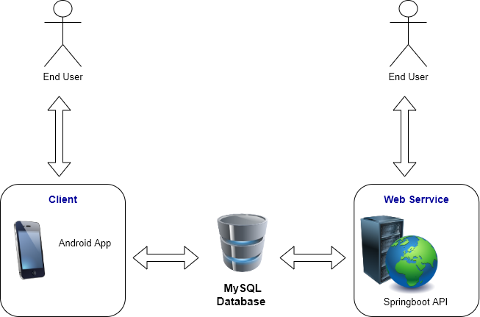

SQL server database

d

## Context Level Diagram:

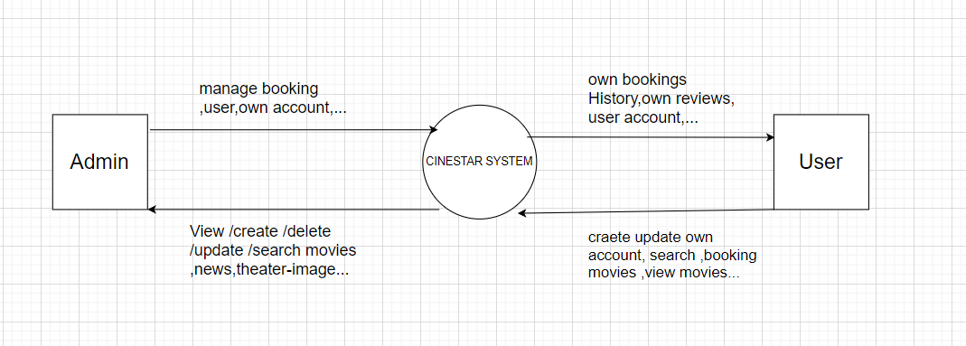

## First Level DFD:

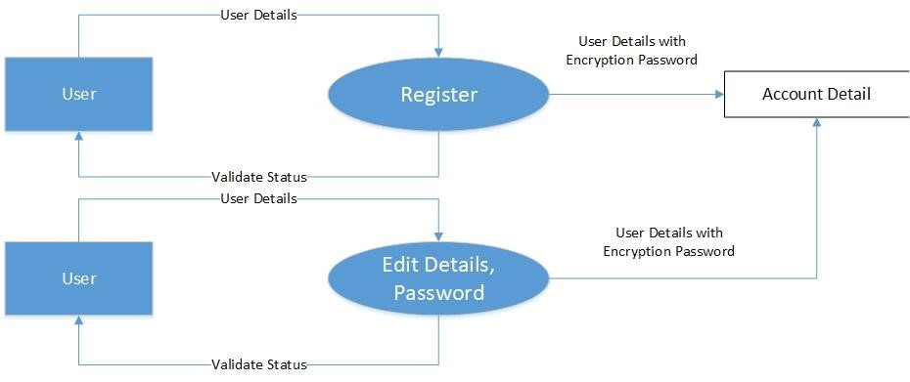

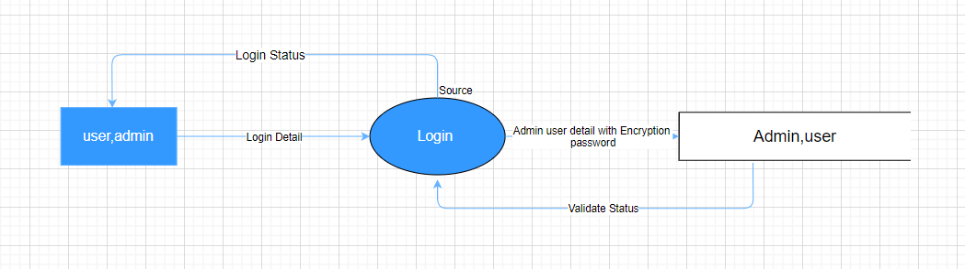

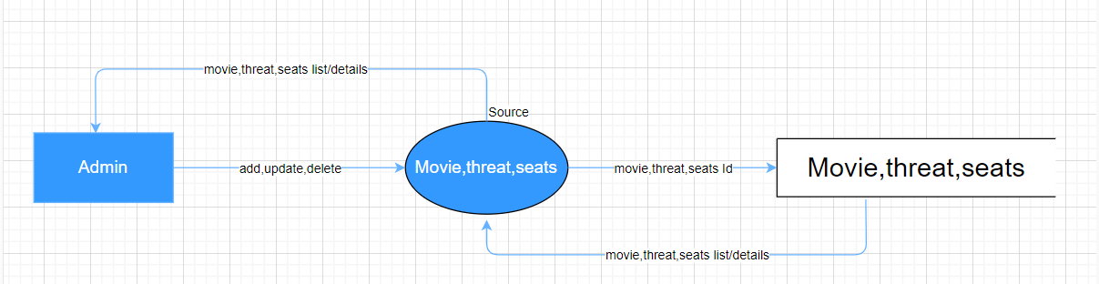

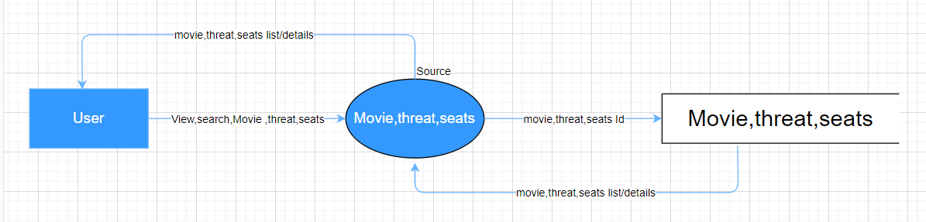

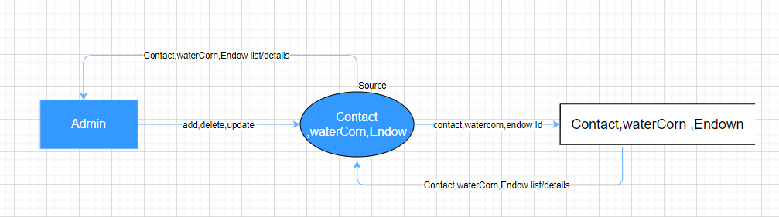

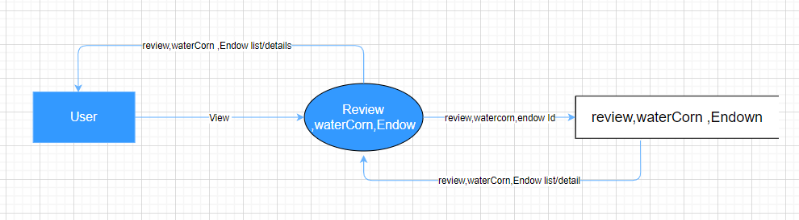

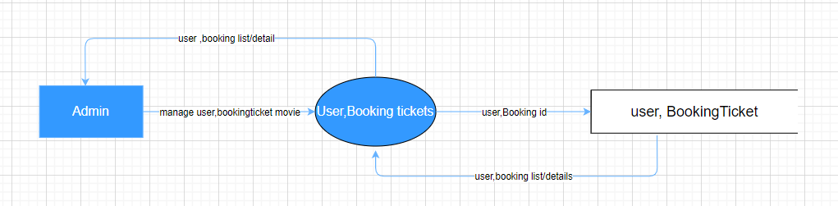

# **Flowchart**

1. Login function: (user)

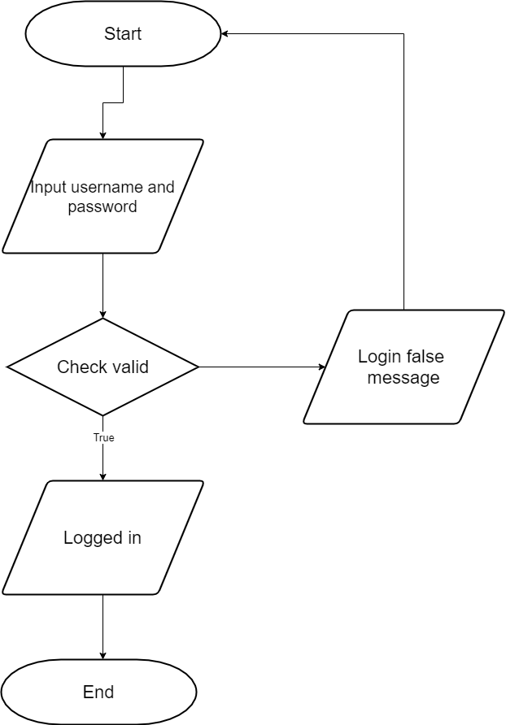

false

1. Signup Function for customers : (user)

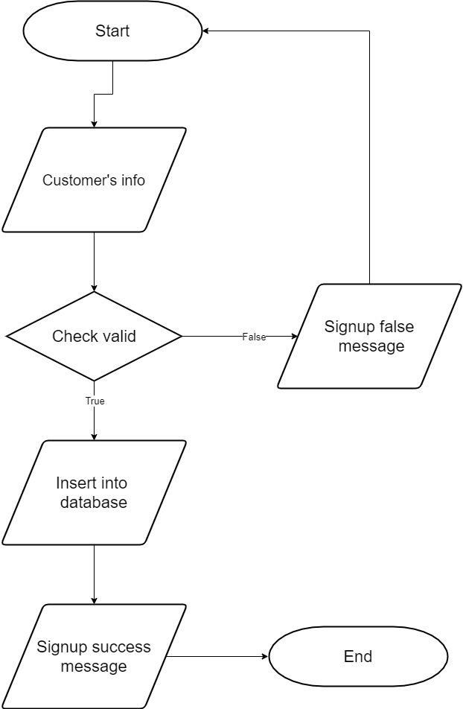

1. Login Function: (Admin)

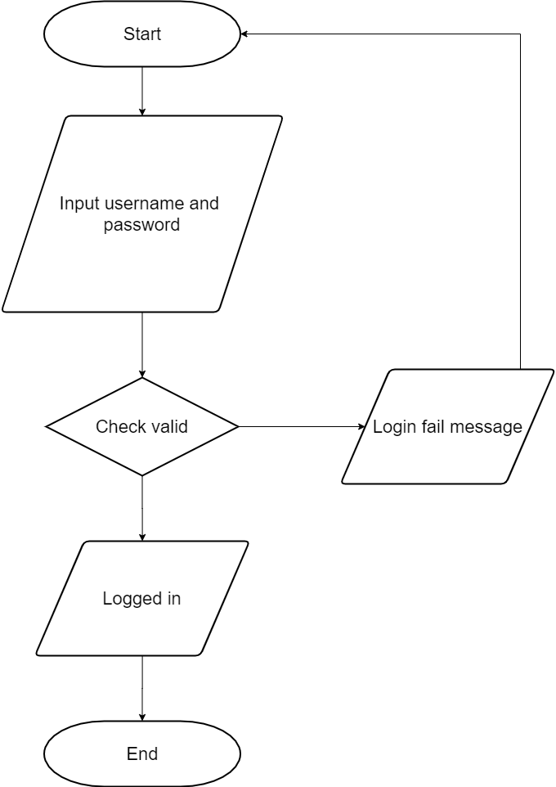

false

true

1. View data Function:

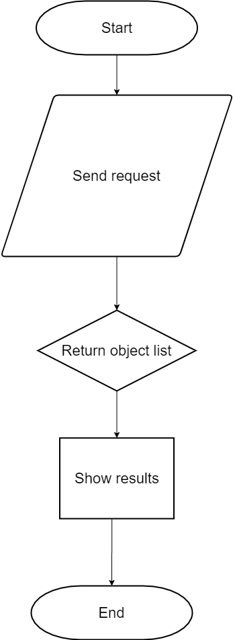

1. Insert Data:

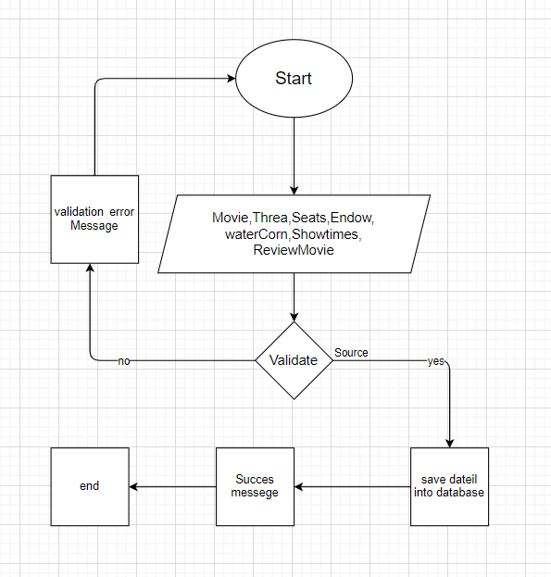

1. Search Data Function:

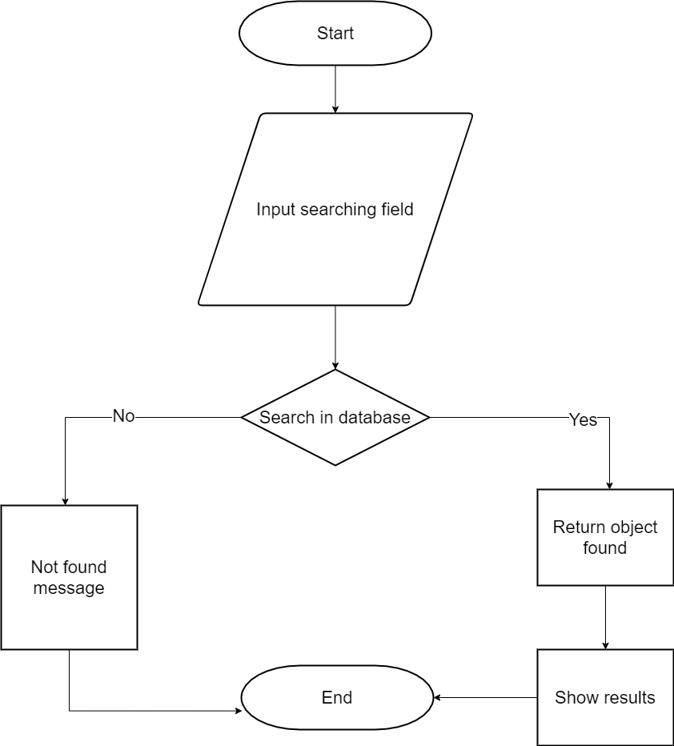

1. Booking tickets movies Function:

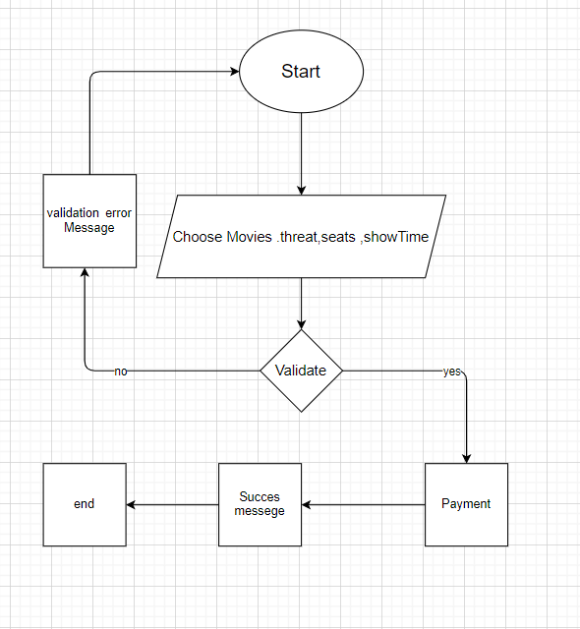

1. Rating Function:

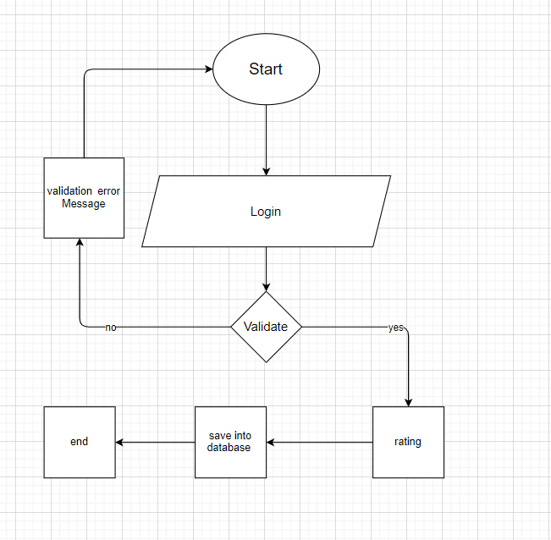

1. Wishlist Function:

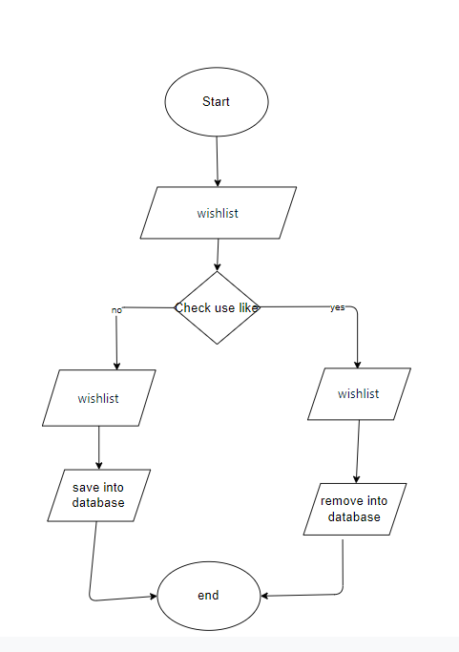

1. Change Profile ,password Function

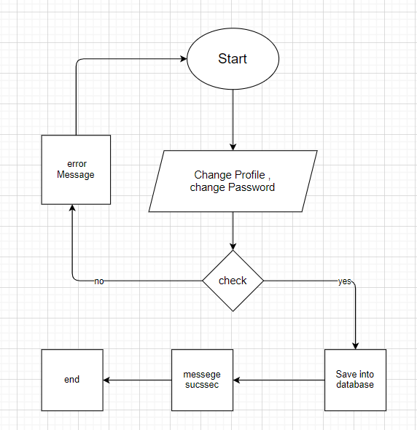

1. Change Coupon

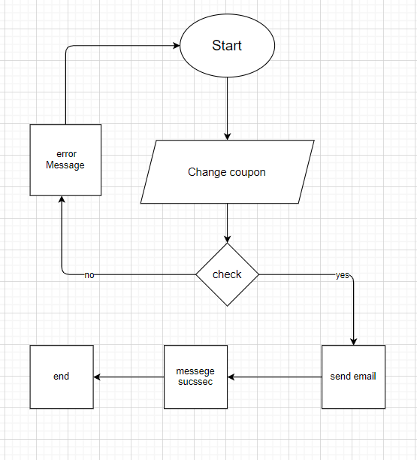

1. Fogot password function

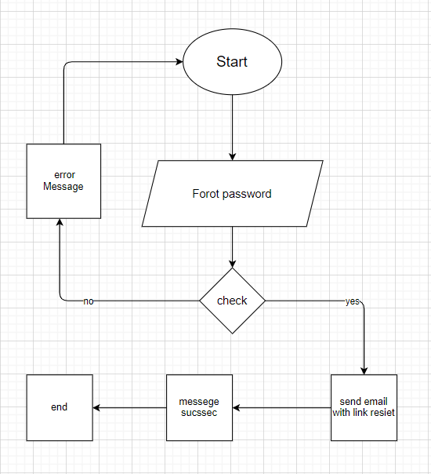

# **Entity Relationship Diagram(ERD)**

* 1. ***Conceptual***

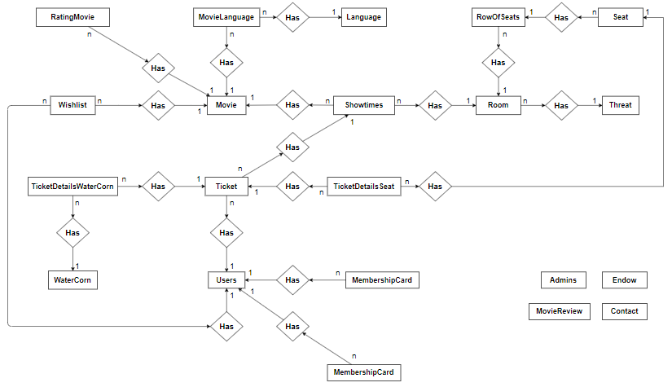

* 1. ***Logical***



# **Use case and Sequence Diagram**

## Guest

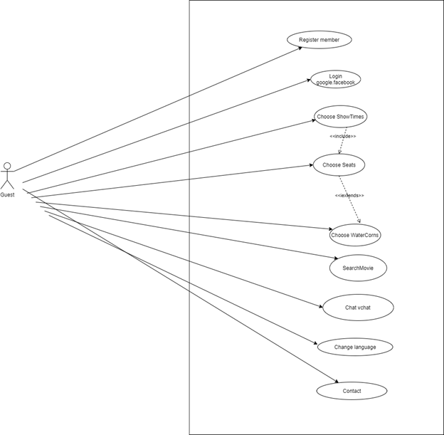

### Register Member

|  |  |  |
| --- | --- | --- |
| **Author** | Tran Kim Dat | |
| **Use Case Name** | Register Member | |
| **Actors** | Guest | |
| **Description** | Guest wants to register with the website to become a member. | |
| **Requirements** | Guest provides Guest’s information | |
| **Pre-conditions** |  | |
| **Post-conditions** | Success: Guest creates account in this website  Fail: Refill information | |
| **Basic flow** | Actor Actions:  1. Actor clicks ‘Sign Up’ link in below menu website  3. Actor inputs register’s information | System Responses:  2. System redirects to LoginRegister page and displays Registration form with the following control :  - ‘Name’ text field  _- ‘Birthday’ datebox  - ‘Sex’ combobox  - ‘Phone’ text field  - ‘Email’ text field  - ‘Password’ text filed  - ‘ConfirmPassword’ text field  - ‘Address’ text field  - ‘Province’ combobox  - ‘District’ combobox  - ‘Ward’ combobox  - ‘Captcha’ textfile  - ‘Register’ button  4. System checks the information  5. System inserts the account into database,and then login user and redirect home page. |
| **Exception** | Actor Actions:  1. Actor lefts ‘UserName’ text field blank.  3.Actor left ‘Email’ text field blank  5. Actor lefts ‘Password’ text field blank.  7. Actor lefts ‘Confirm Password’ text field blank.  9. Password and confirm password don’t match.  11. Actor lefts ‘Name’ text field blank.  13.. Actor lefts ‘Birthday’ datebox blank.  15. Actor lefts ‘Address’ text field blank.  17. Actor lefts ‘Phone’ text field blank.  19. Actor lefts ‘Gender’ text field blank.  21. Actor lefts ‘Province’ combo blank.  23. Actor lefts ‘District’ combo blank.  25. Actor lefts ‘Ward’ combo blank..  27. Actor lefts ‘Email’ text field blank or input an invalid email address.  29. Actor left ‘Captcha’ text field blank  31. Email has already exists. | System Responses:  System displays error according to input for Actor :  2. ‘UserName cannot be blank’.  4 ‘Email cannot blank’’.  6.‘Password cannot be blank’’.  8. ‘Confirm Password can’t be blank’.  10. ‘Confirm password not match password.’  12. ‘Name cannot be blank’.  14. ‘Birthday cannot blank’.  16.‘Address cannot be blank’.  18. ‘Phone cannot be blank’.  20.‘Gender cannot blank’.  22.‘Province cannot blank’.  24.‘District cannot blank’.  26.‘Ward cannot blank’.  28. ‘Email is invalid’.  30.‘capcha cannot blank’.  32. ‘Email has exists’. |

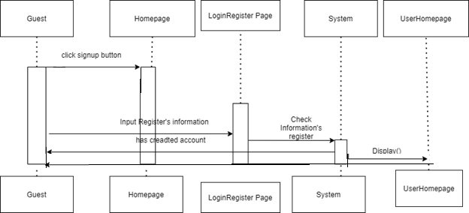

### Login google,facebook

|  |  |  |
| --- | --- | --- |
| **Author** | Tran Kim Dat | |
| **Use Case Name** | Login google,facebook | |
| **Actors** | Guest | |
| **Description** | Guest wants to login/Register through google,facebook account. | |
| **Requirements** | Guest has account google/facebook | |
| **Pre-conditions** |  | |
| **Post-conditions** | Success: Guest creates an Account according email(if email doesn't exist in database) , Login according email in database . | |
| **Basic flow** | Actor Actions:  1. Actor clicks ‘Login Google, Login facebook’ button in LoginRegister page and then login. | System Responses:  2. System check email according google/facebook account.If email doesn’t exist,system will create account(Alternative 1). Login according google/Facebook account and return home page. |
| **Alternative flow** | Alternative 1:  If email exist , don’t create account and login  according google/Facebook account and return home page. |  |

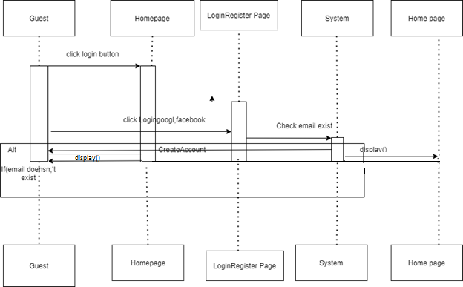

### 1.3 Choose ShowTime

|  |  |  |
| --- | --- | --- |
| **Author** | Tran Kim Dat | |
| **Use Case Name** | Choose ShowTime | |
| **Actors** | Guest | |
| **Description** | Guest wants to choose Showtimes. | |
| **Requirements** |  | |
| **Pre-conditions** |  | |
| **Post-conditions** | Success: Guest will redirect to choose seats according showtimes selected. | |
| **Basic flow** | Actor Actions:  1. Actor choose Region  3.Actor choose Threats  5.Actor choose Date  7. Actor choose showtime | System Responses:  2. System show all threat according to region  4. System show all date that threat have movies show  6.System show all movies according to date of threats actor selected  8.System redirect to page seats according showTime that actor choosed |

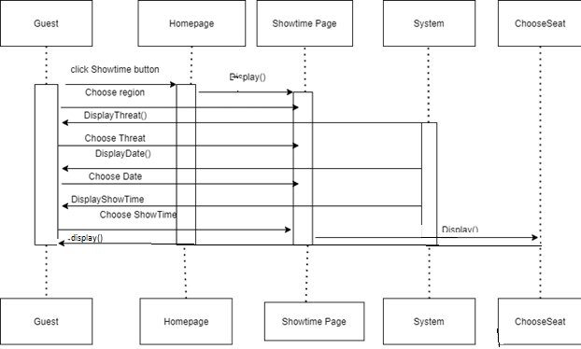

### 1.4 Choose Seats

|  |  |  |
| --- | --- | --- |
| **Author** | Tran Kim Dat | |
| **Use Case Name** | Choose Seats | |
| **Actors** | Guest | |
| **Description** | Guest wants to choose Seats. | |
| **Requirements** |  | |
| **Pre-conditions** |  | |
| **Post-conditions** |  | |
| **Basic flow** | Actor Actions:  1. Actor choose Seats  2.Actor click button next | System Responses:  3. shoe message required login |

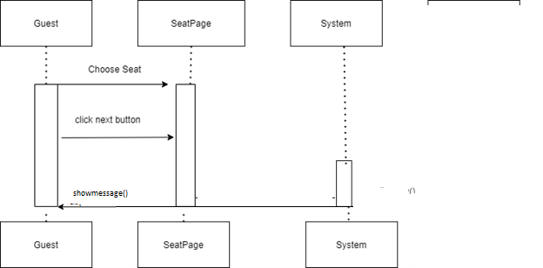

### Choose WaterCorn

|  |  |  |
| --- | --- | --- |
| **Author** | Tran Kim Dat | |
| **Use Case Name** | Choose Seats | |
| **Actors** | Guest | |
| **Description** | Guest wants to choose water corn. | |
| **Requirements** |  | |
| **Pre-conditions** |  | |
| **Post-conditions** |  | |
| **Basic flow** | Actor Actions:  1.actor click button choose watercorn  3.Actor click button next | System Responses:  2.show watercorn  4.show message require login |
| **Exception** | 1.Actor click button chooseWaterCorn but hasn’t choose seat | 2.Show message |

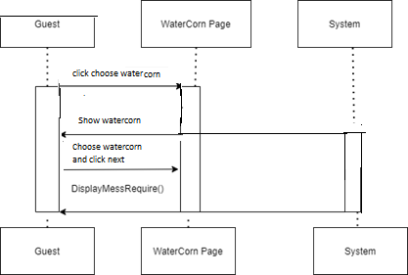

### Search Movie

|  |  |  |
| --- | --- | --- |
| **Author** | Tran Kim Dat | |
| **Use Case Name** | Search Movie | |
| **Actors** | Guest | |
| **Description** | Guest wants to search movie . | |
| **Requirements** |  | |
| **Pre-conditions** |  | |
| **Post-conditions** | Success: Guest will see movie according to keyword. | |
| **Basic flow** | Actor Actions:  1. Actor enter movie want to search.  3. Actor click button search. | System Responses:  2.System show title contains key that actor enter(show when user keyup).  4.System redirect to search page and show movie contains keyword that actor entered. |
| **Exception** |  | 1.System not found.  2.show result as blank if in search bar.  show message not found if in search page. |

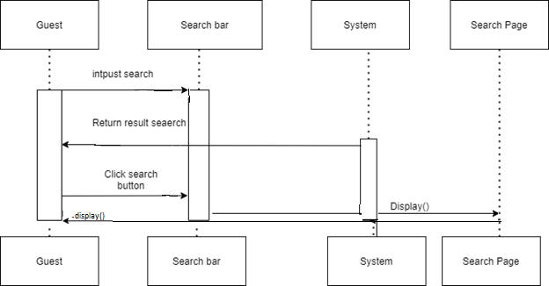

### Chat vchat

|  |  |  |
| --- | --- | --- |
| **Author** | Tran Kim Dat | |
| **Use Case Name** | Chat vchat | |
| **Actors** | Guest | |
| **Description** | Guest wants to chat through vchat . | |
| **Requirements** |  | |
| **Pre-conditions** |  | |
| **Post-conditions** | Success: Guest will chat with chatbox or employee through vChat. | |
| **Basic flow** | Actor Actions:  1.Actor click icon Vchat  3. Actor click button send  4.Actor click close boxchat  5.Close boxchat | Vchat Responses:  2. Vchat show  5.Vchat close |

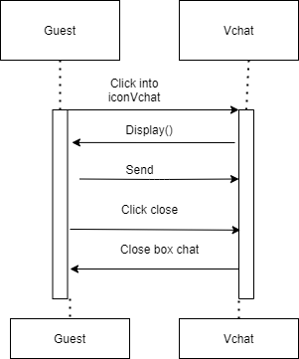

### 1.8 Change Language

|  |  |  |
| --- | --- | --- |
| **Author** | Tran Kim Dat | |
| **Use Case Name** | Change language | |
| **Actors** | Guest | |
| **Description** | Guest wants to search movie . | |
| **Requirements** |  | |
| **Pre-conditions** |  | |
| **Post-conditions** | Success: Langue will change. | |
| **Basic flow** | Actor Actions:  1. Actor click en/vi language | System Responses:  2.System change language according actor clicked(en with english and vi with vietnamese) |

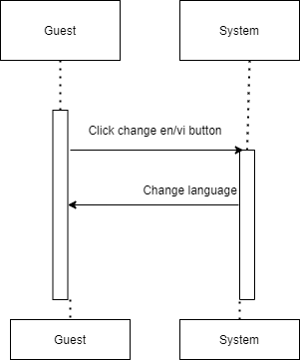

### 1.9 Contact

|  |  |  |
| --- | --- | --- |
| **Author** | Tran Kim Dat | |
| **Use Case Name** | Contact | |
| **Actors** | Guest | |
| **Description** | Guest wants to contact . | |
| **Requirements** |  | |
| **Pre-conditions** |  | |
| **Post-conditions** | Success: System show message contact has been seen. | |
| **Basic flow** | Actor Actions:  1. Actor clicks ‘Contact’ link in menu website  3. Actor inputs register’s information | System Responses:  2. System redirects to contact page and displays Contact form with the following control :  - ‘Name' text field  - ‘Phone’ text field  - ‘Email’ text field  - ‘Content’ textarea  - ‘Contact’ button  4. System checks the information  5. System inserts the contact into database ,and show message contact has been seen. |
| **Exception** | Actor Actions:  1. Actor lefts ‘Name’ text field blank.  3. Actor lefts ‘Phone’ text field blank.  5. Actor lefts ‘Email’ text filed blank.  7. Actor lefts ‘Content’ text area blank  8. Actor lefts ‘Email’ invalid. | System Responses:  System displays message to Actor :  2.‘Name ‘ cannot be blank’.  4.‘Phone‘ cannot be blank’.  6. ‘Email ‘cannot be blank’  8.‘Content ‘cannot be blank’.  9.’Email’ invalid |

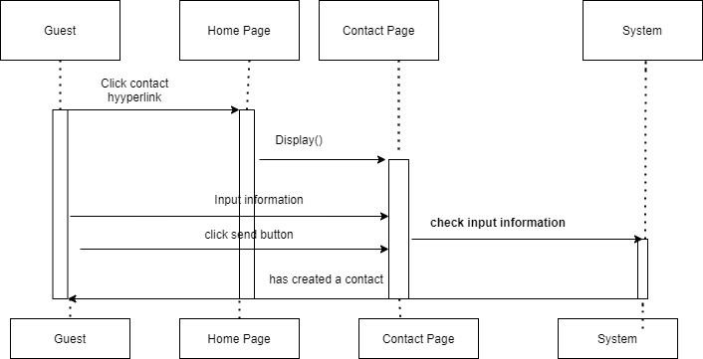

## User

### User’s information

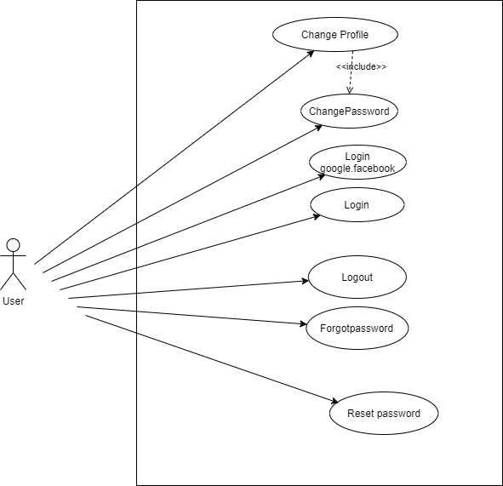

#### 2.1.1 Login

|  |  |  |
| --- | --- | --- |
| **Author** | Tran Kim Dat | |
| **Use Case Name** | Login | |
| **Actors** | User | |
| **Description** | User wants to login to website as a member. | |
| **Requirements** | Actor provides username and password and capcha | |
| **Pre-conditions** |  | |
| **Post-conditions** | Success: User logged in to website.  Fail: Refill information | |
| **Basic flow** | Actor Actions:  1. Actor go to Home page of website.  3. Actor inputs Email and Password, then click the Login button. | System Responses:  2. System redirects to Home page and displays Login form on the left with the following control:  - ‘Email’ text field  - ‘Password’ text field  - ‘Capcha ‘ text field  - ‘Login’ button  4. System checks the information  5. System redirects to Actor’s Home page. |
| **Exception** | Actor Actions:  1.Actor left ‘Email’ text field blank  3.Actor left ‘Password’ text field blank  5. Actor left ‘capcha’ text field blank  7.Actor left’email’ invalid  9. Actor input invalid acccount. | System Responses:  System display error according to input for actor:  2.’Email’ cannot blank,  4.‘Passoword’ cannotblank,  6.‘Capcha cannotblank  8.’Email invalid’  10.System show a message box: “Invalid Account”. |

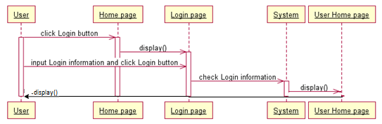

#### 2.1.2 Logout

|  |  |  |
| --- | --- | --- |
| **Author** | Tran Kim Dat | |
| **Use Case Name** | Logout | |
| **Actors** | User | |
| **Description** | User wants to log out of the System. | |
| **Requirements** |  | |
| **Pre-conditions** | Actor has logged in. | |
| **Post-conditions** | Success: Actor Logged out. | |
| **Basic flow** | Actor Actions:  1. Actor clicks ‘Log out’ button on the Actor’s Home menu. | System Responses:  2. System remove session, and then redirect to Home page. |
| **Alternative flow** |  |  |
| **Exception** |  |  |

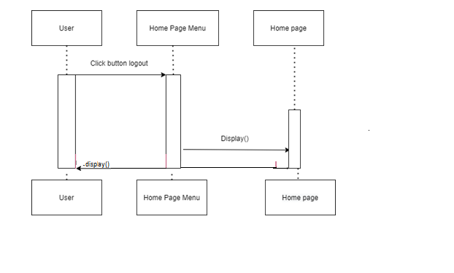

#### 2.1.3 Login google,facebook

|  |  |  |
| --- | --- | --- |
| **Author** | Tran Kim Dat | |
| **Use Case Name** | Login google,facebook | |
| **Actors** | User | |
| **Description** | User wants to login/Register through google,facebook account. | |
| **Requirements** | User has account google/facebook | |
| **Pre-conditions** |  | |
| **Post-conditions** | Success: User login according email in database . | |
| **Basic flow** | Actor Actions:  1. Actor clicks ‘Login Google, Login facebook’ button in LoginRegister page and then login. | System Responses:  2. System check email according google/facebook account. And then login according google/Facebook account and return home page. |

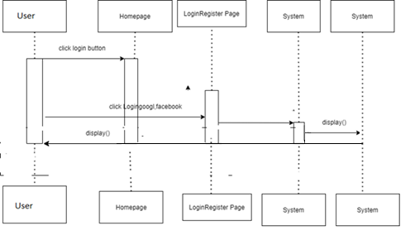

#### 2.1.4 Change Profile/ Change Password

|  |  |  |
| --- | --- | --- |
| **Author** | Tran Kim Dat | |
| **Use Case Name** | Change Profile/ Change Password | |
| **Actors** | User | |
| **Description** | Actor want update actor’s profile | |
| **Requirements** | User provides information that update | |
| **Pre-conditions** |  | |
| **Post-conditions** | Success: User update account according email in this website  Fail: Refill information | |
| **Basic flow** | Actor Actions:  1.Actor clicks ‘Profile’ link in below menu website  6.Actor inputs profile’s information  8.Actor click change Password  10.Actor inputs information | System Responses:  2. System redirects to Profile page(ow and displays Registration form with the following control :  - ‘Name’ text field  _- ‘Birthday’ datebox  - ‘Sex’ combobox  - ‘Phone’ text field  - ‘Email’ text field(Readonly)  - ‘Address’ text field  - ‘Province’ combobox  - ‘District’ combobox  - ‘Ward’ combobox  - ‘Captcha’ textfile  - ‘Register’ button  6. System checks the information  7. System update the account according to email user into database,and then show messag succes update  9.System show `oldpassword` textfiled,`newpassword` textfiled,`confirmnewxpassword`tex filed  11.System update password, profile according to email user into database,and then show messag succes update and |
| **Exception** | Actor Actions:  1. Actor lefts ‘UserName’ text field blank.  3. Actor lefts ‘Name’ text field blank.  5. Actor lefts ‘Birthday’ datebox blank.  7. Actor lefts ‘Address’ text field blank.  9. Actor lefts ‘Phone’ text field blank.  11. Actor lefts ‘Gender’ text field blank.  13. Actor lefts ‘Province’ combo blank.  15. Actor lefts ‘District’ combo blank.  17. Actor lefts ‘Ward’ combo blank..  19. Actor lefts ‘Captcha’ text field blank.  If filed oldpassword,newpassword,  confirmpassword show in page  21.Actor lefts`oldpassword` is blank  23.Actor lefts`newpassword` is blank  25. Actor lef `confirmpassword` is blank  27. Actor lefts`newpassword`not same `confirm new passoword` text  29. Actor lefts`oldpassword`same `new passoword` text filed if these text filed show in website  31.Actor left `oldpassword` not correct with account | System Responses:  System displays error according to input for Actor :  2. ‘UserName cannot be blank’.  4. ‘Name cannot be blank’.  6.‘Birthday cannot blank’.  8. ‘Address cannot be blank’.  10.‘Phone cannot be blank’.  12. ‘Gender cannot blank’.  14.‘Province cannot blank’.  16. ‘District cannot blank’.  -18.‘Ward cannot blank’.  20. ‘capcha cannot blank’.  If filed oldpassword,newpassword,  confirmpassword show in page  22. ‘Oldpass cannot blank’  24.‘NewPass cannot blank’.  26. ‘Confirm newpass cannot blank’.  28`password and confirm password must same`.  30.`Old password and new password can not same`.  32.`oldpassword` not correct |

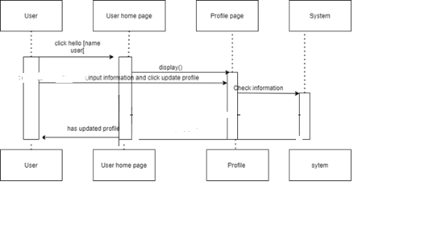

When user click change password:

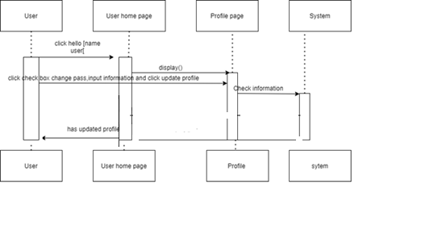

#### 2.1.5 Forgot PassWord

|  |  |  |
| --- | --- | --- |
| **Author** | Tran Kim Dat | |
| **Use Case Name** | Forgot PassWord/ ResetPassowrd | |
| **Actors** | User | |
| **Description** | Actor want to change password | |
| **Requirements** | User provides old password | |
| **Pre-conditions** |  | |
| **Post-conditions** | Success: User update password account according email in this website  Fail: Refill information | |
| **Basic flow** | Actor Actions:  1. Actor clicks fortgotpassword in login page  3.Actor inputs email and click checkbox recapcha  5.Actor click send button | System Responses:  2. System show modal with form with following control :  - ‘Email’ text field  _- ‘Recapcha’  4.System check information and recapcha  6.System generate token and send link resetpassword to email of actor.Link only has effect 1 hour  7.system show message success |
| **Exception** | Actor Actions:  1.Actor lefts ‘Email’ text field blank.  3.Actor don’t click ‘Recapcha`.  5.Actor lefts `invalid` email .  7.Actor lefts `email` doesn’t exist in database . | System Responses:  System displays error:  2.‘Email` cannot be blank’.  4. Please click recapcha.  6. ‘Email` invalid.  8. ‘Email` doesn’t exist ’. |

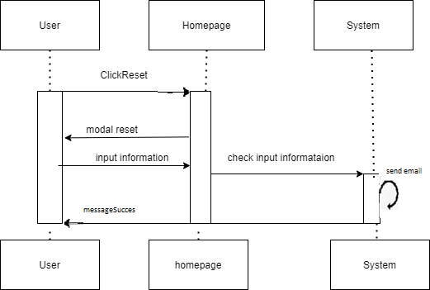

#### Reset password

|  |  |  |
| --- | --- | --- |
| **Author** | Tran Kim Dat | |
| **Use Case Name** | Forgot PassWord/ ResetPassowrd | |
| **Actors** | User | |
| **Description** | Actor want to change password | |
| **Requirements** | User provides old password | |
| **Pre-conditions** |  | |
| **Post-conditions** | Success: User update password account according email in this website  Fail: Refill information | |
| **Basic flow** | Actor Actions:  1 Actor click link reset at actor’s email  2.Acotr inputs information | System Responses:  3 .System redirect to resetpassword page and displays Rest form with the following control :  - ‘Password’ text field  _- ‘Confirmpassword’ textfiled  4.System check information  5.system show message success |
| **Exception** | Actor Actions:  1. Actor lefts ‘Password’ text field blank.  3.Actor lefts ‘ConfirmPassword’ text field blank.  5.Actor lefts ‘ConfirmPassword’ text field and  Password’ text field not match | System Responses:  System displays error :  2.‘Password` cannot be blank’.  4.`Confirmpassword` cannot be blank.  6.‘Password` and `Confirmpassword` must match. |

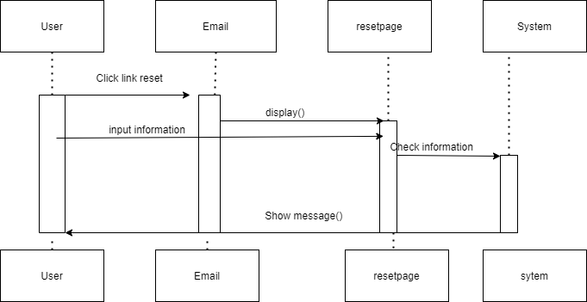

### User choose and book

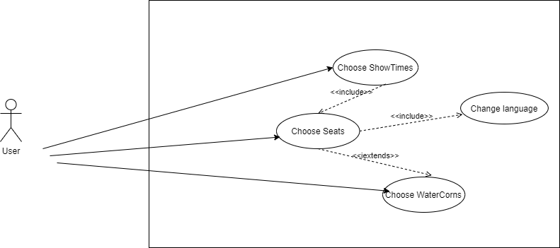

#### 2.2.1 Choose ShowTime

|  |  |  |
| --- | --- | --- |
| **Author** | Tran Kim Dat | |
| **Use Case Name** | Choose ShowTime | |
| **Actors** | User | |
| **Description** | User wants to choose Showtimes. | |
| **Requirements** |  | |
| **Pre-conditions** |  | |
| **Post-conditions** | User: User will redirect to choose seats according showtimes selected. | |
| **Basic flow** | Actor Actions:  1. Actor choose Region  3.Actor choose Threats  5.Actor choose Date  7. Actor choose showtime | System Responses:  2. System show all threat according to region  4. System show all date that threat have movies show  6.System show all movies according to date of threats actor selected  8.System redirect to page seats according showTime that actor choosed |

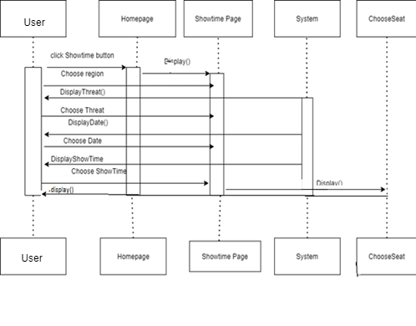

#### 2.2.2 Choose Seats

|  |  |  |
| --- | --- | --- |
| **Author** | Tran Kim Dat | |
| **Use Case Name** | Choose Seats | |
| **Actors** | User | |
| **Description** | User wants to choose Seats. | |
| **Requirements** |  | |
| **Pre-conditions** |  | |
| **Post-conditions** | Success: User will redirect to ticketpage | |
| **Basic flow** | Actor Actions:  1. Actor choose Seats  2.Actor click button next | System Responses:  3. System redirect choose WaterCorns. |

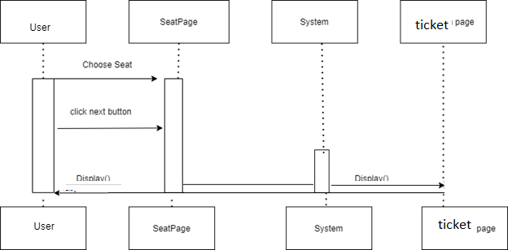

#### 2.2.3 Choose WaterCorn

|  |  |  |
| --- | --- | --- |
| **Author** | Tran Kim Dat | |
| **Use Case Name** | Choose WaterCorn | |
| **Actors** | User | |
| **Description** | User wants to choose water corn. | |
| **Requirements** |  | |
| **Pre-conditions** |  | |
| **Post-conditions** | Success: User will redirect to ticketpage | |
| **Basic flow** | Actor Actions:  1.actor click button choose watercorn  3.Actor click button next | System Responses:  2.show watercorn  4.show message require login |
| **Exception** | 1.Actor click button chooseWaterCorn but hasn’t choose seat | 2.Show message |

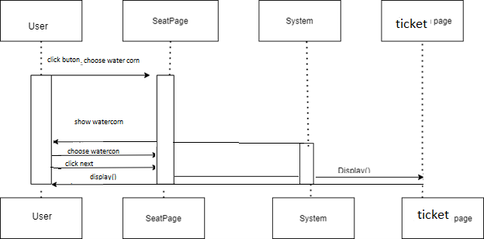

#### 2.2.4 BookTicket

|  |  |  |
| --- | --- | --- |
| **Author** | Tran Kim Dat | |
| **Use Case Name** | Book ticket | |
| **Actors** | User | |
| **Description** | User wants to book ticket. | |
| **Requirements** |  | |
| **Pre-conditions** |  | |
| **Post-conditions** |  | |
| **Basic flow** | Actor Actions:  1. Actor click book ticket button  3.Actor choose payment method and book | System Responses:  2.system show all payment method  4.System send message bookticket sucessfully and send email with detail ticket and redirect Home page/ |

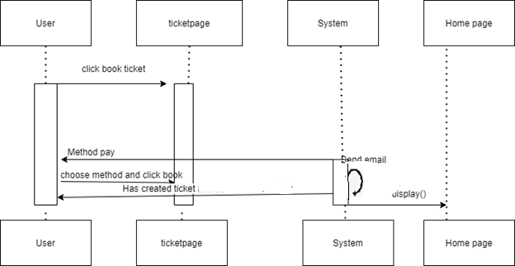

### 2.3 Facebook,Zalo,Vchat

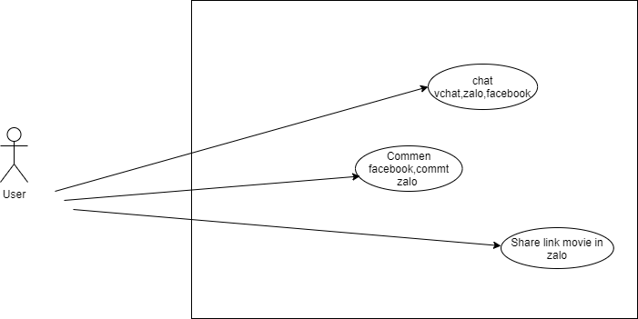

#### 2.3.1 Chat vChat, zalo,facebook

|  |  |  |
| --- | --- | --- |
| **Author** | Tran Kim Dat | |
| **Use Case Name** | Chat vchat,zalo,facebook | |
| **Actors** | User | |
| **Description** | User wants to chat through vchat/zalo/facebook . | |
| **Requirements** | Login zalo/facebook if chat throught zalo/facebook at pugin | |
| **Pre-conditions** |  | |
| **Post-conditions** | Success: User will chat with employee through vchat,zalo, facebook. | |
| **Basic flow** | Actor Actions:  1.Actor click icon vchat  /zalo/facebook  3.Actor click send button  4.actor click close button | Responses:  2.System show boxchat  5.boxchat close |

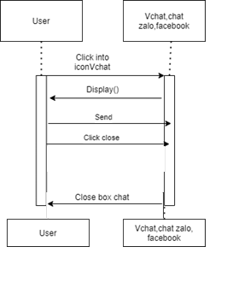

#### 2.3.2 Conment facebook, Conment zalo

|  |  |  |
| --- | --- | --- |
| **Author** | Tran Kim Dat | |
| **Use Case Name** | Conment facebook/ Conment zalo | |
| **Actors** | User | |
| **Description** | User want to comment | |
| **Requirements** | Login into facebook/zalo at plugin | |
| **Pre-conditions** |  | |
| **Post-conditions** | Success: User post comment. | |
| **Basic flow** | Actor Actions:  1. Actor clicks ‘Post` | response:  2..display comment |

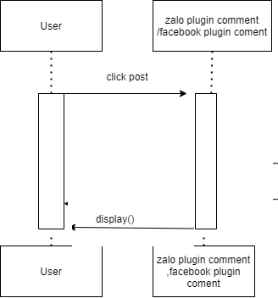

#### 2.3.3 share link movie in zalo

|  |  |  |
| --- | --- | --- |
| **Author** | Tran Kim Dat | |
| **Use Case Name** | Conment facebook/ Conment zalo | |
| **Actors** | User | |
| **Description** | User want to comment | |
| **Requirements** | Login into zalo at plugin | |
| **Pre-conditions** |  | |
| **Post-conditions** | Success: User post comment. | |
| **Basic flow** | Actor Actions:  1.Actor click ‘DETAIL` MOVIE  3. Actor clicks ‘share zalo` | System response:  2.display movie detail page  4. share link movie in zalo |

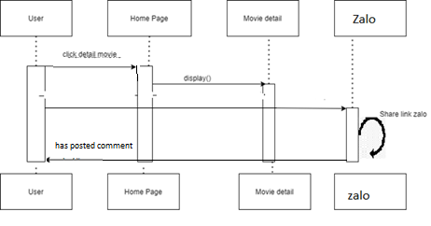

### 2.4.Find nearest threater,change coupon

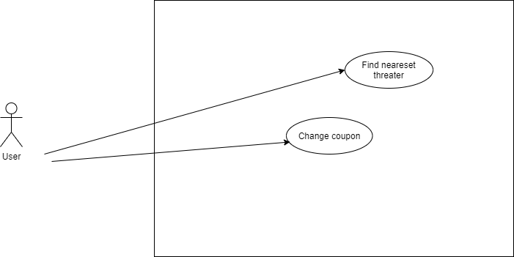

#### 2.4.1.Find neareset threaterer

|  |  |  |
| --- | --- | --- |
| **Author** | Tran Kim Dat | |
| **Use Case Name** | Find neareset threater | |
| **Actors** | User | |
| **Description** | User want to find nearest threater | |
| **Requirements** |  | |
| **Pre-conditions** |  | |
| **Post-conditions** | Success: find Neareset threater | |
| **Basic flow** | Actor Actions:  1.Actor find Neareset threater  3.Actor search and choose location | Here response:  2.check information and find nearset threat from actor location  4.find nearset threat from actor choose |

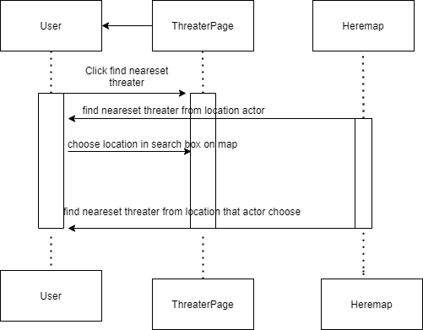

#### 2.4.2.Change coupon

|  |  |  |
| --- | --- | --- |
| **Author** | Tran Kim Dat | |
| **Use Case Name** | Change coupon | |
| **Actors** | User | |
| **Description** | User want to change coupon | |
| **Requirements** |  | |
| **Pre-conditions** |  | |
| **Post-conditions** | Success: change coupon | |
| **Basic flow** | Actor Actions:  1.Actor click change coupon  3.Actor click confirm that point actor want change | Response:  2.Show modal  4.check information and send email |

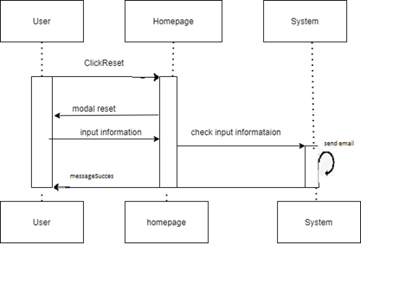

### 2.5.Manage User’sWishList,Movie’s watched,Order history

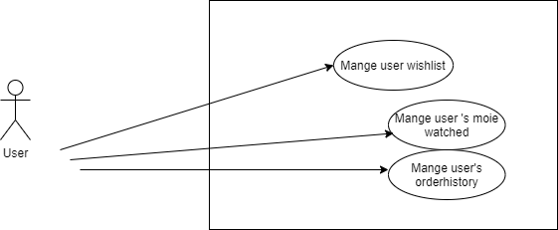

#### 2.5.6 Manage User’s WishList

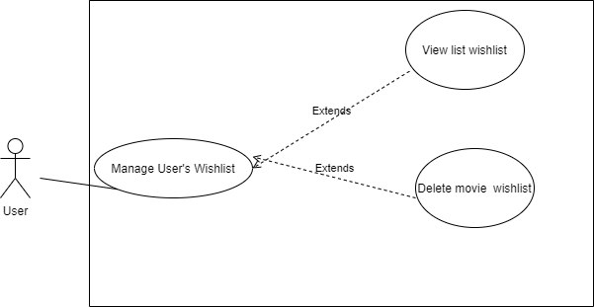

##### 2.5.6.1 View

|  |  |  |
| --- | --- | --- |
| **Author** | Tran Kim Dat | |
| **Use case name** | View List wishlist | |
| **Actors** | user | |
| **Description** | View owner list movie wishlist | |
| **Requirements** |  | |
| **Pre-conditions** | Actor has already logged into intoWebsite | |
| **Post-conditions** | Success: View List of owner wishlist | |
| **Basic flow** | Actor actions:  1. From ‘Profile’ page, actor clicks on to ‘wishlist/watchedlist` button. | System response:  2. System redirects to wishList/watchedlist t` page and display list movie of owner wishlist |

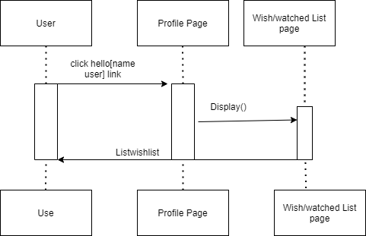

##### 2.5.6.2 Delete

|  |  |  |
| --- | --- | --- |
| **Author** | Tran Kim Dat | |
| **Use case name** | Delete movie wishlist | |
| **Actors** | user | |
| **Description** | Delete movie out of owner wishlist | |
| **Requirements** |  | |
| **Pre-conditions** | Actor has already logged into intoWebsite | |
| **Post-conditions** | Success: Delete movie out of owner wishlist | |
| **Basic flow** | Actor actions:  1.Actor clicks remove icon that movie want remove out of owner wishlist. | System response:  2. System remove movie out of owner wishlist |

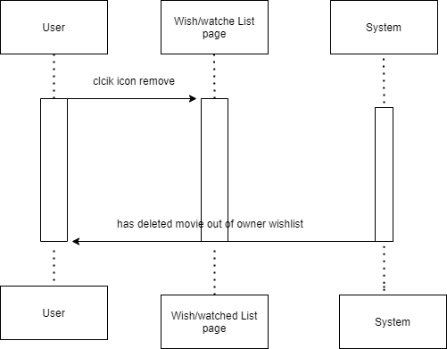

#### 2.5.7 .Manage Movie’s watched

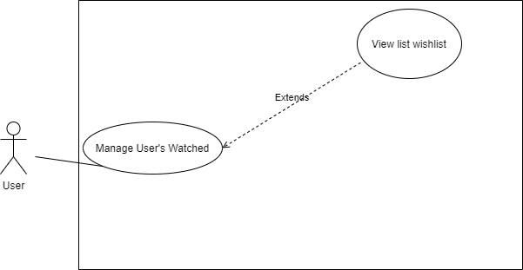

##### View

|  |  |  |
| --- | --- | --- |
| **Author** | Tran Kim Dat | |
| **Use case name** | View List owner movie watched | |
| **Actors** | user | |
| **Description** | View owner List movie watched | |
| **Requirements** |  | |
| **Pre-conditions** | Actor has already logged into intoWebsite | |
| **Post-conditions** | Success: View List of owner watched | |
| **Basic flow** | Actor actions:  1. From ‘Profile’ page, actor clicks on to ‘wishlist/watchedlist ` button. | System response:  2. System redirects to wishList/watchedlist` page and display list movie of owner watchedt |

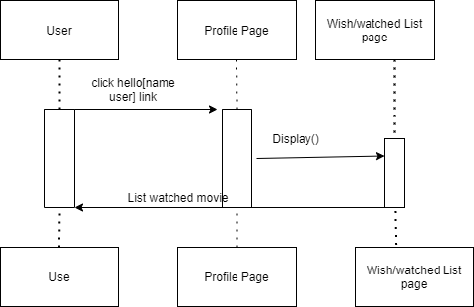

#### 2.5.8 .Manage order History

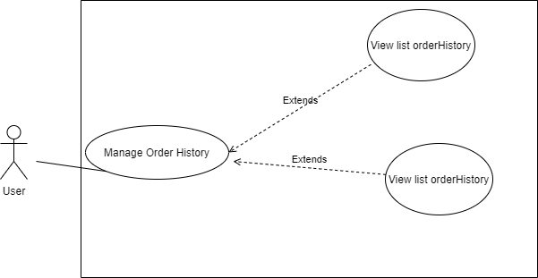

##### 2.5.8.1 View

|  |  |  |
| --- | --- | --- |
| **Author** | Tran Kim Dat | |
| **Use case name** | View List Order history | |
| **Actors** | user | |
| **Description** | View owner list ticket order history | |
| **Requirements** |  | |
| **Pre-conditions** | Actor has already logged into intoWebsite | |
| **Post-conditions** | Success: View Owner Order History | |
| **Basic flow** | Actor actions:  1. From ‘Profile’ page, actor clicks on to ‘Order history` button. | System response:  2. System redirects to`Order history` page and display owner list ticket in table form |

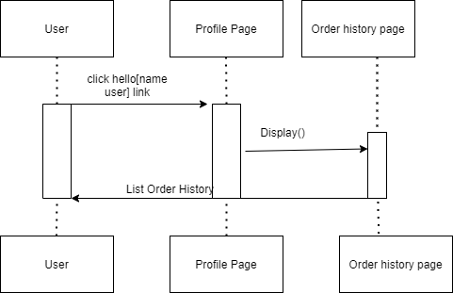

##### 2.5.8.2 Detail

|  |  |  |
| --- | --- | --- |
| **Author** | Tran Kim Dat | |
| **Use case name** | View List of owner wishlist | |
| **Actors** | user | |
| **Description** | View Detail ticket | |
| **Requirements** |  | |
| **Pre-conditions** | Actor has already logged into intoWebsite | |
| **Post-conditions** | Success: View List of owner wishlist | |
| **Basic flow** | Actor actions:  1. Click detail button at table on `Order History` page | System response:  2. System redirects to detail order page and display detail ticket according to id of ticket with QR code. |

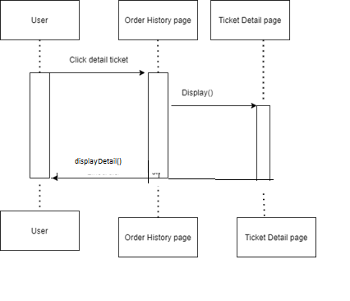

### 2.6.Other

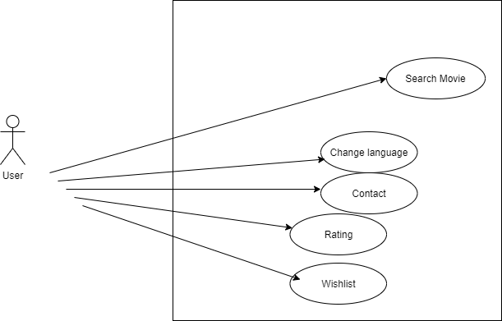

#### 2.6.1 Search Movie

|  |  |  |
| --- | --- | --- |
| **Author** | Tran Kim Dat | |
| **Use Case Name** | Search Movie | |
| **Actors** | User | |
| **Description** | User wants to search movie . | |
| **Requirements** |  | |
| **Pre-conditions** |  | |
| **Post-conditions** | Success: User will see movie according to keyword. | |
| **Basic flow** | Actor Actions:  1. Actor enter movie want to search.  3. Actor click button search. | System Responses:  2.System show title contains key that actor enter(show when user keyup).  4.System redirect to search page and show movie contains keyword that actor entered. |
| **Exception** |  | 1.System not found.  2.show result as blank if in search bar.  show message not found if in search page. |

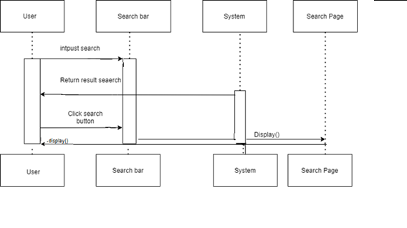

#### 2.6.2 Change Language

|  |  |  |
| --- | --- | --- |
| **Author** | Tran Kim Dat | |
| **Use Case Name** | Change language | |
| **Actors** | User | |
| **Description** | User wants to change language . | |
| **Requirements** |  | |
| **Pre-conditions** |  | |
| **Post-conditions** | Success: Language will change. | |
| **Basic flow** | Actor Actions:  1. Actor click en/vi language | System Responses:  2.System change language according actor clicked(en with english and vi with vietnamese) |

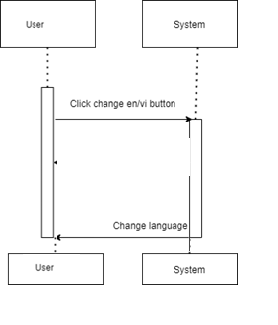

#### 2.6.3 Contact

|  |  |  |
| --- | --- | --- |
| **Author** | Tran Kim Dat | |
| **Use Case Name** | Contact | |
| **Actors** | User | |
| **Description** | User wants to contact . | |
| **Requirements** |  | |
| **Pre-conditions** |  | |
| **Post-conditions** | Success: System show message contact has been seen. | |
| **Basic flow** | Actor Actions:  1. Actor clicks ‘Contact’ link in menu website  3. Actor inputs register’s information | System Responses:  2. System redirects to contact page and displays Contact form with the following control :  - ‘Name' text field  - ‘Phone’ text field  - ‘Email’ text field  - ‘Content’ textarea  - ‘Contact’ button  4. System checks the information  5. System inserts the contact into database ,and show message contact has been seen. |
| **Exception** | Actor Actions:  1. Actor lefts ‘Name’ text field blank.  3. Actor lefts ‘Phone’ text field blank.  5. Actor lefts ‘Email’ text filed blank.  7. Actor lefts ‘Content’ text area blank  8. Actor lefts ‘Email’ invalid. | System Responses:  System displays message to Actor :  2.‘Name ‘ cannot be blank’.  4.‘Phone‘ cannot be blank’.  6. ‘Email ‘cannot be blank’  8.‘Content ‘cannot be blank’.  9.’Email’ invalid |

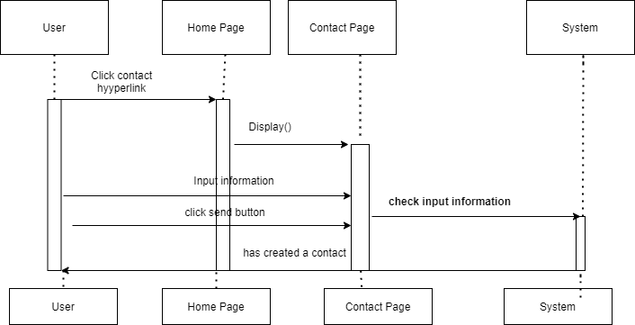

#### 2.6.4 Rating

|  |  |  |
| --- | --- | --- |
| **Author** | Tran Kim Dat | |
| **Use Case Name** | Rating | |
| **Actors** | Rating | |
| **Description** | User want to rating movie . | |
| **Requirements** |  | |
| **Pre-conditions** |  | |
| **Post-conditions** | Success: User rating movie. | |
| **Basic flow** | Actor Actions:  1. Actor click rating button | System Responses:  2.System show message “evaluated successfully” if acor hasn’t been evaluated that movie  3. update point evalution ,number or reviewers that movie |
| **Exception** | show message”you have already been evaluated” if actor has evaluated that movie |  |

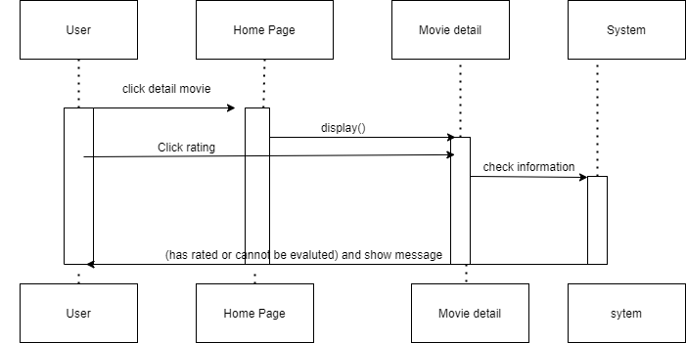

#### 2.6.5 Wishlist

|  |  |  |
| --- | --- | --- |
| **Author** | Tran Kim Dat | |
| **Use Case Name** | Wishlist | |
| **Actors** | User | |
| **Description** | User want to add or remove movie in actor’s wishList . | |
| **Requirements** |  | |
| **Pre-conditions** |  | |
| **Post-conditions** | Success: User add/Remove movie in actor’s wishList . | |
| **Basic flow** | Actor Actions:  1. Actor click hreart image | System Responses:  if actor like [al1]  2.System show message “liked” [alt1]  3.system add to actor’s wishlist[alt1] |
| **Alternative** | [alt1] System show message “disliked” and remove actor’s wishlist if actor dislike |  |

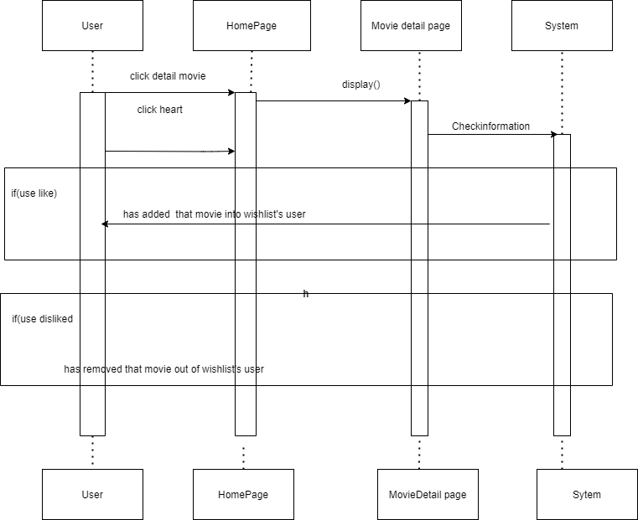

## Administrators

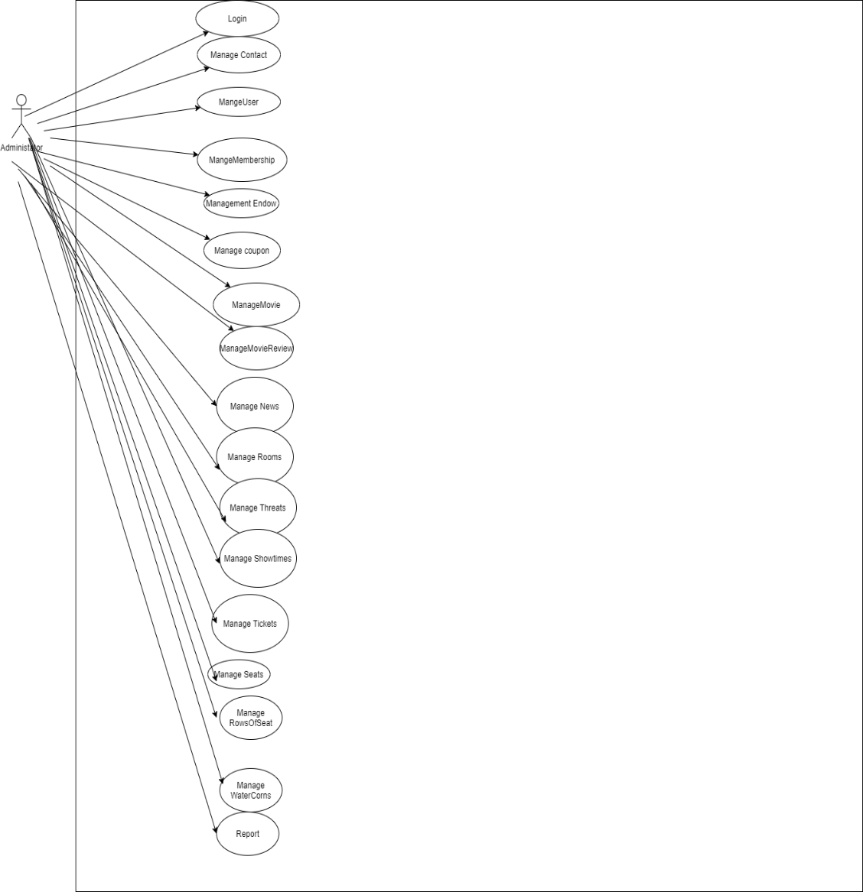

### 3.1 Login

|  |  |  |
| --- | --- | --- |
| **Author** | Tran Kim Dat | |
| **Use Case Name** | Login | |
| **Actors** | Administrator | |
| **Description** | Administrator wants to login to Admin page. | |
| **Requirements** | Actor provides username and password | |
| **Pre-conditions** |  | |
| **Post-conditions** | Success: Administrator logged in to website.  Fail: Refill information | |
| **Basic flow** | Actor Actions:  1. Actor inputs Admin page URL in Address bar of Browser.  3. Actor inputs email and Password, then click the Login button. [Alternative 1] | System Responses:  2. System redirects to Login page and displays Login form with the following control:  - ‘email’ text field  - ‘Password’ text field  - ‘Login’ button  4. System checks the information  [Exception 1]  5. System redirects to Admin Home page. |
| **Alternative flow** |  |  |
| **Exception** | Actor Actions:  [Exception 1]  1. Actor lefts ‘email’ text field blank. 3. Actor lefts ‘Password’ text field blank. 5.Actor lefts’email’ invalid 8.Actor lefts `accounts` invalid | System Responses:  System displays message to Guest :  2 ‘email’ cannot be blank’.  4. ‘Password cannot be blank’. 6.`Email` invalid  8.`Account` invalid |

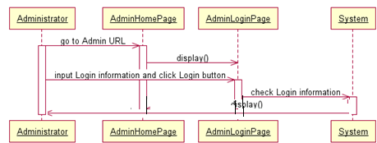

### Manage Contacts

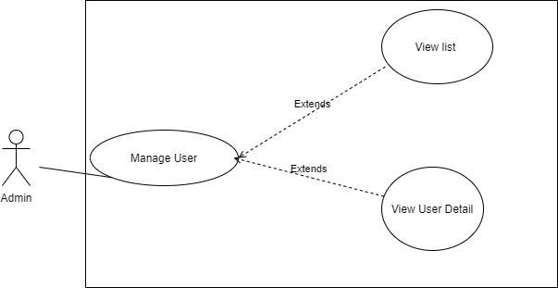

#### 3.2.1 ViewList

|  |  |  |
| --- | --- | --- |
| **Author** | Tran Kim Dat | |
| **Use case name** | View List | |
| **Actors** | Administrator | |
| **Description** | View List of contact | |
| **Requirements** |  | |
| **Pre-conditions** | Actor has already logged into the System as Administrator and Full Control property is true. | |
| **Post-conditions** | Success: View List of Properties | |
| **Basic flow** | Actor actions:  1. From ‘Admin’ page, actor clicks on to the ‘Manage Contacts` button. | System response:  2. System redirects to ‘Manage Contacts’ page and display list of all of Property in table form:   * ID * Name * Email * Phone * Content |
|  |  |  |
| **Alternative flow** |  |  |
| **Exception** |  |  |

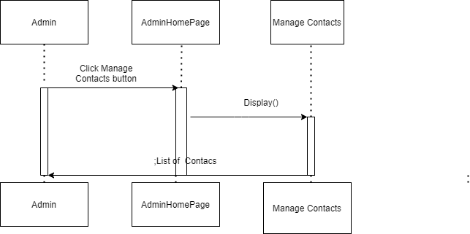

#### 3.2.2 Delete

|  |  |  |
| --- | --- | --- |
| **Author** | Tran Kim Dat | |
| **Use case name** | Delete | |
| **Actors** | Administrator | |
| **Description** | Delete a contact | |
| **Requirements** |  | |
| **Pre-conditions** | Actor has already logged into the System as Administrator and Full Control property is true. | |
| **Post-conditions** | Success: Deleted a contact | |
| **Basic flow** | Actor actions:  1. From ‘Manage Contacts’ page, actor clicks on to the ‘Delete’ button which contact wants to delete.  3. Actor clicks ‘Yes’ button.[Alternative 1] | System response:  2. A confirms message box appears:”Are you sure that you want to delete this contact?”  4. System deletes the administrator in the database. |
| **Alternative flow** | [Alternative 1]  1. Actor clicks on to ‘No’ button | 2. System redirects to ‘Manage Contacts’ page |
| **Exception** |  |  |

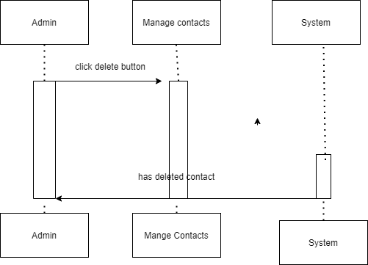

### 3.3 Manage Users

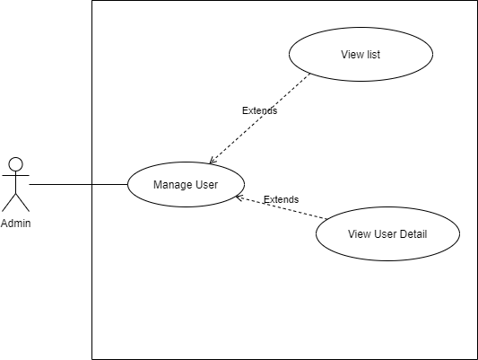

#### 3.3.1 ViewList

|  |  |  |
| --- | --- | --- |
| **Author** | Tran Kim Dat | |
| **Use case name** | View List | |
| **Actors** | Administrator | |
| **Description** | View List of user | |
| **Requirements** |  | |
| **Pre-conditions** | Actor has already logged into the System as Administrator and Full Control property is true. | |
| **Post-conditions** | Success: View List of Properties | |
| **Basic flow** | Actor actions:  1. From ‘Admin’ page, actor clicks on to the ‘Manage Usesr` button. | System response:  2. System redirects to ‘Manage Users’ page and display list of all of Property in table form:   * email * Name * dob * Phone * Address * Province * District * Ward * Gender |
|  |  |  |
| **Alternative flow** |  |  |
| **Exception** |  |  |

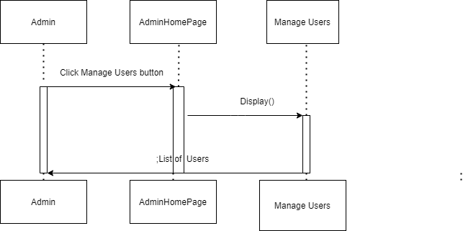

#### 3.3.2 View User Detail

|  |  |  |
| --- | --- | --- |
| **Author** | Tran Kim Dat | |
| **Use case name** | View user detail | |
| **Actors** | Administrator | |
| **Description** | View User Detail | |
| **Requirements** |  | |
| **Pre-conditions** | Actor has already logged into the System as Administrator and Full Control property is true. | |
| **Post-conditions** | Success: view detail of user | |
| **Basic flow** | Actor actions:  1. From ‘Manage Users` page, actor clicks on to the ‘Detail’ button of User which actor wants to watch detail. | System response:  2. System redirects to ‘Manage User Detail ’ page and memebershipcard according |
| **Exception** |  |  |

=

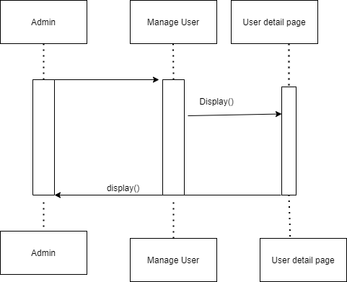

### Manage Memberships

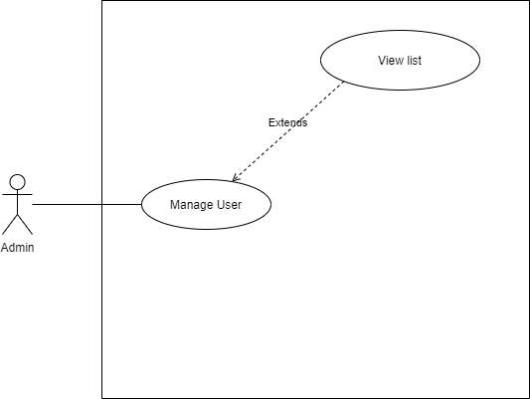

#### ViewList

|  |  |  |
| --- | --- | --- |
| **Author** | Tran Kim Dat | |
| **Use case name** | View List | |
| **Actors** | Administrator | |
| **Description** | View List of membership | |
| **Requirements** |  | |
| **Pre-conditions** | Actor has already logged into the System as Administrator and Full Control property is true. | |
| **Post-conditions** | Success: View List of Properties | |
| **Basic flow** | Actor actions:  1. From ‘Admin’ page, actor clicks on to the ‘Manage memberships` button. | System response:  2. System redirects to ‘Manage Memberships’ page and display list of all of Property in table form:   * Register * Email * Total spend * Type * Point |
|  |  |  |
| **Alternative flow** |  |  |
| **Exception** |  |  |

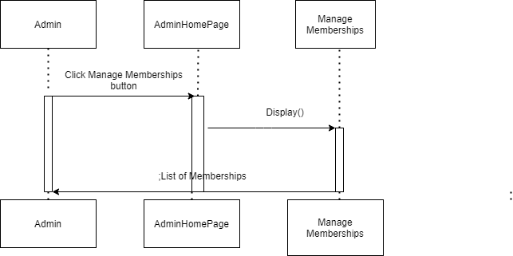

### Manage Coupons

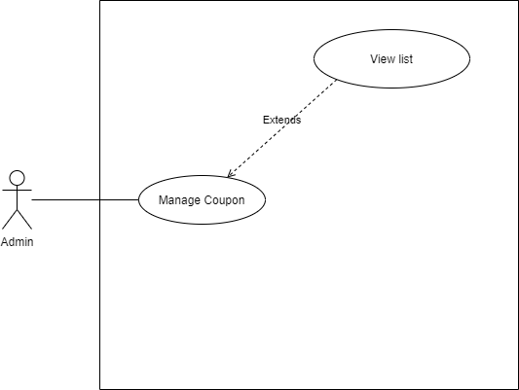

#### View List of Coupons

|  |  |  |
| --- | --- | --- |
| **Author** | Tran Kim Dat | |
| **Use case name** | View List | |
| **Actors** | Administrator | |
| **Description** | View List of coupons | |
| **Requirements** |  | |
| **Pre-conditions** | Actor has already logged into the System as Administrator and Full Control property is true. | |
| **Post-conditions** | Success: View List of Properties | |
| **Basic flow** | Actor actions:  1. From ‘Admin’ page, actor clicks on to the ‘Manage Coupons` button. | 2. System redirects to ‘Manage coupons’ page and display list of all of Property in table form:  -Id  -Email  -PriceCoupon |
|  |  |  |
| **Alternative flow** |  |  |

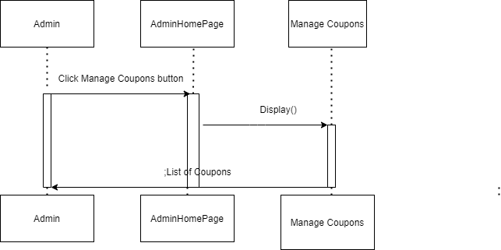

### Manage Movie

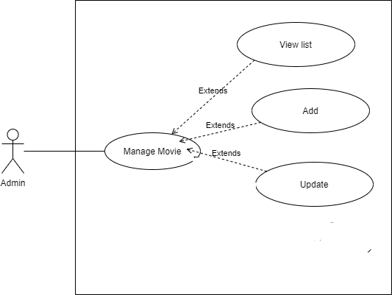

#### 3.6.1 View List of Movies

|  |  |  |
| --- | --- | --- |
| **Author** | Tran Kim Dat | |
| **Use case name** | View List | |
| **Actors** | Administrator | |
| **Description** | View List of movies | |
| **Requirements** |  | |
| **Pre-conditions** | Actor has already logged into the System as Administrator and Full Control property is true. | |
| **Post-conditions** | Success: View List of Properties | |
| **Basic flow** | Actor actions:  1. From ‘Admin’ page, actor clicks on to the ‘Manage Movies` button. | 2. System redirects to ‘Manage Movies` page and display list of all of Property in table form:  -movieId  -movieTitle  -movieCategory  -performer  -filmdirectory  -moviecontent  -image  -trailer  -starmovie  -endmovie  -status  -number or users rating  -Rating point |
|  |  |  |
| **Alternative flow** |  | **Alternative flow** |

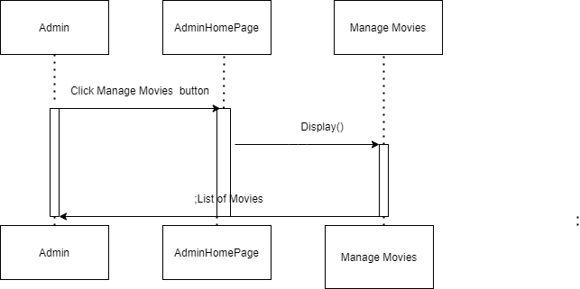

#### Add Movie

|  |  |  |
| --- | --- | --- |
| **Author** | Tran Kim Dat | |
| **Use Case Name** | Add | |
| **Actors** | Administrator | |
| **Description** | Admonistrator wish to add new Movie | |
| **Requirements** |  | |
| **Pre-conditions** | Actor has logged in as Administrator | |
| **Post-conditions** | Success: Add movie successful  Fail: Refill information | |
| **Basic flow** | Actor Actions:  1. Actor clicks ‘Add’ button on Manage movies page  3. Actor inputs property type information :  5. Actor click ‘Add’ button. | System Responses:  2. System redirects to this page and displays form for Actor to input information with the following control :   1. -‘movieId’ text field 2. -‘movietTitle’ text field 3. -‘movieCategory’ text field 4. -‘performer’ text field 5. -‘filmdirector’ text field 6. -‘movieContent’ text field 7. -‘Image’ text field 8. -‘Trailer’ text field 9. -‘startMovie’ text field 10. -‘endMovie’ text field 11. -‘Status` text field 12. -‘Add’ button   4. System checks information input [Exception 1]  6. System add movie into database,redirect manage movie and then display message ‘Your Movie has been add successful’. |
| **Alternative flow** |  |  |
| **Exceptions** | [Exception 1]  Actor Actions:  1. Actor left ‘movieId’ text field blank  3 Actor left ‘movieName text field blank  5.Actor left movieCategory’ text field  7.Actor left -‘performer’ text field  9.Actor left -‘filmdirector’ text field  11.Actor left -‘movieContent’ text field  13. Actor left -‘Image’ text field  15. Actor left ‘Trailer’ text field  17. Actor left ‘startMovie’ text field  19. Actor left ‘endMovie’ text field  21. Actor left Status` text field | System Response:  System displays message to notice admin:  2.‘MovieId can’t be blank.’  4`.MovieName can’t be blank.’  6`.MovieCategory can’t be blank.’  8`.Performer can’t be blank.’  10`.Filmdiretor can’t be blank.’  12`.Movie content can’t be blank.’  14`.Image can’t be blank.’  16`.Trailer can’t be blank.  18`.StartMovie can’t be blank  20`.EndMovie can’t be blank  22`.Status can’t be blank |
|  |  |  |

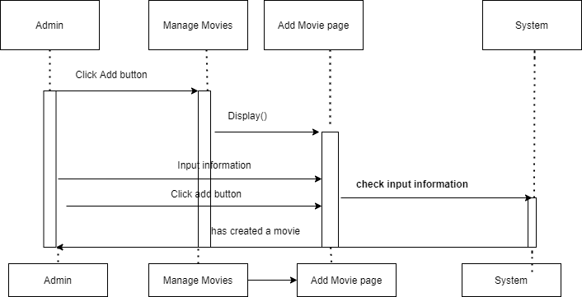

#### 3.6.3 Update Movie

|  |  |  |
| --- | --- | --- |
| **Author** | Tran Kim Dat | |
| **Use Case Name** | Update | |
| **Actors** | Administrator | |
| **Description** | Administrator wish to update movie | |
| **Requirements** |  | |
| **Pre-conditions** | Actor has logged in as Administrator | |
| **Post-conditions** | Success: Modify movie successful  Fail: Refill information | |
| **Basic flow** | Actor Actions:  1. From ‘Manage Movies’ page, actor clicks on button`Update` on table at Movie which wants to modify.  3. Actor inputs property type information :  5. Actor click ‘Update’ button. | System Responses:  2. System redirects to this page and displays form for Actor to input information with the following control :   1. ‘movietTitle’ text field(Readonly) 2. ‘movieCategory’ text field 3. ‘performer’ text field 4. ‘filmdirector’ text field 5. ‘movieContent’ text field 6. ‘Image’ text field 7. ‘Trailer’ text field 8. ‘startMovie’ text field 9. ‘endMovie’ text field 10. ‘Status` text field 11. ‘Update’ button   4. System checks information input [Exception 1]  6. System update movie into database,redirect manage movie and then display message ‘Your Movie has been update successful’. |
| **Alternative flow** |  |  |
| **Exceptions** | [Exception 1]  Actor Actions:  1.Actor left ‘movieName text field blank  3.Actor left movieCategory’ text field  5.Actor left -‘performer’ text field  7.Actor left -‘filmdirector’ text field  9.Actor left -‘movieContent’ text field  11.Actor left -‘Image’ text field  13.Actor left ‘Trailer’ text field  15.Actor left ‘startMovie’ text field  17.Actor left ‘endMovie’ text field  19.Actor left Status` text field | System Response:  System displays message to notice admin:  2`.MovieName can’t be blank.’  4.`.MovieCategory can’t be blank.’  6.`.Performer can’t be blank.’  8.`.Filmdiretor can’t be blank.’  10.`.Movie content can’t be blank.’  12.`.Image can’t be blank.’  14.`.Trailer can’t be blank.  16.`.StartMovie can’t be blank  18`.EndMovie can’t be blank  20`.Status can’t be blank |

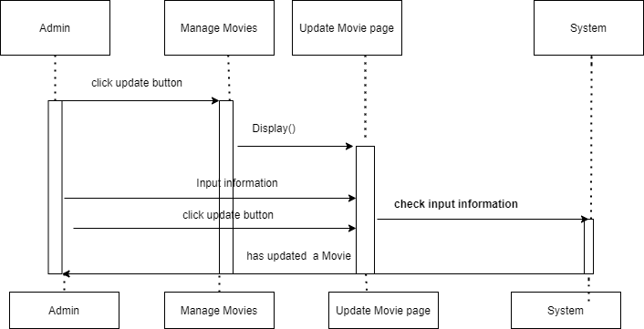

### 3.7 Manage MovieReviews

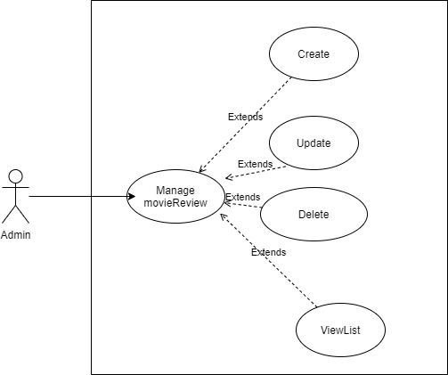

#### 3.7.1 View List of MovieReviews

|  |  |  |
| --- | --- | --- |
| **Author** | Tran Kim Dat | |
| **Use case name** | View List | |
| **Actors** | Administrator | |
| **Description** | View List of movieReview | |
| **Requirements** |  | |
| **Pre-conditions** | Actor has already logged into the System as Administrator and Full Control property is true. | |
| **Post-conditions** | Success: View List of Properties | |
| **Basic flow** | Actor actions:  1. From ‘Admin’ page, actor clicks on to the ‘Manage MovieReviews` button. | 2. System redirects to ‘Manage MovieReviews’ page and display list of all of Property in table form:   1. -Id 2. -Title 3. -movieReviewContent 4. movieReviewView 5. -Type 6. -Image |
|  |  |  |
| **Alternative flow** |  | **Alternative flow** |

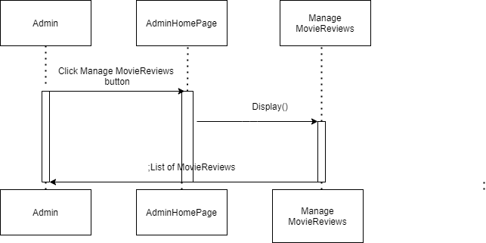

#### Add MovieReview

|  |  |  |
| --- | --- | --- |
| **Author** | Tran Kim Dat | |
| **Use Case Name** | Add | |
| **Actors** | Administrator | |
| **Description** | Admonistrator wish to add new MovieReview | |
| **Requirements** |  | |
| **Pre-conditions** | Actor has logged in as Administrator | |
| **Post-conditions** | Success: Add MovieReview successful  Fail: Refill information | |
| **Basic flow** | Actor Actions:  1. Actor clicks ‘Add’ button on View list of banks page  3. Actor inputs property type information :  5. Actor click ‘Add’ button. | System Responses:  2. System redirects to this page and displays form for Actor to input information with the following control :   1. Id textfiled 2. Title textfiled 3. movieReviewContent textfiled 4. movieReviewView textfiled 5. Type textfiled 6. Add button   4. System checks information input [Exception 1]  6. System add movie into database,redirect manage movie and then display message ‘Your MovieReview has been add successful’. |
| **Alternative flow** |  |  |
| **Exceptions** | [Exception 1]  Actor Actions:  1.Actor left Id textfiled bank  3.Actor left Title textfiled bank  5.Actor left movieReviewContent textfiled bank  7.movieReviewView textfiled bank  9.Actor left Type textfiled bank | System Response:  System displays message to notice admin:  2.`Id can’t be blank.’  4`.Title` can’t be blank.’  6.`movieReviewContent` can’t be blank.’  8`type` can’t be blank.’ |

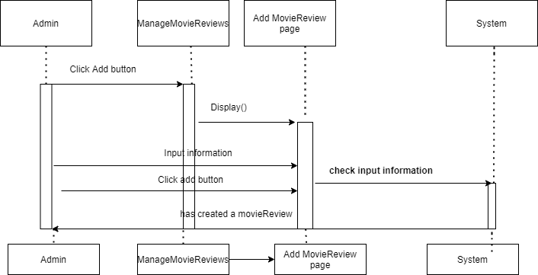

#### Update MovieReview

|  |  |  |
| --- | --- | --- |
| **Author** | Tran Kim Dat | |
| **Use Case Name** | Update | |
| **Actors** | Administrator | |
| **Description** | Administrator wish to update moviereview | |
| **Requirements** |  | |
| **Pre-conditions** | Actor has logged in as Administrator | |
| **Post-conditions** | Success: Update movieReview successful  Fail: Refill information | |
| **Basic flow** | Actor Actions:  1. . From ‘Manage MovieReviews’ page, actor clicks on button`Update` on table at MovieReview which wants to modify.  3. Actor inputs property type information :  5. Actor click‘update` button. | System Responses:  2. System redirects to this page and displays form for Actor to input information with the following control :   1. Id textfiled(Read only) 2. Title textfiled 3. movieReviewContent textfiled 4. movieReviewView textfiled 5. Type textfiled 6. Image textfiled   7.Update button  4. System checks information input [Exception 1]  6. System add movie into database,redirect manage movieReview and then display message ‘Your MovieReview has been aupdate successful’. |
| **Alternative flow** |  |  |
| **Exceptions** | [Exception 1]  Actor Actions:  1.Actor left Title textfiled bank  3.Actor left movieReviewContent textfiled bank  5.movieReviewView textfiled bank  7.Actor left Type textfiled bank | System Response:  1. System displays message to notice admin:  2`.Title` can’t be blank.’  4.`movieReviewContent` can’t be blank.’  6.`view` can’t be blank.’  8. `Type` can’t be blank.’ |

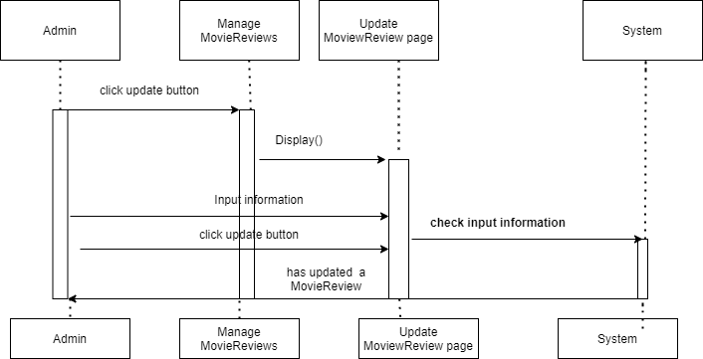

#### 3.7.4 Delete MovieReview

|  |  |  |
| --- | --- | --- |
| **Author** | Tran Kim Dat | |
| **Use case name** | Delete | |
| **Actors** | Administrator | |
| **Description** | Delete an Administrator | |
| **Requirements** |  | |
| **Pre-conditions** | Actor has already logged into the System as Administrator and Full Control property is true. | |
| **Post-conditions** | Success: Deleted a moviereview | |
| **Basic flow** | Actor actions:  1. From ManageMovieReviews’ page, actor clicks on to the ‘Delete’ button of MovieReview which actor wants to delete.  3. Actor clicks ‘Yes’ button.[Alternative 1] | System response:  2. A confirms message box appears:”Are you sure that you want to delete this movie review?”  4. System deletes the administrator in the database. |
| **Alternative flow** | [Alternative 1]  1. Actor clicks on to ‘No’ button | 2. System redirects to ‘manage moviereview` |
| **Exception** |  |  |

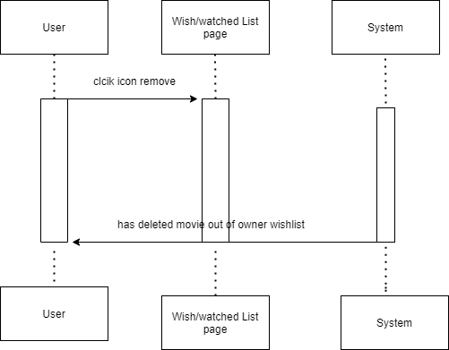

### Manage Endows

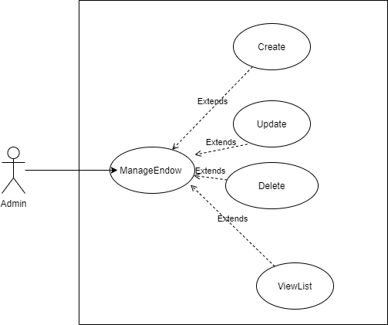

#### ViewList

|  |  |  |
| --- | --- | --- |
| **Author** | Tran Kim Dat | |
| **Use case name** | View List | |
| **Actors** | Administrator | |
| **Description** | View List of Endows | |
| **Requirements** |  | |
| **Pre-conditions** | Actor has already logged into the System as Administrator and Full Control property is true. | |
| **Post-conditions** | Success: View List of Properties | |
| **Basic flow** | Actor actions:  1. From ‘Admin’ page, actor clicks on to the ‘Manage Endows` button. | System response:  2. System redirects to ‘Manage Endows’ page and display list of all of Property in table form:   1. endowId 2. endowContent 3. endowImage 4. endowTitle 5. startTime 6. endTime |
|  |  |  |
| **Alternative flow** |  |  |
| **Exception** |  |  |

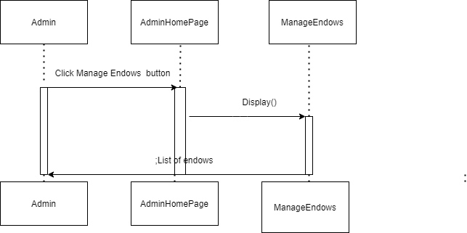

#### Add Endow

|  |  |  |
| --- | --- | --- |
| **Author** | Tran Kim Dat | |
| **Use Case Name** | Add Endow | |
| **Actors** | Administrator | |
| **Description** | Admonistrator wish to add new Endow | |
| **Requirements** |  | |
| **Pre-conditions** | Actor has logged in as Administrator | |
| **Post-conditions** | Success: Add Endow successful  Fail: Refill information | |
| **Basic flow** | Actor Actions:  1. Actor clicks ‘Add’ button on Manage Endows page  3. Actor inputs property type information :  5. Actor click ‘Add’ button. | System Responses:  2. System redirects to this page and displays form for Actor to input information with the following control :   1. endowId textfiled 2. endowContent textfiled   3.endowTitle textfiled  4. add button  4. System checks information input [Exception 1]  6. System add movie into database,redirect manage movie and then display message ‘Your Endow has been add successful’. |
| **Alternative flow** |  |  |
| **Exceptions** | [Exception 1]  Actor Actions:  1.Actor left endowId textfiled blank  3.Actor left endowContent textfiled blank  5.Actor left endowImage textfiled blank | System Response:  System displays message to notice admin:  2.endowId can’t blank  4.endowContent can’t blank  6.endowTitle can’t blank |

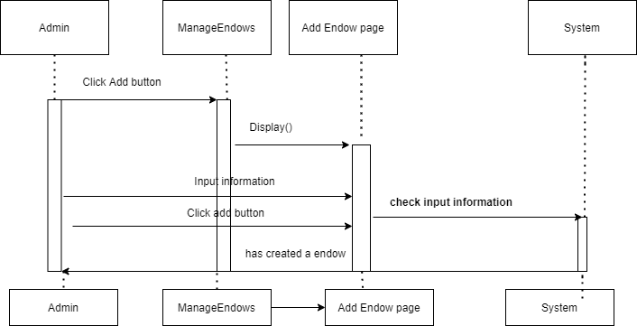

#### 3.8.3 Update Endow

|  |  |  |
| --- | --- | --- |
| **Author** | Tran Kim Dat | |
| **Use Case Name** | Update endow | |
| **Actors** | Administrator | |
| **Description** | Administrator wish to update endow | |
| **Requirements** |  | |
| **Pre-conditions** | Actor has logged in as Administrator | |
| **Post-conditions** | Success: Update endow successful  Fail: Refill information | |
| **Basic flow** | Actor Actions:  1. . From ‘Manage Endows’ page, actor clicks on button`Update` on table at endow which wants to modify.  3. Actor inputs property type information :  5. Actor click ‘update` button. | System Responses:  2. System redirects to this page and displays form for Actor to input information with the following control :   1. endowId textfiled(read only) 2. endowContent textfiled 3. endowImage textfiled 4. button update   4. System checks information input [Exception 1]  6. System add movie into database,redirect manage movie and then display message ‘Your Endow has been update successful’. |
| **Alternative flow** |  |  |
| **Exceptions** | [Exception 1]  Actor Actions:  1.Actor left endowContent textfiled blank  3.Actor left endowTitle textfiled blank | System Response: System displays message to notice admin:  2.endowContent can’t blank  4.endowtitle can’t blank |

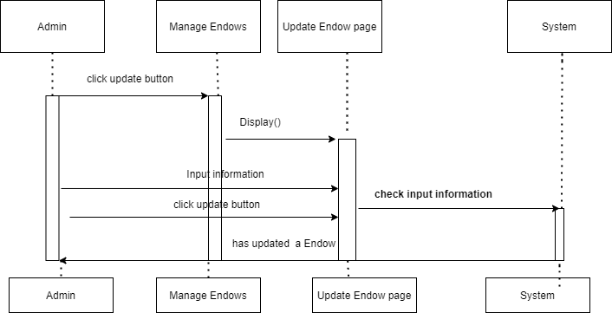

#### 3.8.4 Delete

|  |  |  |
| --- | --- | --- |
| **Author** | Tran Kim Dat | |
| **Use case name** | Delete | |
| **Actors** | Administrator | |
| **Description** | Delete an Endow | |
| **Requirements** |  | |
| **Pre-conditions** | Actor has already logged into the System as Administrator and Full Control property is true. | |
| **Post-conditions** | Success: Deleted an Endow | |
| **Basic flow** | Actor actions:  1. From ‘Manage Endows` page, actor clicks on to the ‘Delete’ button of Endow which actor wants to delete.  3. Actor clicks ‘Yes’ button.[Alternative 1] | System response:  2. A confirms message box appears:”Are you sure that you want to delete this Endow?”  4. System deletes the administrator in the database. |
| **Alternative flow** | [Alternative 1]  1. Actor clicks on to ‘No’ button | 2. System redirects to ‘Manage Endow’ page |
| **Exception** |  |  |

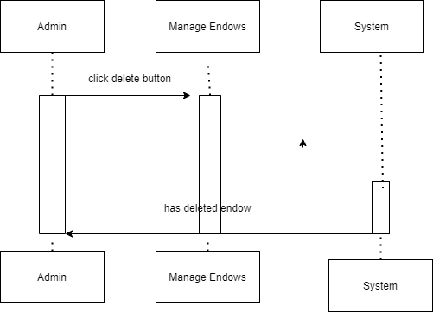

### Manage Rooms

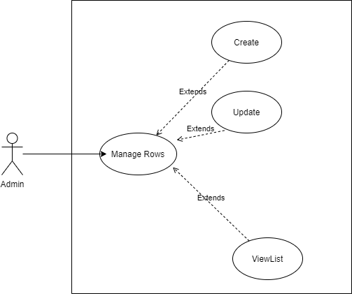

#### 3.9.1 ViewList

|  |  |  |
| --- | --- | --- |
| **Author** | Tran Kim Dat | |
| **Use case name** | View List | |
| **Actors** | Administrator | |
| **Description** | View List of Room | |
| **Requirements** |  | |
| **Pre-conditions** | Actor has already logged into the System as Administrator and Full Control property is true. | |
| **Post-conditions** | Success: View List of Properties | |
| **Basic flow** | Actor actions:  1. From ‘Admin’ page, actor clicks on to the ‘Manage Rooms` button. | System response:  2. System redirects to ‘Manage Rooms’ page and display list of all of Property in table form:   1. roomId 2. roomName 3. roomSize 4. roomCategory 5. threatid |
|  |  |  |
| **Alternative flow** |  |  |
| **Exception** |  |  |

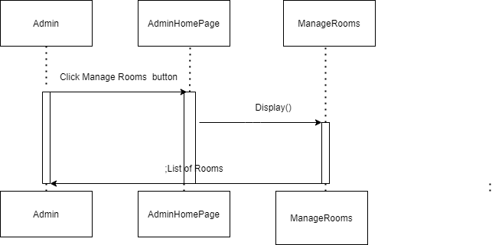

#### Add Room

|  |  |  |
| --- | --- | --- |
| **Author** | Tran Kim Dat | |
| **Use Case Name** | Add Room | |
| **Actors** | Administrator | |
| **Description** | Admonistrator wish to add new Room | |
| **Requirements** |  | |
| **Pre-conditions** | Actor has logged in as Administrator | |
| **Post-conditions** | Success: Add Room successful  Fail: Refill information | |
| **Basic flow** | Actor Actions:  1. Actor clicks ‘Add’ button on Manage Rooms page  3. Actor inputs property type information :  5. Actor click ‘Add’ button. | System Responses:  2. System redirects to this page and displays form for Actor to input information with the following control :   1. roomId texfiled 2. roomName texfiled 3. roomSize texfiled 4. roomCategory texfiled 5. threatName combobox 6. add button   4. System checks information input [Exception 1]  6. System add movie into database,redirect manage movie and then display message ‘Your Room has been add successful’. |
| **Alternative flow** |  |  |
| **Exceptions** | [Exception 1]  Actor Actions:  1.actor left roomId texfiled blank  3.actor left roomName texfiled blank  5.actor left roomSize texfiled blank  7.actor left roomCategory texfiled blank  9.actor left don’t choose threaterName combobox | System Response:  System displays message to notice admin:  2.roomId can’t blank  4.roomName can’t blank  6.roomSize can’t blank  8.roomCategory can’t blank  10.please choose threaterName |

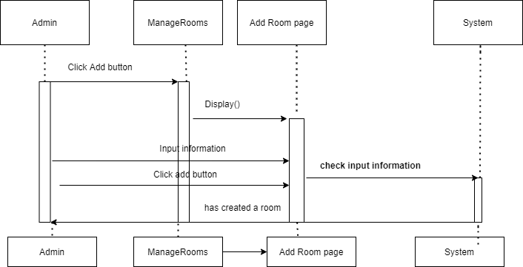

#### Update Room

|  |  |  |
| --- | --- | --- |
| **Author** | Tran Kim Dat | |
| **Use Case Name** | Update movie | |
| **Actors** | Administrator | |
| **Description** | Administrator wish to update Room | |
| **Requirements** |  | |
| **Pre-conditions** | Actor has logged in as Administrator | |
| **Post-conditions** | Success: Update room successful  Fail: Refill information | |
| **Basic flow** | Actor Actions:  1. . From ‘Manage Rooms’ page, actor clicks on button`Update` on table at rooom which wants to modify.  3. Actor inputs property type information :  5. Actor click ‘update` button. | System Responses:  2. System redirects to this page and displays form for Actor to input information with the following control :   1. roomId texfiled(readonly) 2. roomName texfiled 3. roomSize texfiled 4. roomCategory texfiled 5. threatName combobox 6. update button   4. System checks information input [Exception 1]  6. System add movie into database,redirect manage movie and then display message ‘Your Room has been update successful’. |
| **Alternative flow** |  |  |
| **Exceptions** | [Exception 1]  Actor Actions:  1.actor left roomName texfiled blank  3.actor left roomSize texfiled blank  5.actor left roomCategory texfiled blank  7.actor left don’t choose threatName combobox | System Response:  System displays message to notice admin:  2.roomName can’t blank  4.roomSize can’t blank  6.roomCategory can’t blank  8.please choose threatName |

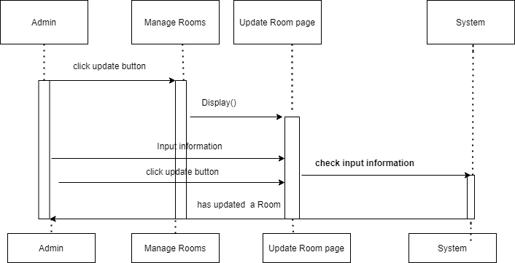

### Manage Row of Seats

#### ViewList

|  |  |  |
| --- | --- | --- |
| **Author** | Tran Kim Dat | |
| **Use case name** | View List | |
| **Actors** | Administrator | |
| **Description** | View List of Row of Seats | |
| **Requirements** |  | |
| **Pre-conditions** | Actor has already logged into the System as Administrator and Full Control property is true. | |
| **Post-conditions** | Success: View List of Properties | |
| **Basic flow** | Actor actions:  1. From ‘Admin’ page, actor clicks on to the ‘Manage Row of Seats ` button. | System response:  2. System redirects to ‘Row of Seats `page and display list of all of Property in table form:   1. rowid 2. roomid 3. rowNo |
| **Alternative flow** |  |  |
| **Exception** |  |  |

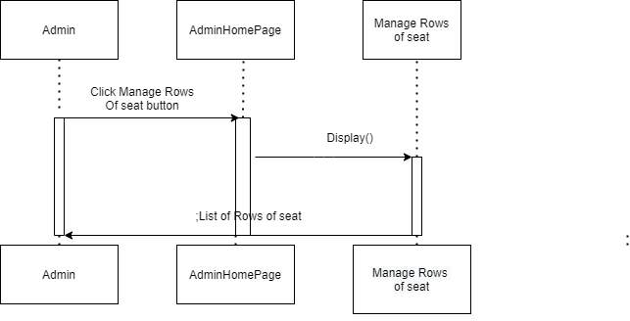

#### Add Row of Seats

|  |  |  |
| --- | --- | --- |
| **Author** | Tran Kim Dat | |
| **Use Case Name** | Add | |
| **Actors** | Administrator | |
| **Description** | Admonistrator wish to add new Row of Seats | |
| **Requirements** |  | |
| **Pre-conditions** | Actor has logged in as Administrator | |
| **Post-conditions** | Success: Add Row of Seats successful  Fail: Refill information | |
| **Basic flow** | Actor Actions:  1. Actor clicks ‘Add’ button on Manage Rows of room page  3. Actor inputs property type information :  5. Actor click ‘Add’ button. | System Responses:  2. System redirects to this page and displays form for Actor to input information with the following control :   1. rowid textfiled 2. roomName combobox 3. rowNo textfiled 4. Add button   4. System checks information input [Exception 1]  6. System add movie into database,redirect manage movie and then display message ‘add successful’. |
| **Alternative flow** |  |  |
| **Exceptions** | [Exception 1]  Actor Actions:   1. actor left rowId texfiled blank   3.actor don’t choose roomName combobox  5.actor left rowNo textfiled blank | System Response:System displays message to notice admin:  2.rowId can’t blank  4.Please choose roomName  6.rowNo can’t blank |

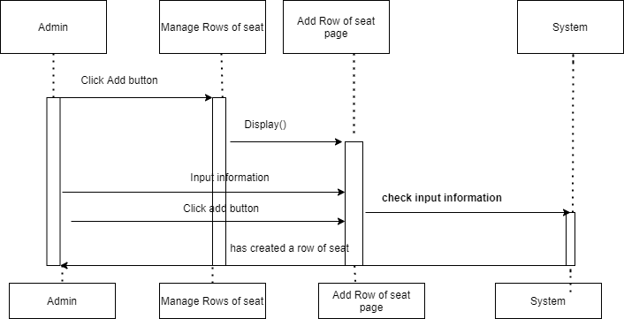

#### Update Row of Seats

|  |  |  |
| --- | --- | --- |
| **Author** | Tran Kim Dat | |
| **Use Case Name** | Update | |
| **Actors** | Administrator | |
| **Description** | Administrator wish to update Row Of room | |
| **Requirements** |  | |
| **Pre-conditions** | Actor has logged in as Administrator | |
| **Post-conditions** | Success: Update Row Of room successful  Fail: Refill information | |
| **Basic flow** | Actor Actions:  1. . From ‘Manage Row of Seats page, actor clicks on button`Update` on table at row which wants to modify.  3. Actor inputs property type information :  5. Actor click ‘update` button. | System Responses:  2. System redirects to this page and displays form for Actor to input information with the following control :   1. rowid textfiled(read only) 2. roomName combobox 3. rowNo textfiled   4. System checks information input [Exception 1]  6. System add movie into database,redirect manage Row of Seats and then display message ‘update successful’. |
| **Alternative flow** |  |  |
| **Exceptions** | [Exception 1]  Actor Actions:  1.actor don’t choose roomName combobox  3.actor left rowNo textfiled blank | System Response:  . System displays message to notice admin:  2.Please choose roomName  4.rowNo can’t blank |

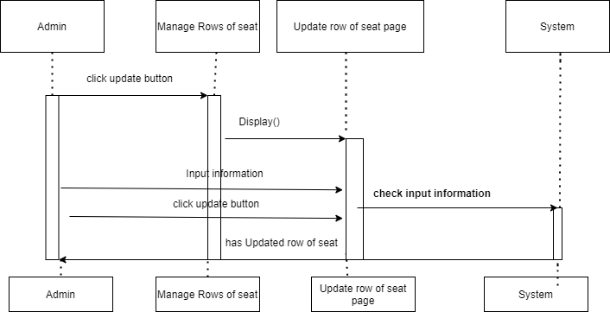

### 3.11 Manage Threaters

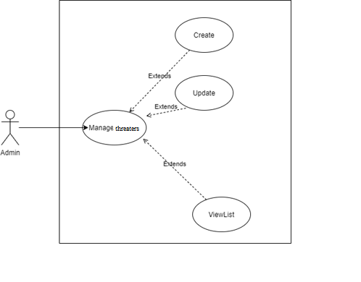

#### 3.11.1 ViewList

|  |  |  |
| --- | --- | --- |
| **Author** | Tran Kim Dat | |
| **Use case name** | View List | |
| **Actors** | Administrator | |
| **Description** | View List of Threaters | |
| **Requirements** |  | |
| **Pre-conditions** | Actor has already logged into the System as Administrator and Full Control property is true. | |
| **Post-conditions** | Success: View List of Properties | |
| **Basic flow** | Actor actions:  1. From ‘Admin’ page, actor clicks on to the ‘Manage Threaters ` button. | 2. System redirects to ‘Row of Seats `page and display list of all of Property in table form:   1. Id texfiled 2. Name texfiled 3. Phone texfiled 4. Address texfiled 5. Region combobox |
| **Alternative flow** | ` |  |
| **Exception** |  |  |

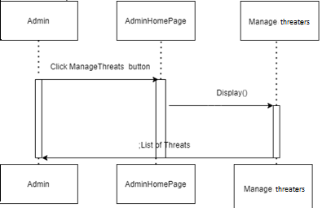

#### Add Threater

|  |  |  |
| --- | --- | --- |
| **Author** | Tran Kim Dat | |
| **Use Case Name** | Add | |
| **Actors** | Administrator | |
| **Description** | Admonistrator wish to add new threater | |
| **Requirements** |  | |
| **Pre-conditions** | Actor has logged in as Administrator | |
| **Post-conditions** | Success: Add Theater successful  Fail: Refill information | |
| **Basic flow** | Actor Actions:  1. Actor clicks ‘Add’ button on Manage Theater page  3. Actor inputs property type information :  5. Actor click ‘Add’ button. | System Responses:  2. System redirects to this page and displays form for Actor to input information with the following control :  1.Id texfiled(read only)  2.Name texfiled  3.Phone texfiled  4.Address texfiled  5.Region combobox  6.Add button  4. System checks information input [Exception 1]  6. System add movie into database,redirect manage movie and then display message ‘Your Threat has been add successful’. |
| **Alternative flow** |  |  |
| **Exceptions** | [Exception 1]  Actor Actions:  1.actor left Id texfiled blank  3.actor left Name texfiled blank  5.actor left Phone texfiled blank  7.actor left Address texfiled blank  9.actor don’t choose region combobox | System Response:  System displays message to notice admin:  2.Id can’t blank  4.Name can’t blank  6.Phone can’t blank  8.Address can’t blank  10.please choose region |

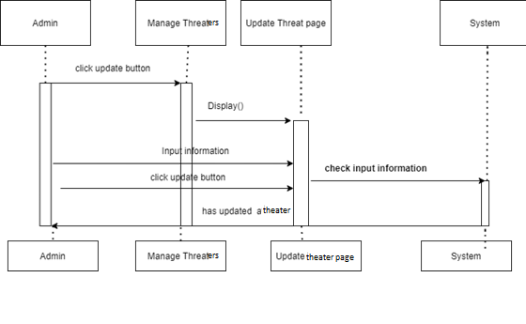

#### Update Threater

|  |  |  |
| --- | --- | --- |
| **Author** | Tran Kim Dat | |
| **Use Case Name** | Update | |
| **Actors** | Administrator | |
| **Description** | Administrator wish to update Threater | |
| **Requirements** |  | |
| **Pre-conditions** | Actor has logged in as Administrator | |
| **Post-conditions** | Success: Update Threater successful  Fail: Refill information | |
| **Basic flow** | Actor Actions:  1. . From ‘Manage Threater’ page, actor clicks on button`Update` on table at threat which wants to modify.  3. Actor inputs property type information :  5. Actor click ‘update` button. | System Responses:  2. System redirects to this page and displays form for Actor to input information with the following control :   1. Id texfiled(read only) 2. Name texfiled 3. Phone texfiled 4. Address texfiled 5. Region combobox 6. Update button   4. System checks information input [Exception 1]  6. System add movie into database,redirect manage movie and then display message ‘Your Threat has been update successful’. |
| **Alternative flow** |  |  |
| **Exceptions** | Actor Actions:  1.actor left Name texfiled blank  3.actor left Phone texfiled blank  5.actor left Address texfiled blank  7.actor don’t choose region combobox | Actor Actions:  2.actor left Name texfiled blank  4.actor left Phone texfiled blank  6.actor left Address texfiled blank  8.actor left don’t choose region |

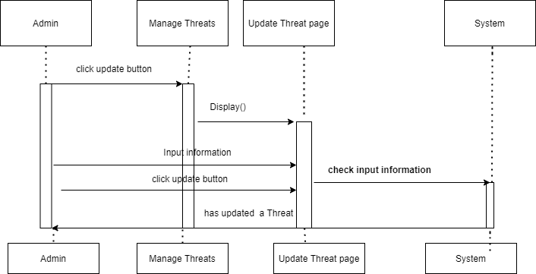

### Manage ShowTimes

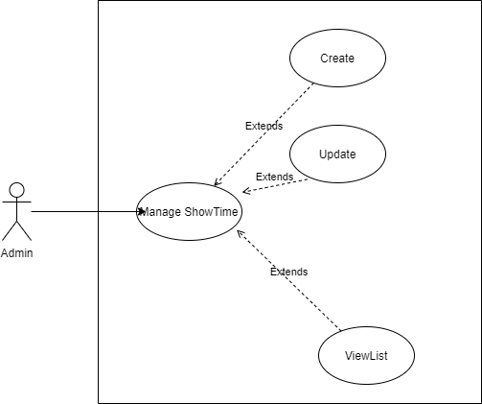

#### 3.12.1 ViewList

|  |  |  |
| --- | --- | --- |
| **Author** | Tran Kim Dat | |
| **Use case name** | View List | |
| **Actors** | Administrator | |
| **Description** | View List of ShowTimes | |
| **Requirements** |  | |
| **Pre-conditions** | Actor has already logged into the System as Administrator and Full Control property is true. | |
| **Post-conditions** | Success: View List of Properties | |
| **Basic flow** | Actor actions:  1. From ‘Admin’ page, actor clicks on to the ‘Manage ShowTimes ` button. | System response:  2. System redirects to ‘Manage ShowTimes `page and display list of all of Property in table form:   1. showTimeid 2. movieId 3. roomid 4. time 5. date |
| **Alternative flow** |  |  |
| **Exception** |  |  |

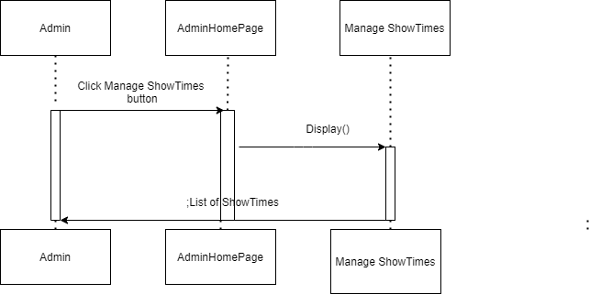

#### Add ShowTime

|  |  |  |
| --- | --- | --- |
| **Author** | Tran Kim Dat | |
| **Use Case Name** | Add | |
| **Actors** | Administrator | |
| **Description** | Admonistrator wish to add new ShowTime | |
| **Requirements** |  | |
| **Pre-conditions** | Actor has logged in as Administrator | |
| **Post-conditions** | Success: Add ShowTime successful  Fail: Refill information | |
| **Basic flow** | Actor Actions:  1. Actor clicks ‘Add’ button on Manage ShowTime page  3. Actor inputs property type information :  5. Actor click ‘Add’ button. | System Responses:  2. System redirects to this page and displays form for Actor to input information with the following control :   1. showTime textfiled 2. movieName combobox 3. roomName combobox 4. time timebox 5. date datebox 6. Add button   4. System checks information input [Exception 1]  6. System add movie into database,redirect manage movie and then display message ‘Your ShowTime has been add successful’. |
| **Alternative flow** |  |  |
| **Exceptions** | [Exception 1]  Actor Actions:  1.actor left showTimeId texfiled blank  3.actor don’t choose movieName combobox  5.actor don’t choose roomName combobox  7.actor left time timebox blank  9.actor left date datebpx blank | System Response:  1. System displays message to notice admin:  2.showTimeid can’t blank  4.Please choose movieName  6.Please choose roomName  8.time timebox can’t blank  10.date datebox can’t blank |

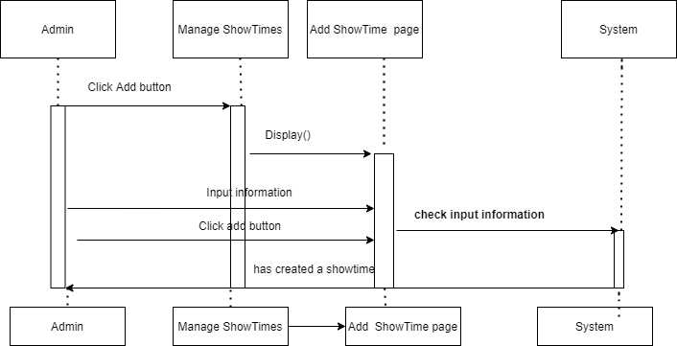

#### Update ShowTime

|  |  |  |
| --- | --- | --- |
| **Author** | Tran Kim Dat | |
| **Use Case Name** | Update | |
| **Actors** | Administrator | |
| **Description** | Administrator wish to update ShowTime | |
| **Requirements** |  | |
| **Pre-conditions** | Actor has logged in as Administrator | |
| **Post-conditions** | Success: Update ShowTime successful  Fail: Refill information | |
| **Basic flow** | Actor Actions:  1. . From ‘Manage ShowTimes’ page, actor clicks on button`Update` on table at showtime which wants to modify.  3. Actor inputs property type information :  5. Actor click ‘update` button. | System Responses:  2. System redirects to this page and displays form for Actor to input information with the following control :   1. showTimeid textfiled(read only) 2. movieName combobox 3. roomName combobox 4. time timebox 5. date datebox 6. Update button   4. System checks information input [Exception 1]  6. System add movie into database,redirect manage movie and then display message ‘Your Showtime has been update successful’. |
| **Alternative flow** |  |  |
| **Exceptions** | [Exception 1]  Actor Actions:  1.actor don’t choose movieName combobox  3.actor don’t choose roomName combobox  5.actor left time timebox blank  7.actor left date datebpx blank | System Response:  System displays message to notice admin:  2.Please choose movieName  4.Please choose roomName  6.time timebox can’t blank  8.date datebox can’t blank |

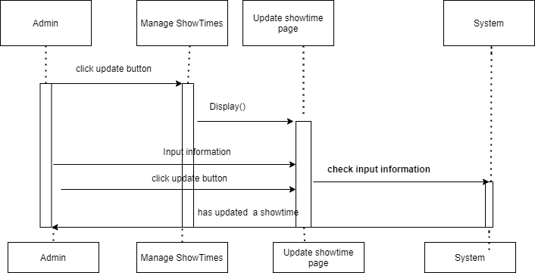

### Manage Tickets

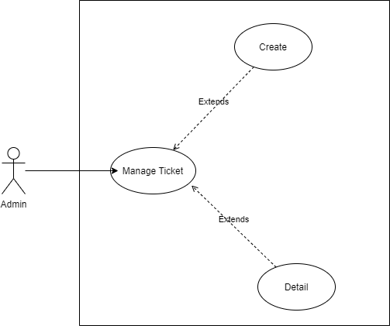

#### 3.13.1 ViewList

|  |  |  |
| --- | --- | --- |
| **Author** | Tran Kim Dat | |
| **Use case name** | View List | |
| **Actors** | Administrator | |
| **Description** | View List of tickets | |
| **Requirements** |  | |
| **Pre-conditions** | Actor has already logged into the System as Administrator and Full Control property is true. | |
| **Post-conditions** | Success: View List of Properties | |
| **Basic flow** | Actor actions:  1. From ‘Admin’ page, actor clicks on to the ‘Manage Tickets` button. | System response:  2. System redirects to ‘Manage Tickets’ page and display list of all of Property in table form:   * ticketid * showtimeid * user_email * ticketBooking Time * pay * totalPrice |
| **Alternative flow** |  |  |
| **Exception** |  |  |

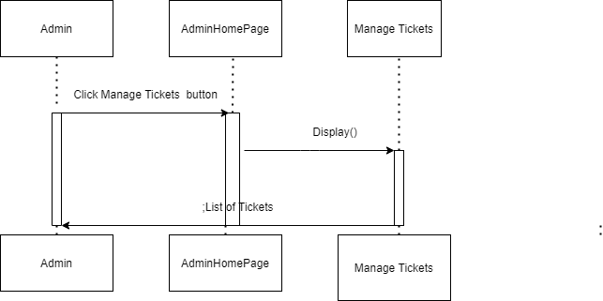

#### 3.13.2 View Ticket Detail

|  |  |  |
| --- | --- | --- |
| **Author** | Tran Kim Dat | |
| **Use case name** | Detail | |
| **Actors** | Administrator | |
| **Description** | View TicketDetail | |
| **Requirements** |  | |
| **Pre-conditions** | Actor has already logged into the System as Administrator and Full Control property is true. | |
| **Post-conditions** | Success:view detail of ticket | |
| **Basic flow** | Actor actions:  1. From ‘Manage Tickets` page, actor clicks on to the ‘Detail’ button of Ticket which actor wants to watch detail. | System response:  2. System redirects to ‘Manage Ticket Detail ’ page |
| **Exception** |  |  |

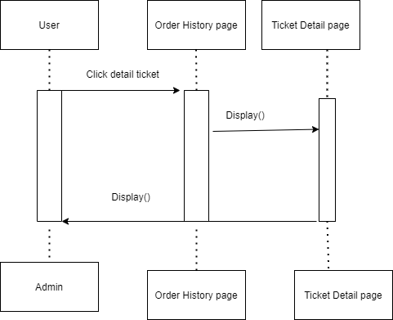

### Manage Seats

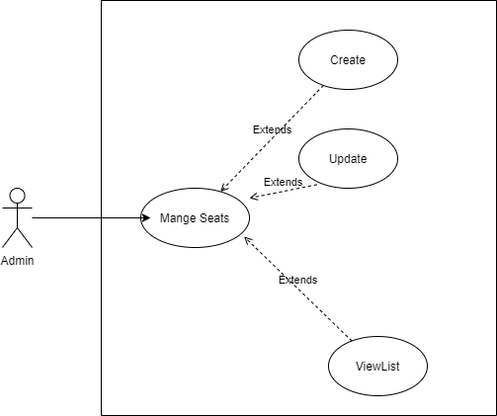

#### ViewList

|  |  |  |
| --- | --- | --- |
| **Author** | Tran Kim Dat | |
| **Use case name** | View List | |
| **Actors** | Administrator | |
| **Description** | View List of Seats | |
| **Requirements** |  | |
| **Pre-conditions** | Actor has already logged into the System as Administrator and Full Control property is true. | |
| **Post-conditions** | Success: View List of Properties | |
| **Basic flow** | Actor actions:  1. From ‘Admin’ page, actor clicks on to the ‘Manage Seats ` button. | System response:  2. System redirects to ‘Manage seats `page and display list of all of Property in table form:   1. seatid 2. seatNo 3. rowId 4. status |
| **Alternative flow** |  |  |
| **Exception** |  |  |

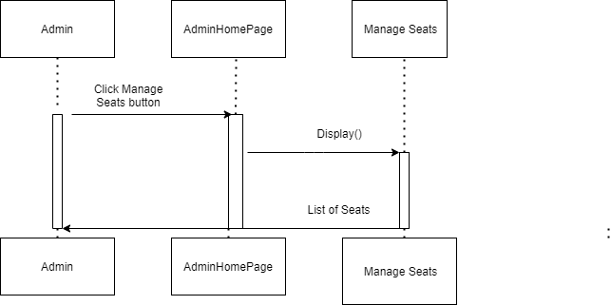

#### Add Seats

|  |  |  |
| --- | --- | --- |
| **Author** | Tran Kim Dat | |
| **Use Case Name** | Add | |
| **Actors** | Administrator | |
| **Description** | Admonistrator wish to add new Seat | |
| **Requirements** |  | |
| **Pre-conditions** | Actor has logged in as Administrator | |
| **Post-conditions** | Success: Add Seat successful  Fail: Refill information | |
| **Basic flow** | Actor Actions:  1. Actor clicks ‘Add’ button on Manage Seats page  3. Actor inputs property type information :  5. Actor click ‘Add’ button. | System Responses:  2. System redirects to this page and displays form for Actor to input information with the following control :   1. seatid textfiled 2. seatNo textfiled 3. rowName combobox 4. status combobox   5. Add button  4. System checks information input [Exception 1]  6. System add movie into database,redirect manage movie and then display message ‘Your Seat has been add successful’. |
| **Alternative flow** |  |  |
| **Exceptions** | [Exception 1]  Actor Actions:  1.actor left seatid texfiled blank  3.actor left seat no texfiled blank  5.actor don’t choose rowName combobox  7.actor don’t choose status combobox | System Response:  System displays message to notice admin:  2.seatid can’t blank  4.seatNo can’t blank  6.Please choose rowName  8.Please choose status |

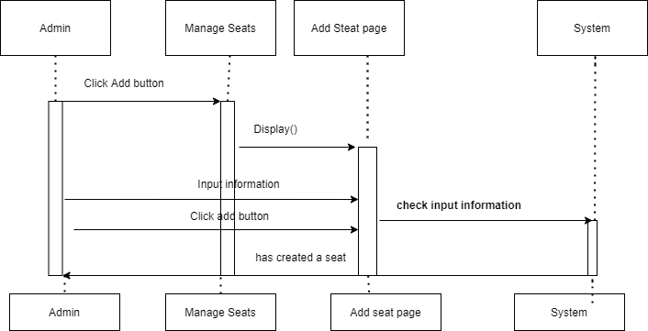

#### Update Seat

|  |  |  |
| --- | --- | --- |
| **Author** | Tran Kim Dat | |
| **Use Case Name** | Update | |
| **Actors** | Administrator | |
| **Description** | Administrator wish to update Seat | |
| **Requirements** |  | |
| **Pre-conditions** | Actor has logged in as Administrator | |
| **Post-conditions** | Success: Update seat successful  Fail: Refill information | |
| **Basic flow** | Actor Actions:  1. . From ‘Manage Seats’ page, actor clicks on button`Update` on table at seat which wants to modify.  3. Actor inputs property type information :  5. Actor click ‘update` button. | System Responses:  2. System redirects to this page and displays form for Actor to input information with the following control :   1. seatid textfiled(Read only) 2. seatNo textfiled 3. rowName combobox 4. status combobox 5. button update   4. System checks information input [Exception 1]  6. System add movie into database,redirect manage movie and then display message ‘Your Seats has been update successful’. |
| **Alternative flow** |  |  |
| **Exceptions** | [Exception 1]  Actor Actions:  1.actor left seat no texfiled blank  3.actor don’t choose rowName combobox  5.actor don’t choose status combobox | System Response:  1. System displays message to notice admin:  2.seatNo can’t blank  4.Please choose rowName  6.Please choose status |

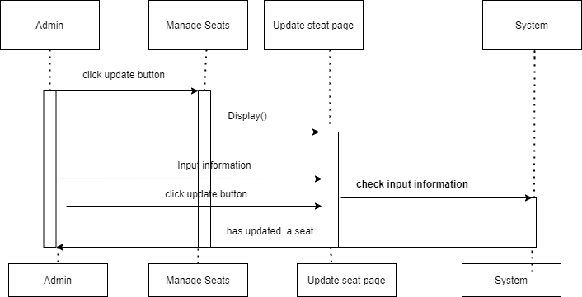

### Report

#### Report Top 3 watched movies

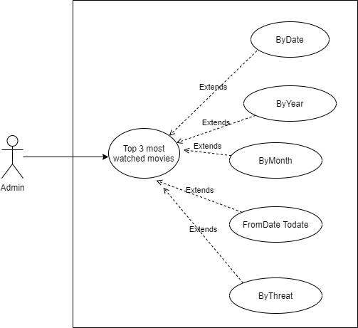

##### 3.15.1.1 By date

|  |  |  |
| --- | --- | --- |
| **Author** | Tran Kim Dat | |
| **Use Case Name** | ByDay | |
| **Actors** | Administrator | |
| **Description** | Administrator wish to know top 3 movies with the most tickectes sold by day | |
| **Requirements** |  | |
| **Pre-conditions** | Actor has logged in as Administrator | |
| **Post-conditions** | Success: report infomation by pdf  Fail: Refill information | |
| **Basic flow** | Actor Actions:  1. From ‘Admin’ page, actor clicks on to the ‘Report` button.  3.Actor select `byDate`  5.Actor select date | System Responses:  2.System redirect to this page and show combobox with :Report by day, Report by month, Report by year, Report from date to date,Report by threat  4.System will display datebox date  6.System will find top 3 watched movies by Date and export filed pdf with data found.If no have movie sold in this day system will send message data not found and don’t export filde pd |
| **Alternative flow** |  |  |
| **Exceptions** | Actor Actions:  1.Actor don’t choose date | System reponse:  2.Please choose date  3.system not found  4.system show mess |

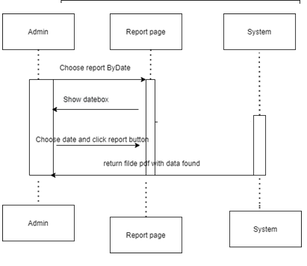

##### 3.15.1.2 By Month

|  |  |  |
| --- | --- | --- |
| **Author** | Tran Kim Dat | |
| **Use Case Name** | ByMonth | |
| **Actors** | Administrator | |
| **Description** | Administrator wish to know top 3 movies with the most tickectes sold by Month | |
| **Requirements** |  | |
| **Pre-conditions** | Actor has logged in as Administrator | |
| **Post-conditions** | Success: report infomation by pdf  Fail: Refill information | |
| **Basic flow** | Actor Actions:  1. From ‘Admin’ page, actor clicks on to the ‘Report` button.  3.Actor select `by Month `  5.Actor select month and year | System Responses:  2.System redirect to this page and show combobox with : Report by day, Report by month, Report by year, Report from date to date,Report by threat  4.System wil display combox year(from 10 years ago)and combox month  6.System will find top 3 watched movies by Month and Year and export filed pdf with data found.If no have movie sold in this day system will send message data not found and don’t export filde pdf |
| **Alternative flow** |  |  |
| **Exceptions** | Actor Actions:  1.Actor left month blank  3.Actor left year blank | System reponse:  2.Please choose Month  4.Please choose Year  5. system not found  6.system show mess |

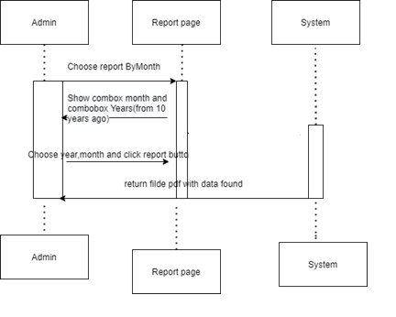

##### 3.15.1.3 By Year

|  |  |  |
| --- | --- | --- |
| **Author** | Tran Kim Dat | |
| **Use Case Name** | ByMonth | |
| **Actors** | Administrator | |
| **Description** | Administrator wish to know top 3 movies with the most tickectes sold by Month | |
| **Requirements** |  | |
| **Pre-conditions** | Actor has logged in as Administrator | |
| **Post-conditions** | Success: report infomation by pdf  Fail: Refill information | |
| **Basic flow** | Actor Actions:  1. From ‘Admin’ page, actor clicks on to the ‘Report` button.  3.Actor select `by Year `  5.Actor choose year | System Responses:  2.System redirect to this page and show combobox with : Report by day, Report by month, Report by year, Report from date to date,Report by threat  4.System show combox year(from 10 yeas ago)  6.System will find top 3 watched movies by Year and export filed pdf with data found.If no have movie sold in this day system will send message data not found and don’t export filde pdf |
| **Alternative flow** |  |  |
| **Exceptions** | Actor Actions:  1.Actor don’t choose year | System reponse:  2.Please choose Year  3.system not found  4.system show mess |

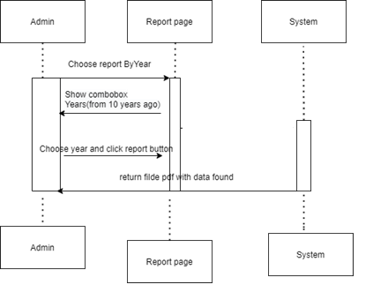

##### 3.15.1.4 from date to date

|  |  |  |
| --- | --- | --- |
| **Author** | Tran Kim Dat | |
| **Use Case Name** | ByMonth | |
| **Actors** | Administrator | |
| **Description** | Administrator wish to know top 3 movies with the most tickectes sold by Month | |
| **Requirements** |  | |
| **Pre-conditions** | Actor has logged in as Administrator | |
| **Post-conditions** | Success: report infomation by pdf  Fail: Refill information | |
| **Basic flow** | Actor Actions:  1. From ‘Admin’ page, actor clicks on to the ‘Report` button.  3.Actor select `from date to date `  5.Actor choose from date and to date | System Responses:  2.System redirect to this page and show combobox with Report by day, Report by month, Report by year, Report from date to date,Report by threat  4.System show datebox from and datebox to  6.System will find top 3 watched movies from date to date and export filed pdf with data found.If no have movie sold in this day system will send message data not found and don’t export filde pdf |
| **Alternative flow** |  |  |
| **Exceptions** | Actor Actions:  1.Actor don’t choose from date  3.Actor don’t choose to date | System reponse:  2.Please choose from date  4.Please choose to date  5.system not found  6.system show mess |

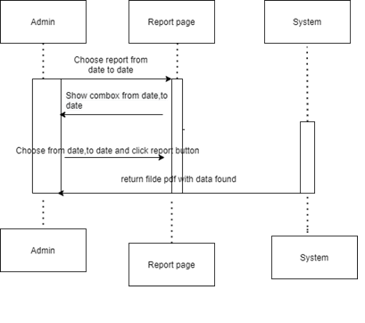

##### 3.15.1.5 By Threater

|  |  |  |
| --- | --- | --- |
| **Author** | Tran Kim Dat | |
| **Use Case Name** | Bythreater | |
| **Actors** | Administrator | |
| **Description** | Administrator wish to know top 3 movies with the most tickectes sold by Threater | |
| **Requirements** |  | |
| **Pre-conditions** | Actor has logged in as Administrator | |
| **Post-conditions** | Success: report infomation by pdf  Fail: Refill information | |
| **Basic flow** | Actor Actions:  1. From ‘Admin’ page, actor clicks on to the ‘Report` button.  3.Actor select `by threat `  5.Actor choose threate | System Responses:  2.System redirect to this page and show combobox with : Report by day, Report by month, Report by year, Report from date to date,Report by threat  4.System show combox threat name  6.System will find top 3 watched movies by threat name and export filed pdf with data found.If no have movie sold in this day system will send message data not found and don’t export filde pdf |
| **Alternative flow** |  |  |
| **Exceptions** | Actor Actions:  1.Actor don’t choose threat name | System reponse:  2.Please choose threat name  3.system not found  4.system show mess |

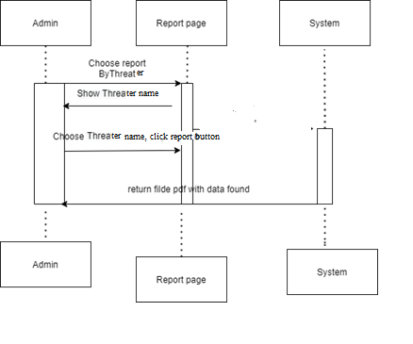

# **ENTITY RELATIONSHIP DIAGRAM**

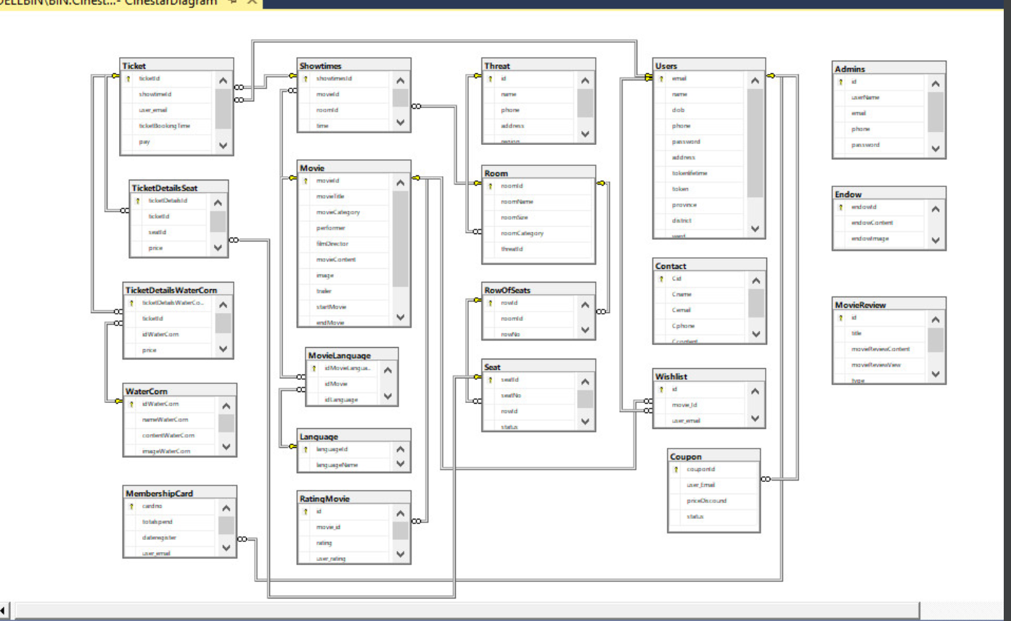

# **TABLE DESIGN**

1. Table Admins

|  |  |  |  |  |  |  |
| --- | --- | --- | --- | --- | --- | --- |
| **Admins** | | | | | | |
| **Field Name** | **Data Type** | **Null** | **Default Value** | **Key** | **Table-Field-Ref** | **Description** |
| id | int | No |  | PK | Identity | Stores Admins id |
| userName | Nvarchar  (50) | No |  |  |  | Stores name of Admins |
| email | varchar  (250) | No |  |  |  | Stores Admins email |
| Password | Varchar  (50) | No |  |  |  | Stores user password |
| phone | Varchar  (11) | No |  |  |  | Stores user phone number |
| address | Nvarchar  (250) | No |  |  |  | Stores address of Admin |

1. Table Contact

|  |  |  |  |  |  |  |
| --- | --- | --- | --- | --- | --- | --- |
| **Contact** | | | | | | |
| **Field Name** | **Data Type** | **Null** | **Default Value** | **Key** | **Table-Field-Ref** | **Description** |
| Cid | int | No |  | PK | Identity | Stores Contact id |
| Cname | Nvarchar  (50) | No |  |  |  | Stores name of user |
| Cemail | varchar  (100) | No |  |  |  | Stores Contact email |
| Cphone | Varchar  (11) | No |  |  |  | Stores user phone number |
| Ccontent | Nvarchar  (max) | No |  |  |  | Stores content contact |

1. Table coupon

|  |  |  |  |  |  |  |
| --- | --- | --- | --- | --- | --- | --- |
| **Contact** | | | | | | |
| **Field Name** | **Data Type** | **Null** | **Default Value** | **Key** | **Table-Field-Ref** | **Description** |
| couponId | int | No |  | PK | Identity | Stores coupon id |
| user_Email | Varchar  (50) | No |  | FK |  | Stores Email of user |
| priceDiscound | int | No |  |  |  | Stores Price coupon |
| status | bit | No |  |  |  | Stores status of coupon |

1. Table language

|  |  |  |  |  |  |  |
| --- | --- | --- | --- | --- | --- | --- |
| **Language** | | | | | | |
| **Field Name** | **Data Type** | **Null** | **Default Value** | **Key** | **Table-Field-Ref** | **Description** |
| languageId | int | No |  | PK | Identity | Stores language id |
| languageName | Nvarchar  (50) | No |  |  |  | Stores Email of user |

1. Table MembershipCard

|  |  |  |  |  |  |  |
| --- | --- | --- | --- | --- | --- | --- |
| **Membershipcard** | | | | | | |
| **Field Name** | **Data Type** | **Null** | **Default Value** | **Key** | **Table-Field-Ref** | **Description** |
| cardno | Varchar  (50) | No |  | PK |  | Stores Membershipcard cardno |
| user_Email | Varchar  (50) | No |  | FK |  | Stores Email of user |
| dateregister | date | No |  |  |  | Stores Membershipcard dateregister |
| totalspend | Int | No |  |  |  | Stores membershipcard totalspend |

1. Table movie

|  |  |  |  |  |  |  |
| --- | --- | --- | --- | --- | --- | --- |
| **Movie** | | | | | | |
| **Field Name** | **Data Type** | **Null** | **Default Value** | **Key** | **Table-Field-Ref** | **Description** |
| movieId | Varchar  (10) | No |  | PK |  | Stores movie id |
| movieTitle | nvarchar  (50) | No |  |  |  | Stores movie title |
| performer | Nvarchar  (100) | No |  |  |  | Stores movie performer |
| filmDirector | Nvarchar(30) | No |  |  |  | Stores movie filmDirector |
| movieContent | Nvarchar(2000) | no |  |  |  | Stores movie Content |
| image | Varchar  (250) | no |  |  |  | Stores movie image |
| trailer | Varchar  (250) | No |  |  |  | Stores movie trailler |
| startMovie | date | No |  |  |  | Stores movie start |
| endMovie | date | no |  |  |  | Stores movie end |
| status | int | no |  |  |  | Stores movie status |

1. Table Movielanguage

|  |  |  |  |  |  |  |
| --- | --- | --- | --- | --- | --- | --- |
| **MovieLanguage** | | | | | | |
| **Field Name** | **Data Type** | **Null** | **Default Value** | **Key** | **Table-Field-Ref** | **Description** |
| idMovieLanguage | int | No |  | PK | Identity | Stores Movie Language id |
| idMovie | Varchar  (10) | No |  | FK |  | Stores movie id |
| idLanguage | int | no |  | FK | indentity | Stores Language id |

1. Table MovieReview

|  |  |  |  |  |  |  |
| --- | --- | --- | --- | --- | --- | --- |
| **MovieReview** | | | | | | |
| **Field Name** | **Data Type** | **Null** | **Default Value** | **Key** | **Table-Field-Ref** | **Description** |
| id | int | No |  | PK | Identity | Stores Review id |
| title | nvarchar  (100) | No |  |  |  | Stores movie title |
| titleR | Nvarchar(250) | no |  |  |  | Stores Riew title accessoríe |
| movieReviewContent | Nvarchar(max) | no |  |  |  | Stores Review content |
| movieReviewView | int | no |  |  |  | Stores Review view |
| type | bit | no |  |  |  | Stores type of Review |
| image | Varchar  (250) | no |  |  |  | Stores image movie |

1. RatingMovie

|  |  |  |  |  |  |  |
| --- | --- | --- | --- | --- | --- | --- |
| **RatingMovie** | | | | | | |
| **Field Name** | **Data Type** | **Null** | **Default Value** | **Key** | **Table-Field-Ref** | **Description** |
| id | int | No |  | PK | Identity | Stores Rating id |
| movie_id | Varchar  (10) | No |  |  |  | Stores movie id |
| rating | int | no |  |  |  | Stores Rating |
| user_rating | Varchar(250) | no |  |  |  | Stores user rating |

1. Table Room

|  |  |  |  |  |  |  |
| --- | --- | --- | --- | --- | --- | --- |
| **Room** | | | | | | |
| **Field Name** | **Data Type** | **Null** | **Default Value** | **Key** | **Table-Field-Ref** | **Description** |
| roomId | Varchar  (10) | No |  | PK |  | Stores Room id |
| roomName | Nvarchar(50) | No |  |  |  | Stores name of room |
| roomSize | int | no |  |  |  | Stores size of room |
| roomCategory | Varchar  (50) | no |  |  |  | Stores category of room |
| threatId | int | no |  | FK |  | Stores threat id |

1. Table RowOfSeats

|  |  |  |  |  |  |  |
| --- | --- | --- | --- | --- | --- | --- |
| **RowOfSeats** | | | | | | |
| **Field Name** | **Data Type** | **Null** | **Default Value** | **Key** | **Table-Field-Ref** | **Description** |
| rowId | int | No |  | PK | indentity | Stores Row id |
| roomId | Varchar  (10) | No |  | FK |  | Stores Room id |
| rowNo | Varchar  (10) | no |  |  |  | Stores name of row |

1. Table Seat

|  |  |  |  |  |  |  |
| --- | --- | --- | --- | --- | --- | --- |
| **Seat** | | | | | | |
| **Field Name** | **Data Type** | **Null** | **Default Value** | **Key** | **Table-Field-Ref** | **Description** |
| seatId | int | No |  | PK | indentity | Stores seat id |
| seatNo | int | No |  |  |  | Stores name of seat |
| rowId | int | no |  | FK |  | Stores row id |
| type | int | no |  |  |  | Stores type of seat |
| status | int | no |  |  |  | Stores status of seat |

1. Table ShowTimes

|  |  |  |  |  |  |  |
| --- | --- | --- | --- | --- | --- | --- |
| **ShowTimes** | | | | | | |
| **Field Name** | **Data Type** | **Null** | **Default Value** | **Key** | **Table-Field-Ref** | **Description** |
| showtimesId | int | No |  | PK | indentity | Stores times id |
| movieId | Varchar  (10) | No |  | FK |  | Stores movie id |
| roomId | Varchar  (10) | no |  | FK |  | Stores room id |
| time | Time(7) | no |  |  |  | Stores time of times |
| date | date | no |  |  |  | Stores date of times |

1. Table Ticket

|  |  |  |  |  |  |  |
| --- | --- | --- | --- | --- | --- | --- |
| **Ticket** | | | | | | |
| **Field Name** | **Data Type** | **Null** | **Default Value** | **Key** | **Table-Field-Ref** | **Description** |
| ticketId | int | No |  | PK | indentity | Stores ticket id |
| showtimeId | int | No |  | FK |  | Stores Showtimes id |
| user_email | Varchar  (250) | no |  | FK |  | Stores email of user |
| ticketBookingTime | date | no |  |  |  | Stores ticket booking |
| pay | int | no |  |  |  | Stores pay booking ticket |
| totalPrice | int | no |  |  |  | Stores total price of booking |

1. Table TicketDetailSeat

|  |  |  |  |  |  |  |
| --- | --- | --- | --- | --- | --- | --- |
| **TicketDetailSeat** | | | | | | |
| **Field Name** | **Data Type** | **Null** | **Default Value** | **Key** | **Table-Field-Ref** | **Description** |
| ticketDetailsId | int | No |  | PK | indentity | Stores detail ticket id |
| ticketId | int | No |  | FK |  | Stores ticket id |
| seatId | int | no |  | FK |  | Stores seat id |
| price | int | no |  |  |  | Stores price of ticket |

1. Table Endow

|  |  |  |  |  |  |  |
| --- | --- | --- | --- | --- | --- | --- |
| **Endow** | | | | | | |
| **Field Name** | **Data Type** | **Null** | **Default Value** | **Key** | **Table-Field-Ref** | **Description** |
| endowId | int | No |  | PK | indentity | Stores endow id |
| endowContent | Nvarchar(2000) | No |  |  |  | Stores content of endow |
| endowImage | Varchar  (250) | no |  |  |  | Stores image of endow |
| endowTitle | Nvarchar(50) | no |  |  |  | Stores title of endow |

1. Table TicketDetailsWaterCorn

|  |  |  |  |  |  |  |
| --- | --- | --- | --- | --- | --- | --- |
| **TicketDetailsWaterCorn** | | | | | | |
| **Field Name** | **Data Type** | **Null** | **Default Value** | **Key** | **Table-Field-Ref** | **Description** |
| ticketDetailsWaterCornId | int | No |  | PK | indentity | Stores detail watercoen id |
| ticketId | int | No |  | FK |  | Stores ticket id |
| idWaterCorn | int | no |  | FK |  | Stores waterCorn id |
| price | int | no |  |  |  | Stores price of waterCorn |

1. Table Threat

|  |  |  |  |  |  |  |
| --- | --- | --- | --- | --- | --- | --- |
| **Threat** | | | | | | |
| **Field Name** | **Data Type** | **Null** | **Default Value** | **Key** | **Table-Field-Ref** | **Description** |
| id | int | No |  | PK | indentity | Stores threat id |
| name | Nvarchar(200) | No |  |  |  | Stores name of threat |
| phone | Varchar(50) | no |  |  |  | Stores phone of threat |
| address | Nvarchar(500) | no |  |  |  | Stores address of threat |
| region | Nvarchar(50) | no |  |  |  | Stores region of threat |

1. Table user

|  |  |  |  |  |  |  |
| --- | --- | --- | --- | --- | --- | --- |
| **User** | | | | | | |
| **Field Name** | **Data Type** | **Null** | **Default Value** | **Key** | **Table-Field-Ref** | **Description** |
| email | Varchar(250) | No |  | PK |  | Stores email of user |
| name | Nvarchar(100) | No |  |  |  | Stores name of user |
| phone | Varchar(50) | no |  |  |  | Stores phone of threat |
| dob | Datetime(7) | no |  |  |  | Stores day of birth of user |
| password | Varchar  (500) | no |  |  |  | Stores password of user |
| address | Nvarchar(500) | no |  |  |  | Stores address of user |
| tokenlifetime | Bigint | no |  |  |  | Stores tolen life time |
| toke | Varchar(50) | no |  |  |  | Stores token of user |
| province | Nvarchar  (100) | no |  |  |  | Stores province of user |
| district | nvarchar(100) | no |  |  |  | Stores district of user |
| ward | nvarchar(50) | no |  |  |  | Stores ward of user |
| Gender | varchar(50) | no |  |  |  | Stores gender of user |

1. WaterCorn

|  |  |  |  |  |  |  |
| --- | --- | --- | --- | --- | --- | --- |
| **WaterCorn** | | | | | | |
| **Field Name** | **Data Type** | **Null** | **Default Value** | **Key** | **Table-Field-Ref** | **Description** |
| idWaterCorn | int | No |  | PK | indentity | Stores water corn id |
| nameWaterCorn | Nvarchar(50) | No |  |  |  | Stores name of watercorn |
| contentWaterCorn | Varchar(500) | no |  |  |  | Stores content of watercorn |
| imageWaterCorn | Nvarchar(500) | no |  |  |  | Stores image of watercorn |
| price | int | no |  |  |  | Stores price of watercorn |

1. Table wishlist

|  |  |  |  |  |  |  |
| --- | --- | --- | --- | --- | --- | --- |
| **wishlisst** | | | | | | |
| **Field Name** | **Data Type** | **Null** | **Default Value** | **Key** | **Table-Field-Ref** | **Description** |
| id | int | No |  | PK | indentity | Stores water corn id |
| movie_Id | Varchar(10) | No |  |  |  | Stores movie id |
| user_email | varchar(250) | no |  |  |  | Stores email of user |

# **TASK SHEET REVIEW 2**

|  |  |  |  |  |  |  |  |
| --- | --- | --- | --- | --- | --- | --- | --- |
| **Project Ref. No.:**  **CINESTAR** | | **Project Title:** | **Activity Plan Prepared By:** | **Date of Preparation of Activity Plan:** | | | |
| **Sr.No.** | **Task** | **Actual Start Date** | **Actual Days** | **Team Mate Names** | **Status** |
| 1 | DFD (Data Flow Diagram) | **Cinestar** | TRAN KIM DAT | 18/08/2021 | 1 | NGUYEN THANH HUY | 100% |
| 2 | Flowcharts | 18/08/2021 | 1 | NGUYEN THANH HUY | 100% |
| 3 | ERD (Entity Relationship Diagram) | 18/08/2021 | 1 | NGUYEN DOAN DAI | 100% |
| 4 | Table Design | 18/08/2021 | 1 | ALL | 100% |
| 5 | User case and squense diagram | 18/08/2021 | 1 | TRAN KIM DAT | 100% |

# **REVIEW 3**

# **GUI DESIGN**

## I.Site map

### 1. Website

#### 1.1 User

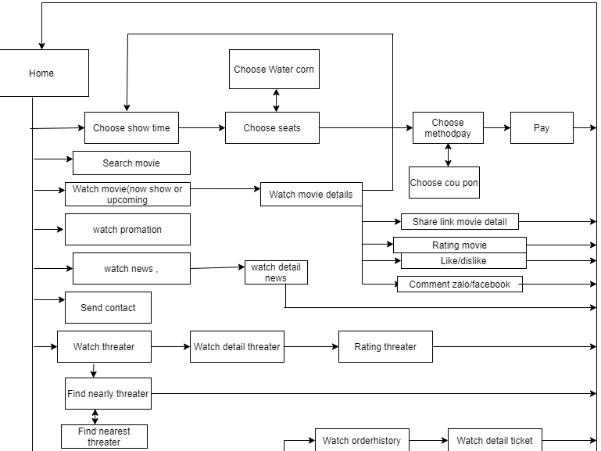

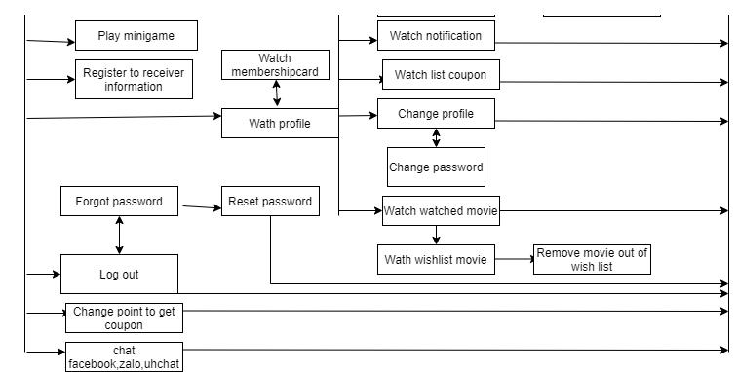

#### 1.2 Guest

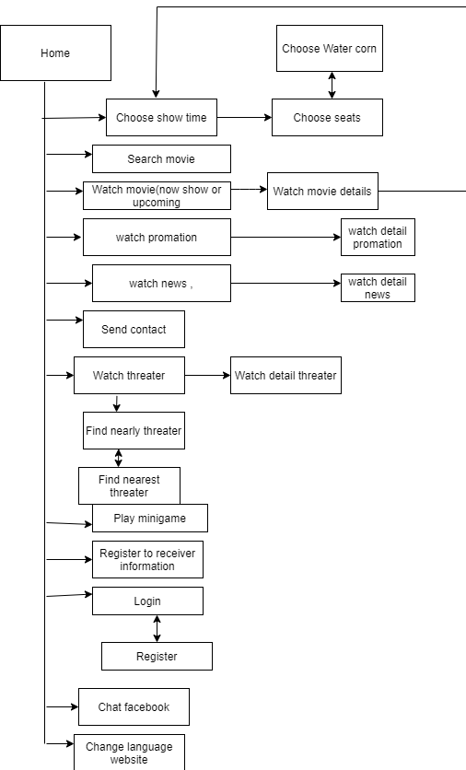

#### 1.3 Admin

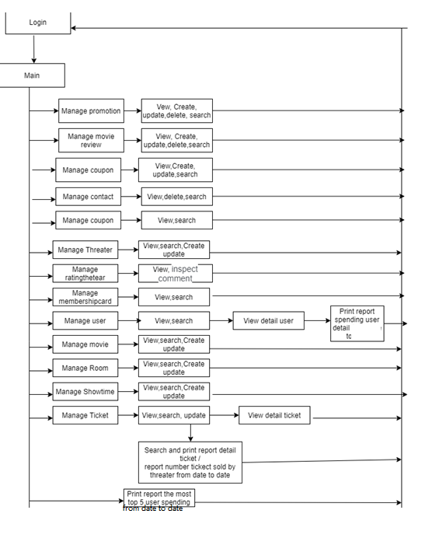  
  
  
  
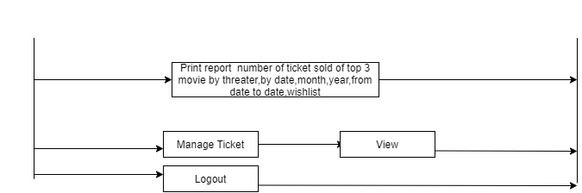

### 2. Android

#### 2.1 Guest

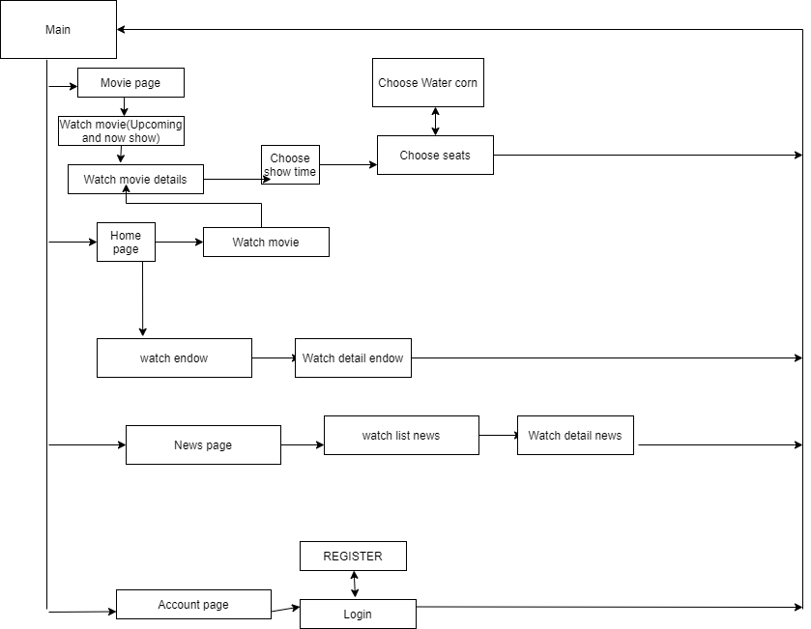

#### 2.2 User

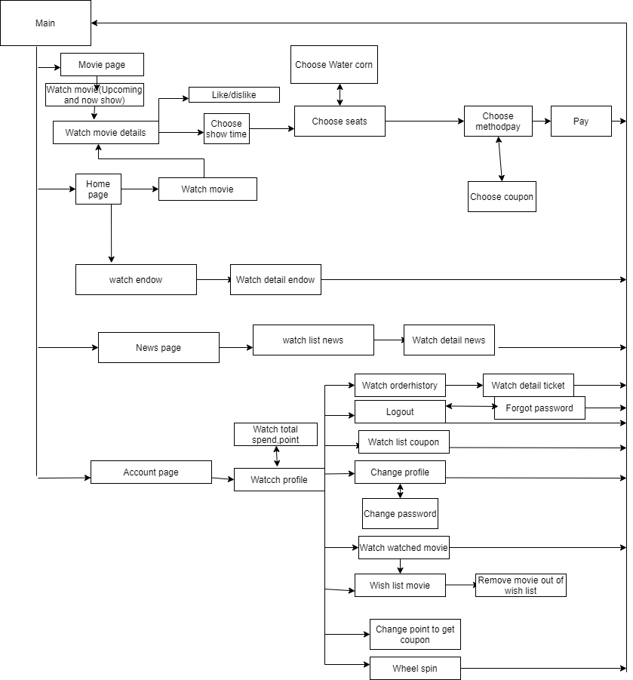

## **II.Admin:**

1.Login

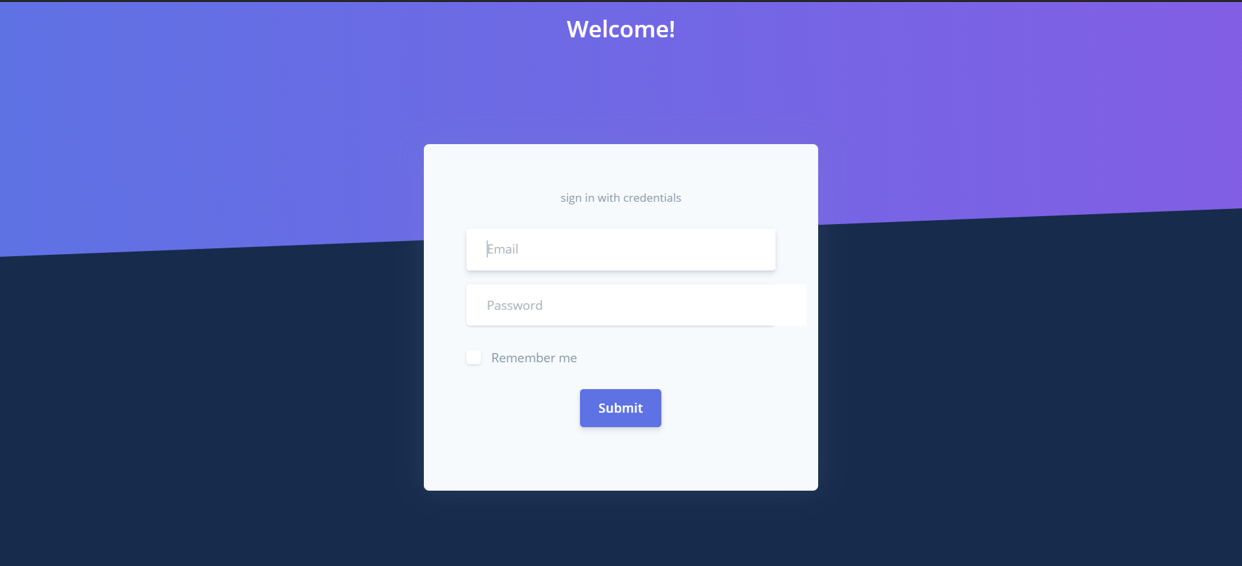

1

3

2

|  |  |  |  |  |  |  |
| --- | --- | --- | --- | --- | --- | --- |
| No | Name | Type | Validation | Event | Description | Status |
| 1 | Email | Textbox | Input not blank, format email | No | Click link to go equivalent page | Enable |
| 2 | Password | Textbox |  | Click | Choose the search filter | Enable |
| 3 | Login | Button |  | Clcik | Click to login | Enable |
|  |  |  |  |  |  |  |

2.Toolbar



|  |  |  |  |  |  |  |
| --- | --- | --- | --- | --- | --- | --- |
| No | Name | Type | Validation | Event | Description | Status |
| 1 | name | label |  | no | Name admin | Enable |
| 2 | Home | Button |  | Click | Back to home page | Enable |
| 3 | Contact | Button |  | Click | Click to contact page | Enable |
| 4 | Language | Button |  | Click | Click to call language modal | Enable |

3.Sidebar

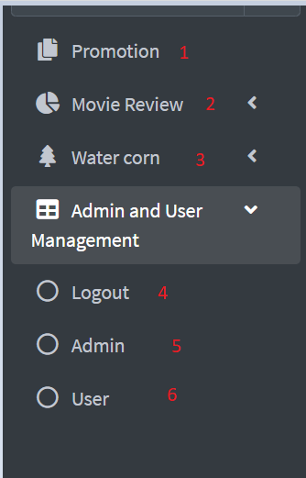

|  |  |  |  |  |  |  |
| --- | --- | --- | --- | --- | --- | --- |
| No | Name | Type | Validation | Event | Description | Status |
| 1 | Promotion | Button |  | Click | Click to Promotion page | Enable |
| 2 | Movie review | Button |  | Click | Click to movie review page | Enable |
| 3 | Water corn | Button |  | Click | Click to water corn page | Enable |
| 4 | Logout | Button |  | Click | Back to login page | Enable |
| 5 | Admin | Button |  | Click | Click to admin manage page | Enable |
| 6 | User | Button |  | Click | Click to user manage page | Enable |

4.Promotion page

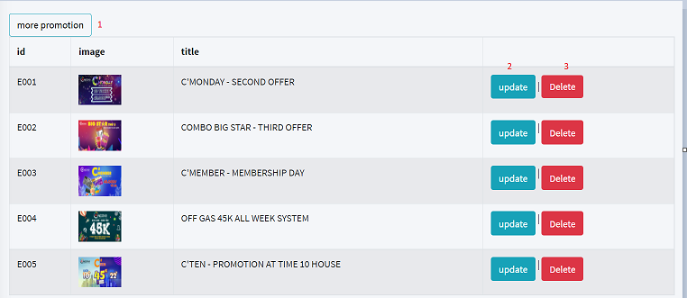

|  |  |  |  |  |  |  |
| --- | --- | --- | --- | --- | --- | --- |
| No | Name | Type | Validation | Event | Description | Status |
| 1 | More promotion | button |  | click | Click to add promotion page | Enable |
| 2 | Update | Button |  | Click | Click to update promotion page | Enable |
| 3 | Delete | Button |  | Click | Click to call confirm delete | Enable |

5.Add Promotion page

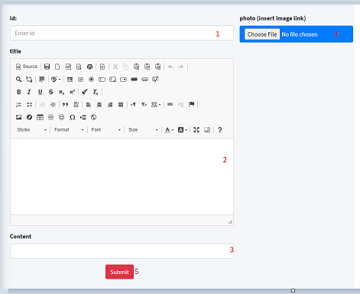

|  |  |  |  |  |  |  |
| --- | --- | --- | --- | --- | --- | --- |
| No | Name | Type | Validation | Event | Description | Status |
| 1 | Id | Textbox | Not null | input | Input Id of promotion | Enable |
| 2 | title | Textbox | Not null | input | Input title of promotion | Enable |
| 3 | content | Textbox | Not null | input | Input content of promotion | Enable |
| 4 | photo | file | Not null | input | Upload photo of promotion | Enable |
| 5 | submit | button |  | click | Click to add information to database |  |

6.Update Promotion page:

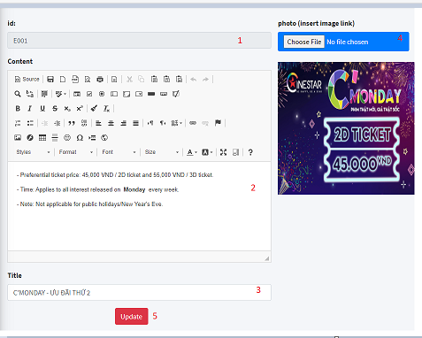

|  |  |  |  |  |  |  |
| --- | --- | --- | --- | --- | --- | --- |
| No | Name | Type | Validation | Event | Description | Status |
| 1 | Id | Textbox |  |  | Id of promotion | Enable |
| 2 | title | Textbox | Not null | input | Input title of promotion | Enable |
| 3 | content | Textbox | Not null | input | Input content of promotion | Enable |
| 4 | photo | file | Not null | input | Upload photo of promotion | Enable |
| 5 | update | button |  | click | Click to save information to database | Enable |

7.Movie review page:

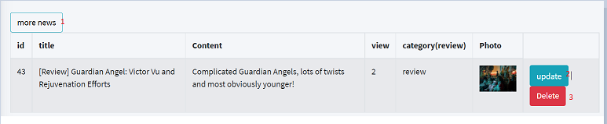

|  |  |  |  |  |  |  |
| --- | --- | --- | --- | --- | --- | --- |
| No | Name | Type | Validation | Event | Description | Status |
| 1 | More news | button |  | click | Click to add movie review page | Enable |
| 2 | Update | Button |  | Click | Click to update movie review page | Enable |
| 3 | Delete | Button |  | Click | Click to call confirm delete | Enable |

8.Add movie review page:

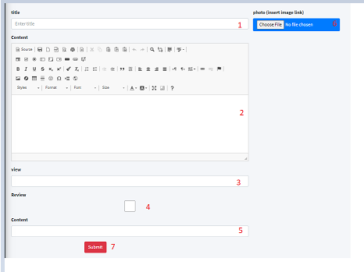

|  |  |  |  |  |  |  |
| --- | --- | --- | --- | --- | --- | --- |
| No | Name | Type | Validation | Event | Description | Status |
| 1 | title | Textbox | Not null | input | Input title of movie review | Enable |
| 2 | content | Textbox | Not null | input | Input content of movie review | Enable |
| 3 | view | Textbox | Not null and start with 1 | input | Input view of movie review | Enable |
| 4 | review | checkbox | Check equal review | checkbox | check type movie | Enable |
| 5 | Sub content | Textbox | Not null | checkbox | Input sub content of movie review | Enable |
| 6 | photo | file | Not null | input | Upload photo of movie review | Enable |
| 7 | submit | button |  | click | Click to add information to database | Enable |

9.Update movie review page:

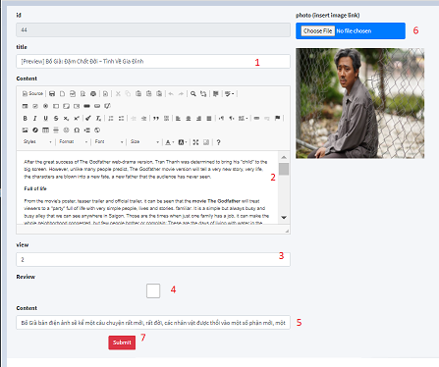

|  |  |  |  |  |  |  |
| --- | --- | --- | --- | --- | --- | --- |
| No | Name | Type | Validation | Event | Description | Status |
| 1 | title | Textbox | Not null | input | Input title of movie review | Enable |
| 2 | content | Textbox | Not null | input | Input content of movie review | Enable |
| 3 | view | Textbox | Not null and start with 1 | input | Input view of movie review | Enable |
| 4 | review | checkbox | Check equal review | checkbox | check type movie | Enable |
| 5 | Sub content | Textbox | Not null | checkbox | Input sub content of movie review | Enable |
| 6 | photo | file | Not null | input | Upload photo of movie review | Enable |
| 7 | submit | button |  | click | Click to save information to database | Enable |

1. Water corn page:

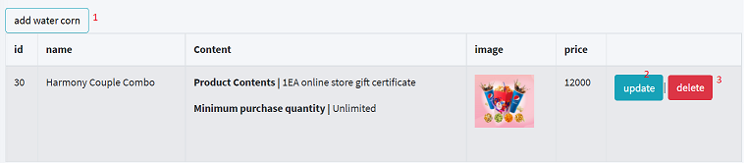

|  |  |  |  |  |  |  |
| --- | --- | --- | --- | --- | --- | --- |
| No | Name | Type | Validation | Event | Description | Status |
| 1 | Add water corn | button |  | click | Click to add water corn page | Enable |
| 2 | Update | Button |  | Click | Click to update water corn page | Enable |
| 3 | Delete | Button |  | Click | Click to call confirm delete | Enable |

1. Add water corn page:

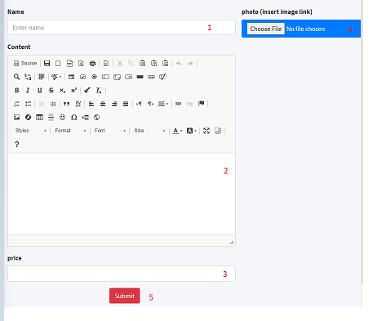

|  |  |  |  |  |  |  |
| --- | --- | --- | --- | --- | --- | --- |
| No | Name | Type | Validation | Event | Description | Status |
| 1 | name | Textbox | Not null | input | Input name of water corn | Enable |
| 2 | content | Textbox | Not null | input | Input content of water corn | Enable |
| 3 | price | Textbox | Not null and start with 1 | input | Input price of water corn | Enable |
| 4 | photo | file | Check equal review | input | Upload photo of water corn | Enable |
| 5 | Submit | button |  | button | Click to add information to database | Enable |

1. Update water corn page:

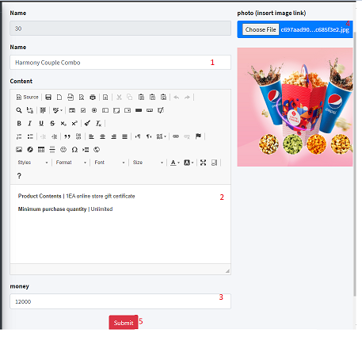

|  |  |  |  |  |  |  |
| --- | --- | --- | --- | --- | --- | --- |
| No | Name | Type | Validation | Event | Description | Status |
| 1 | name | Textbox | Not null | input | Input name of water corn | Enable |
| 2 | content | Textbox | Not null | input | Input content of water corn | Enable |
| 3 | price | Textbox | Not null and start with 1 | input | Input price of water corn | Enable |
| 4 | photo | file | Check equal review | input | Upload photo of water corn | Enable |
| 5 | Submit | button |  | button | Click to save information to database | Enable |

1. Confirm delete (review movie,water corn,promotion):

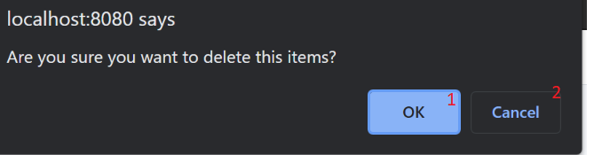

|  |  |  |  |  |  |  |
| --- | --- | --- | --- | --- | --- | --- |
| No | Name | Type | Validation | Event | Description | Status |
| 1 | Ok | button |  | click | Click to delete item | Enable |
| 2 | cancel | button |  | click | Click to close | Enable |

### 14.ManageCoupon page

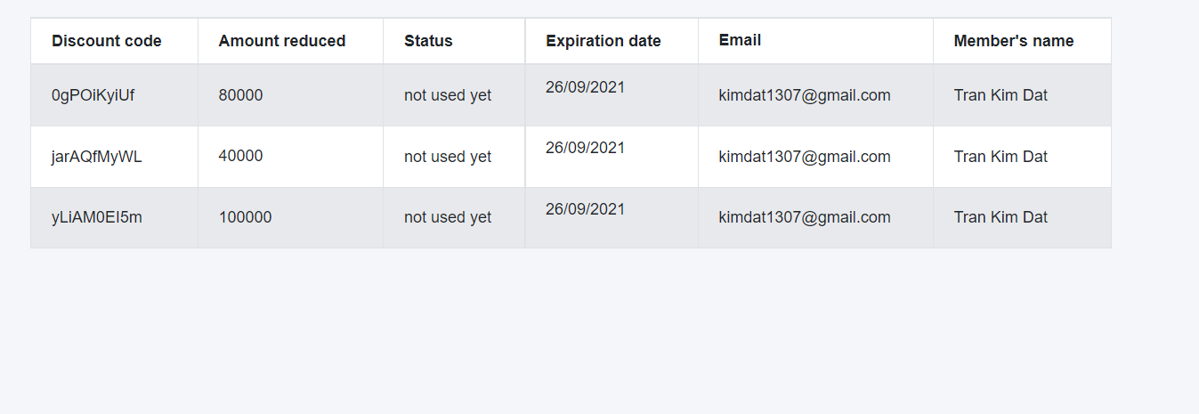

### 15.Search coupon(by code,email,name)

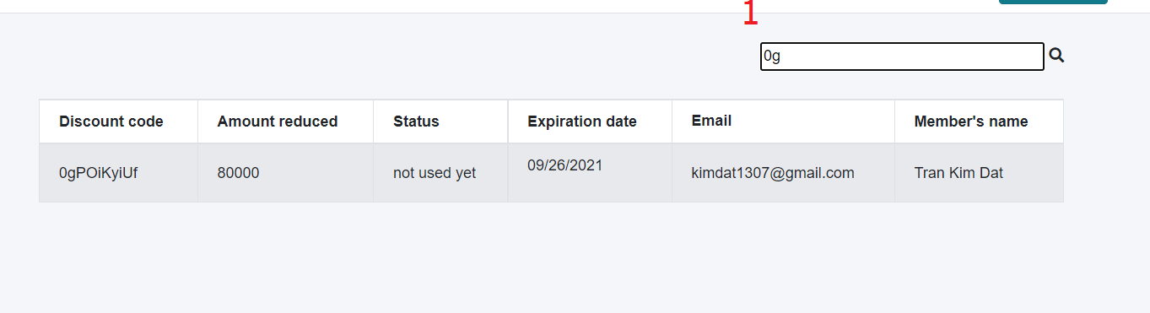

|  |  |  |  |  |  |  |
| --- | --- | --- | --- | --- | --- | --- |
| No | Name | Type | Validation | Event | Description | Status |
| 1 | search | Textbox |  | keyup | Input name,email member’s or discount code | Enable |

### 16.Manage list User Page

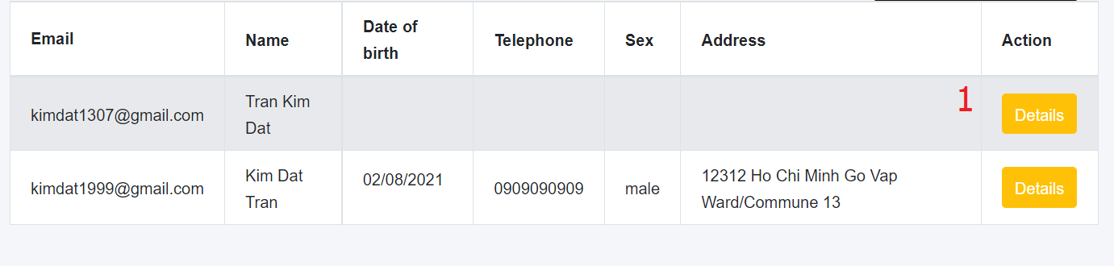

|  |  |  |  |  |  |  |
| --- | --- | --- | --- | --- | --- | --- |
| No | Name | Type | Validation | Event | Description | Status |
| 1 | detail | anchor |  | click | Href to page detail | Enable |

### 17.Search user

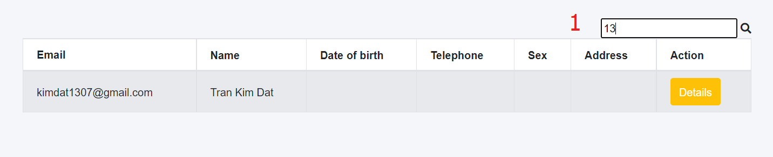

|  |  |  |  |  |  |  |
| --- | --- | --- | --- | --- | --- | --- |
| No | Name | Type | Validation | Event | Description | Status |
| 1 | search | textbox |  | keyup | Search by name or email | Enable |

### 18.Manage User detail and membershipcard’s user

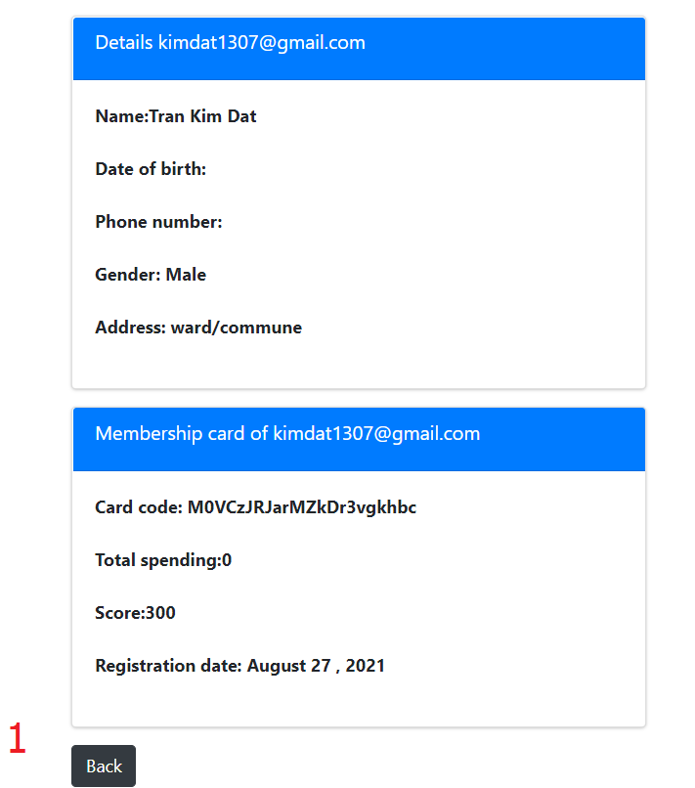

|  |  |  |  |  |  |  |
| --- | --- | --- | --- | --- | --- | --- |
| No | Name | Type | Validation | Event | Description | Status |
| 1 | back | button |  | click | Click back to manage user | Enable |

### 19.Manage membershipcard page

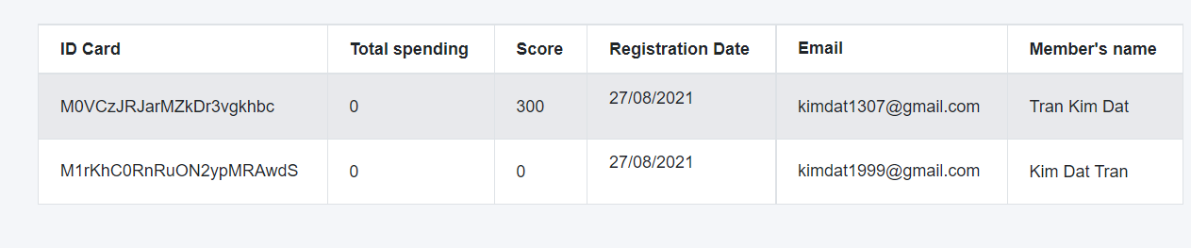

### 20.Search membershipcard

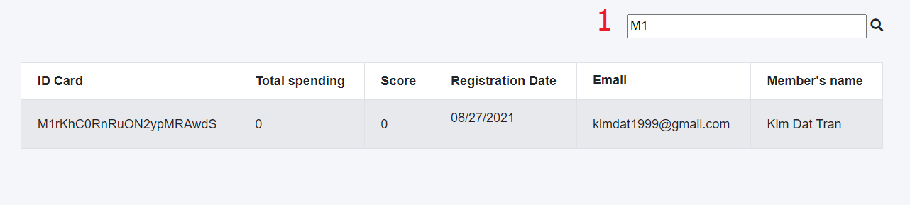

|  |  |  |  |  |  |  |
| --- | --- | --- | --- | --- | --- | --- |
| No | Name | Type | Validation | Event | Description | Status |
| 1 | search | textbox |  | keyup | Search by member’s name or email or idcard | Enable |

### 21.Manage threater page

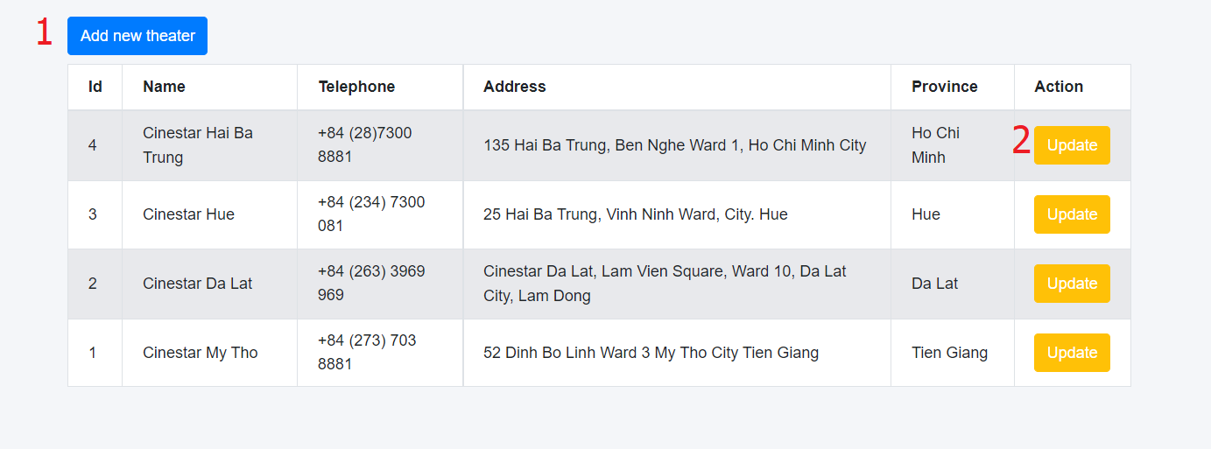

|  |  |  |  |  |  |  |
| --- | --- | --- | --- | --- | --- | --- |
| No | Name | Type | Validation | Event | Description | Status |
| 1 | Add | anchor |  | click | Click to add threater | Enable |
| 2 | Update | anchor |  | click | Click to update threater |  |

### 22.Add threater

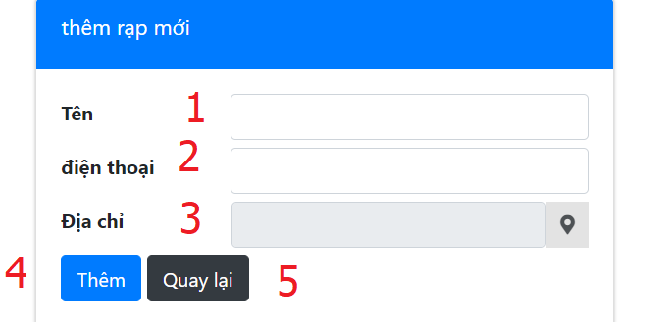

|  |  |  |  |  |  |  |
| --- | --- | --- | --- | --- | --- | --- |
| No | Name | Type | Validation | Event | Description | Status |
| 1 | Name | textbox | Not null,blank,from 6 to 20 character.Valid required.name don’t have special character and digit,Name not same other threater | input | Input name | Enable |
| 2 | Phone | textbox | Not null,blank.Valid required.Example: | input | Input phone | Enable |
| 3 | Address | textbox | Not null,blank,must match in here api | input | Input address | Enable |
| 4 | Back | button |  | click | Click to back manage threater | Enable |
| 5 | location | icon |  | click | Click to open modal | Enable |

### 23.Modal here api

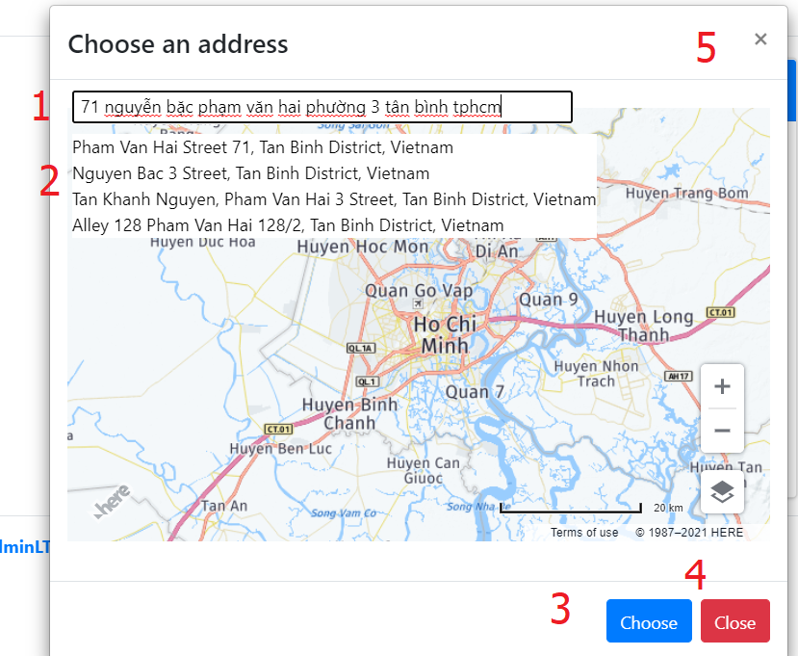

|  |  |  |  |  |  |  |
| --- | --- | --- | --- | --- | --- | --- |
| No | Name | Type | Validation | Event | Description | Status |
| 1 | Search | textbox |  | Key up | Input search | Enable |
| 2 | Panel | div |  | click | Choose address to see location in google | Enable |
| 3 | Choose | button |  | click | Click to confirm choose address | Enable |
| 4 | Close | button |  | click | Click close modal | Enable |
| 5 | Close | button |  | click | Click close modal | Enable |

### 24.Update threater

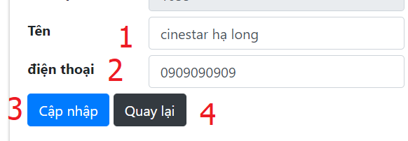

|  |  |  |  |  |  |  |
| --- | --- | --- | --- | --- | --- | --- |
| No | Name | Type | Validation | Event | Description | Status |
| 1 | Name | textbox | Not null,blank,from 6 to 20 character.Valid required.name don’t have special character and digit, not same other threater | input | Input name | Enable |
| 2 | Phone | textbox | Not null,blank.Valid required.Example: | input | Input phone | Enable |
| 3 | Update | button |  | click | Add threater | Enable |
| 4 | Back | button |  | click | Click to back manage threater | Enable |
|  |  |  |  |  |  |  |

### 25.Manage ratingthreater

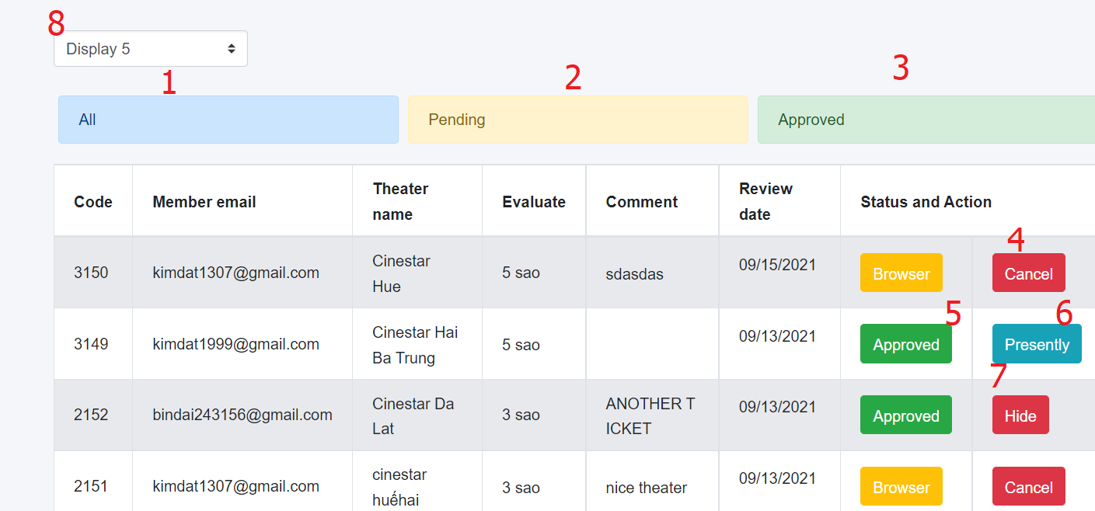

|  |  |  |  |  |  |  |
| --- | --- | --- | --- | --- | --- | --- |
| No | Name | Type | Validation | Event | Description | Status |
| 1 | All | Div |  | Click | Click to show all | Enable |
| 2 | Pending | Div |  | click | Click to show pending | Enable |
| 3 | Approved | Div |  | click | Click to show approvd | Enable |
| 4 | Cancel | button |  | click | Click to cancel comment | Enable |
| 5 | bro | Div |  | click | Click to show approvd | Enable |
| 4 | Cancel | button |  | click | Click to don’t approve comment | Enable |
| 5 | Approve | button |  | click | Click to approve comment | Enable |
| 6 | Show | button |  | click | Click to show comment | Enable |
| 7 | Hide | button |  | click | Click to Hide comment | Enable |
| 8 | display | combox |  | click | Choose number item show earch page | Enable |

### 26.Report top 3 movies

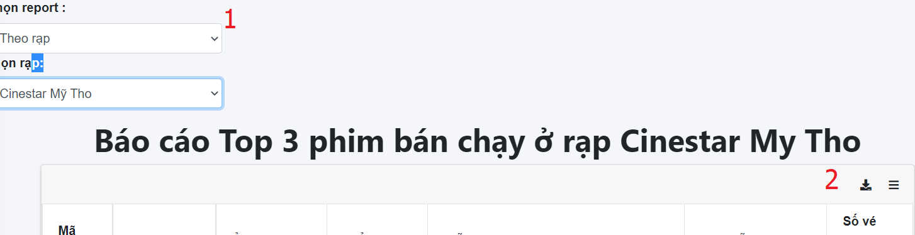

|  |  |  |  |  |  |  |
| --- | --- | --- | --- | --- | --- | --- |
| No | Name | Type | Validation | Event | Description | Status |
| 1 | Type | combobox |  | Click | Choose type report | Enable |
| 2 | print | icon |  | click | Click to print report | Enable |

### 27.Report deatil spending user

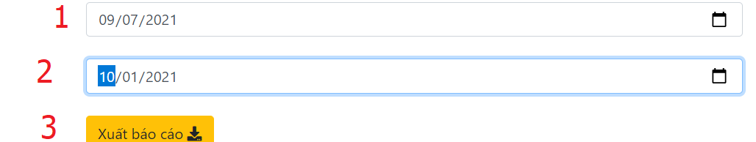

|  |  |  |  |  |  |  |
| --- | --- | --- | --- | --- | --- | --- |
| No | Name | Type | Validation | Event | Description | Status |
| 1 | fromdate | datebox |  | Click | Click to choose from date | Enable |
| 2 | todate | datebox |  | Click | Click to choose to date |  |
| 3 | print | button |  | click | Click to print report | Enable |

### 28.Send email for member registed to receive news

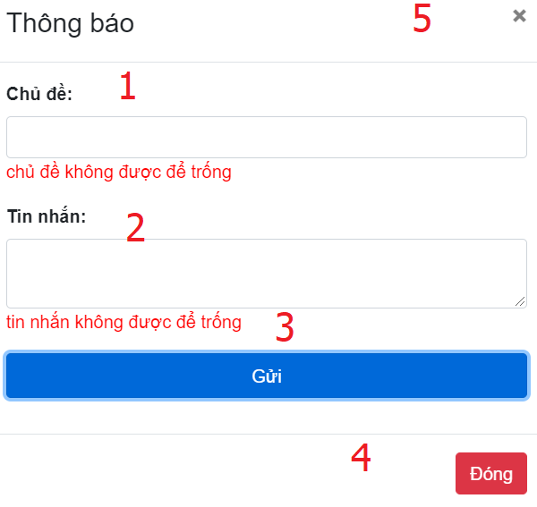

|  |  |  |  |  |  |  |
| --- | --- | --- | --- | --- | --- | --- |
| No | Name | Type | Validation | Event | Description | Status |
| 1 | subject | input | Not blank,not null |  | Subject email | Enable |
| 2 | message | input | Not blank,not null |  | Mess email | Enable |
| 3 | send | button |  | click | Click to send email | Enable |
| 4,5 | Close | button |  | click | Click to close modal | Enable |

### 29. Manage movie page

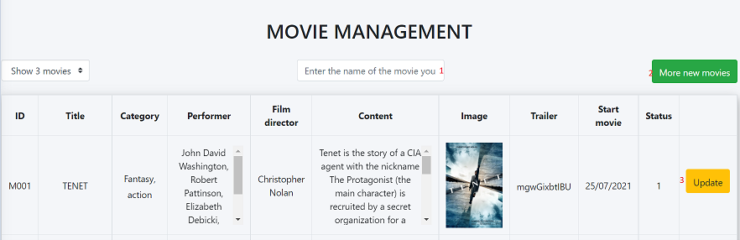

|  |  |  |  |  |  |  |
| --- | --- | --- | --- | --- | --- | --- |
| No | Name | Type | Validation | Event | Description | Status |
| 1 | Search | TextBox |  | input | Search movie |  |
| 2 | Add new movie | anchor |  | click | Click to add new movie | Enable |
| 3 | Update | anchor |  | click | Click to update movie | Enable |

### 30. Add movie page

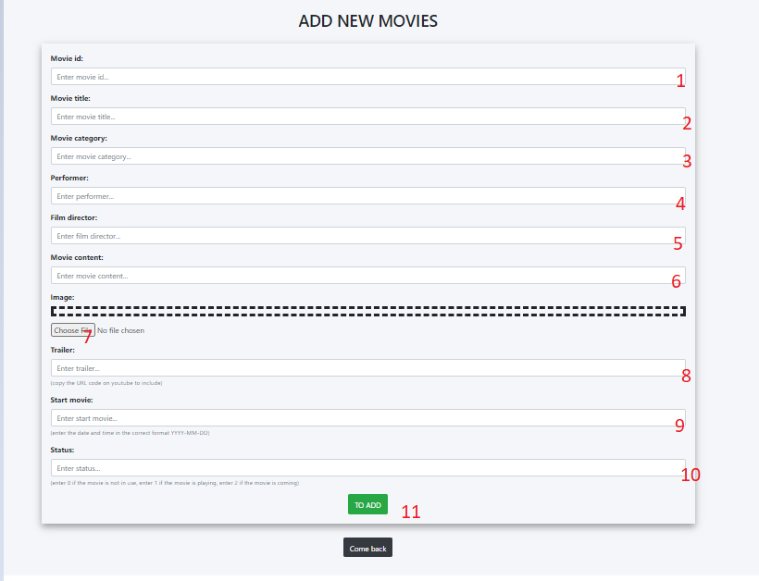

|  |  |  |  |  |  |  |
| --- | --- | --- | --- | --- | --- | --- |
| No | Name | Type | Validation | Event | Description | Status |
| 1 | Movie Id | Textbox | Not null | input | Input Id movie | Enable |
| 2 | Movie title | Textbox | Not null | input | Input title of movie | Enable |
| 3 | Movie category | Textbox | Not null | input | Input category of movie | Enable |
| 4 | Performer | Textbox | Not null | input | Input performer of movie | Enable |
| 5 | Flim director | Textbox | Not null | input | Input director of movie | Enable |
| 6 | Movie contennt | Textbox | Not null | input | Input content of movie | Enable |
| 7 | imgae | file | Check equal review | input | Upload photo of water corn | Enable |
| 8 | Trailler | Textbox | Not null | input | Input Trailer of movie | Enable |
| 9 | Start movie | Textbox | Not null | input | Input day start of movie | Enable |
| 10 | status | Textbox | Not null | input | Input status of movie | Enable |
| 11 | Submit | button |  | button | Click to add information to database | Enable |

### 31. Manage ticket page

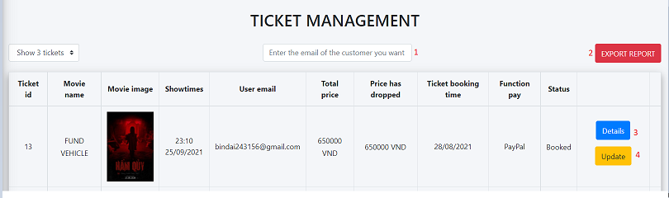

|  |  |  |  |  |  |  |
| --- | --- | --- | --- | --- | --- | --- |
| No | Name | Type | Validation | Event | Description | Status |
| 1 | Search | TextBox |  | input | Search email | Enable |
| 2 | Export report | Button |  | click | Click to page report page | Enable |
| 3 | detail | Button |  | click | Click to detail ticket page | Enable |
| 4 | update | Button |  | click | Click to update ticket page | Enable |

### 32. Report ticket page

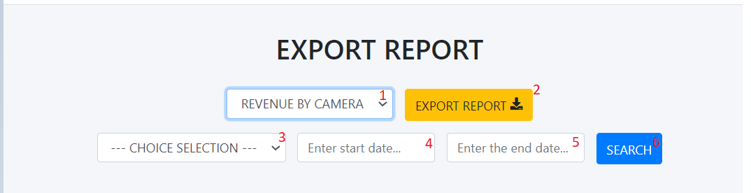

|  |  |  |  |  |  |  |
| --- | --- | --- | --- | --- | --- | --- |
| No | Name | Type | Validation | Event | Description | Status |
| 1 | Revenue by camera | select |  | select | Select revenue | Enable |
| 2 | Export report | button |  | click | Click to export report to file pdf | Enable |
| 3 | Choise selet | select |  | select | Select choise | Enable |
| 4 | Start date | Textbox |  | input | Input start date | Enable |
| 5 | End date | Textbox |  | input | Input end date | Enable |
| 6 | Search | button |  | click | Click search report |  |

### 33. Manage Room page

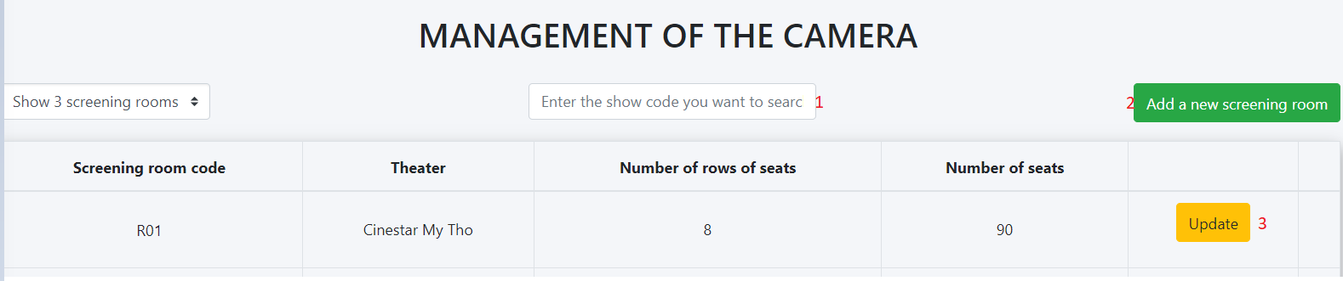

|  |  |  |  |  |  |  |
| --- | --- | --- | --- | --- | --- | --- |
| No | Name | Type | Validation | Event | Description | Status |
| 1 | Search | TextBox |  | input | Search Room | Enable |
| 2 | Add new Room | Button |  | click | Click to add new room page | Enable |
| 3 | update | Button |  | click | Click to update room page | Enable |

### 34. Add new room page

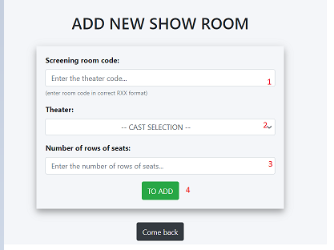

|  |  |  |  |  |  |  |
| --- | --- | --- | --- | --- | --- | --- |
| No | Name | Type | Validation | Event | Description | Status |
| 1 | Screning room | TextBox |  | input | Input screening room code | Enable |
| 2 | Theater | select |  | select | Select theater | Enable |
| 3 | Number of rows of seast | Textbox |  | input | Input number of rows | Enable |

### 35. Report top 5 buyer

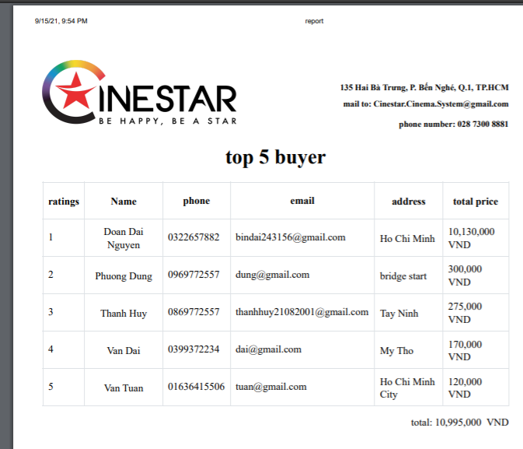

### 36. Update Movie

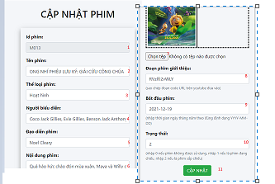

|  |  |  |  |  |  |  |
| --- | --- | --- | --- | --- | --- | --- |
| No | Name | Type | Validation | Event | Description | Status |
| 1 | ID | TextBox |  | input | Id of movie | Enable |
| 2 | Name movie | TextBox |  | input | Input name movie | Enable |
| 3 | Category movie | TextBox |  | input | Input category movie | Enable |
| 4 | Cast movie | TextBox |  | input | Input cast movie | Enable |
| 5 | Director movie | TextBox |  | input | Input director movie | Enable |
| 6 | Content movie | TextBox |  | input | Input content movie | Enable |
| 7 | Image movie | file |  | file | Choose file image movie | Enable |
| 8 | Trailler movie | Texbox |  | input | Input link trailer movie | Enable |
| 9 | Start time | Textbox |  | input | Input start time movie | Enable |
| 10 | End time | Textbox |  | input | Input end time movie | Enable |
| 11 | update | button |  | click | Click to update movie | Enable |

### 37. update ticket

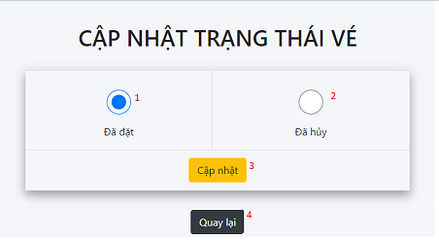

|  |  |  |  |  |  |  |
| --- | --- | --- | --- | --- | --- | --- |
| No | Name | Type | Validation | Event | Description | Status |
| 1 | Booked | checkbox |  | select | Click to choose booket | Enable |
| 2 | cancelled | Checkbox |  | select | Click to choose cancelled | Enable |
| 3 | update | button |  | click | Click to update ticket | Enable |

### 38.Showtimes page

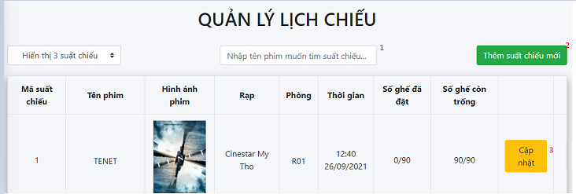

|  |  |  |  |  |  |  |
| --- | --- | --- | --- | --- | --- | --- |
| No | Name | Type | Validation | Event | Description | Status |
| 1 | Search | TextBox |  | input | Search Room | Enable |
| 2 | Add new showtimes | Button |  | click | Click to add new showtimes page | Enable |
| 3 | update | Button |  | click | Click to update room page | Enable |

### 39 Add new showtimes

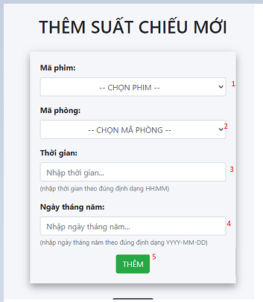

|  |  |  |  |  |  |  |
| --- | --- | --- | --- | --- | --- | --- |
| No | Name | Type | Validation | Event | Description | Status |
| 1 | Movie code | select |  | select | Select choose movie code | Enable |
| 2 | Movie room | select |  | select | Select choose room | Enable |
| 3 | time | Textbox |  | input | Input time of showtimes | Enable |
| 4 | Day month year | Textbox |  | input | Input Day month year of showtimes | Enable |
| 5 | add | button |  | clieck | Click to add showtimes | Enable |

### 40.Update Showtimes

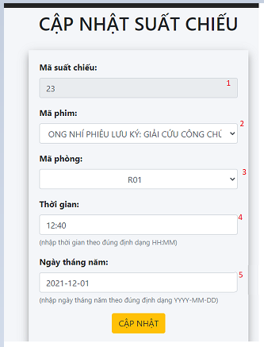

|  |  |  |  |  |  |  |
| --- | --- | --- | --- | --- | --- | --- |
| No | Name | Type | Validation | Event | Description | Status |
| 1 | Movie code | select |  | select | Select choose movie code | Enable |
| 2 | Movie room | select |  | select | Select choose room | Enable |
| 3 | time | Textbox |  | input | Input time of showtimes | Enable |
| 4 | Day month year | Textbox |  | input | Input Day month year of showtimes | Enable |
| 5 | update | button |  | clieck | Click to update showtimes | Enable |

### 41.update room

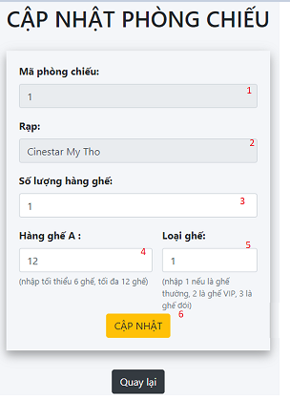

|  |  |  |  |  |  |  |
| --- | --- | --- | --- | --- | --- | --- |
| No | Name | Type | Validation | Event | Description | Status |
| 1 | room code | Textbox |  | input | Input room code | Enable |
| 2 | Theater | Textbox |  | input | Input theater | Enable |
| 3 | Number of seats | Textbox |  | input | Input number of seats | Enable |
| 4 | Row of seats | Textbox |  | input | Input row of seats | Enable |
| 5 | Type of seats | Textbox |  | input | Input type of seats | Enable |
| 6 | update | button |  | click | Click to update room | Enable |

42. Detail ticket page

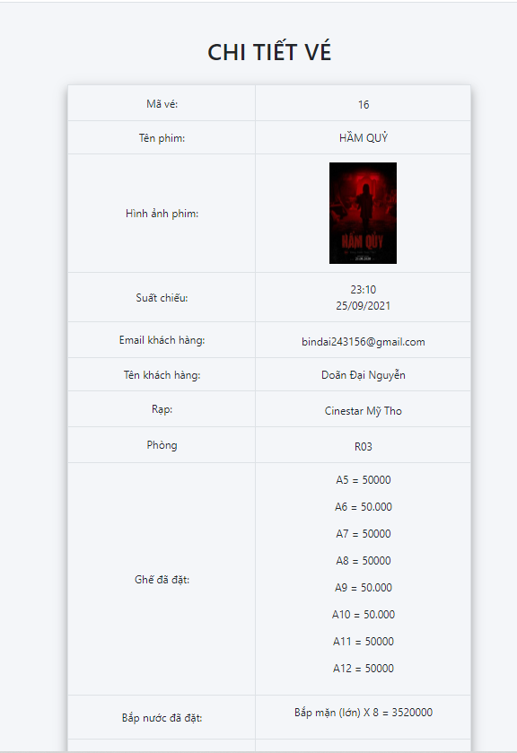

III.Client

1. Home page

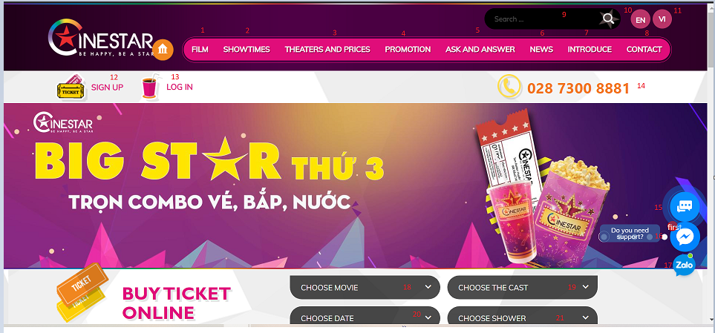

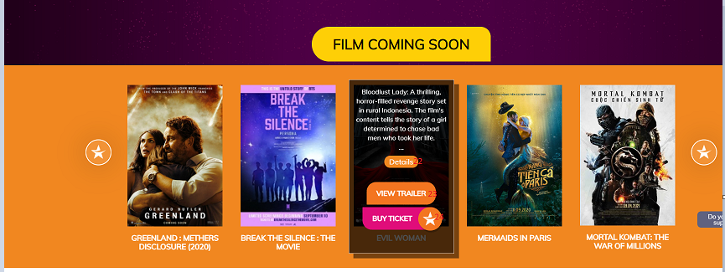



|  |  |  |  |  |  |  |
| --- | --- | --- | --- | --- | --- | --- |
| No | Name | Type | Validation | Event | Description | Status |
| 1 | Flim | Button |  | Click | Click to Film page | Enable |
| 2 | Showtime | Button |  | Click | Click to Showtime page | Enable |
| 3 | Theaters and prices | Button |  | Click | Click to Theaters and prices page | Enable |
| 4 | promotion | Button |  | Click | Click to promotion page | Enable |
| 5 | Ask and answer | Button |  | Click | Click to Ask and answer page | Enable |
| 6 | News | Button |  | Click | Click to News page | Enable |
| 7 | Introduce | Button |  | Click | Click to Introduce page | Enable |
| 8 | Contact | Button |  | Click | Click to Contact page | Enable |
| 9 | Search | Textbox |  | input | Search movie | Enable |
| 10 | EN | button |  | click | Click to change language to English | Enable |
| 11 | VI | button |  | click | Click to change language to Vietnamese | Enable |
| 12 | Sign up | button |  | click | Click to sign up page | Enable |
| 13 | Login | button |  | click | Click to login page | Enable |
| 14 | phone | button |  | click | Click to call | Enable |
| 15 | Vchat | message |  | click | Click to open chat bubble | Enable |
| 16 | Facebook chat | massage |  | click | Click to open chat bubble | Enable |
| 17 | Zalo chat | Massage |  | click | Click to open chat bubble | Enable |
| 18 | Choose movie | Combo  box |  | click | Choose movie | Enable |
| 19 | Choose the cast | Combo  box |  | click | Choose cast | Enable |
| 20 | Choose date | Combo  box |  | click | Choose date | Enable |
| 21 | Choose shower | Combo  box |  | click | Choose shower | Enable |
| 22 | detail | Button |  | click | Click to page detail movie | Enable |
| 23 | View trailer | button |  | click | Click to open modal video trailer | Enable |
| 24 | Buy ticket | button |  | click | Click to ticket page | Enable |
| 25 | uhchat | [Messenger](https://messenger.com/) |  | click | Click to open chat bubble | Enable |

1. Promation page:

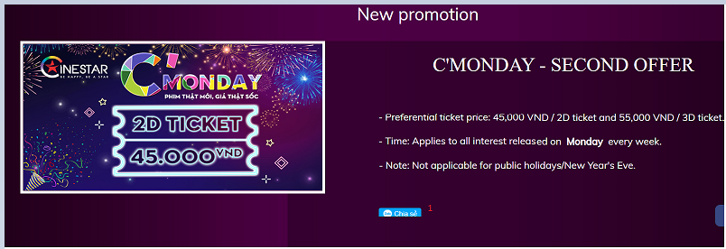

|  |  |  |  |  |  |  |
| --- | --- | --- | --- | --- | --- | --- |
| No | Name | Type | Validation | Event | Description | Status |
| 1 | Share zalo | Button |  | Click | Share page | Enable |

1. News page

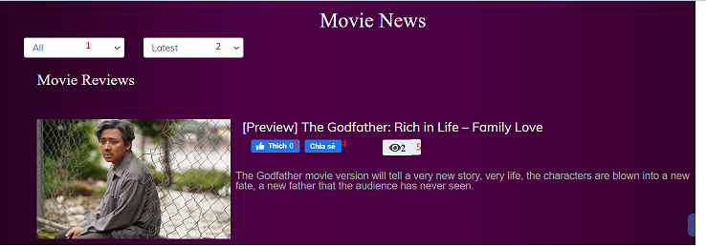

|  |  |  |  |  |  |  |
| --- | --- | --- | --- | --- | --- | --- |
| No | Name | Type | Validation | Event | Description | Status |
| 1 | Search type | Combo box |  | Click | Click to search type | Enable |
| 2 | Search latest and view | Combo  box |  | click | Click to search latest and view | Enable |
| 3 | Like facebook | button |  | click | Click to like items | Enable |
| 4 | Share facebook | button |  | click | Click to share facebook | Enable |
| 5 | view |  |  |  | See the number of people visiting the page | Enable |

1. Contact page

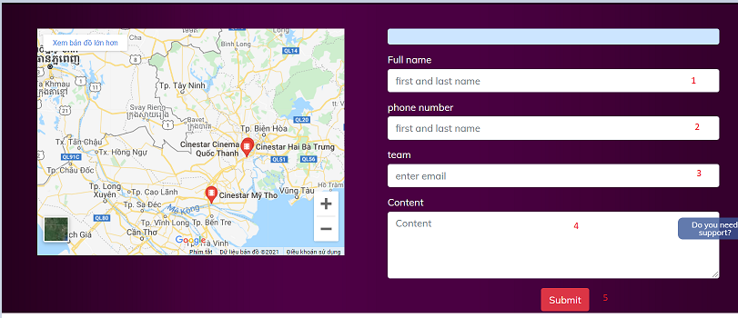

|  |  |  |  |  |  |  |
| --- | --- | --- | --- | --- | --- | --- |
| No | Name | Type | Validation | Event | Description | Status |
| 1 | Full name | Textbox | Not null | input | Input name of contact | Enable |
| 2 | Phone number | Textbox | Not null and is the number | input | Input phone of contact | Enable |
| 3 | email | Textbox | Not null | input | Input email of contact | Enable |
| 4 | Content | Textbox | Not null | input | Input content of contact | Enable |
| 5 | send | button |  | click | Send contact to admin | Enable |

1. Showtimes page

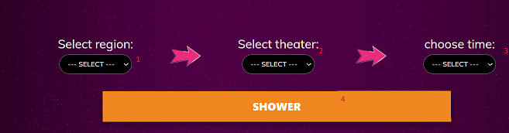

|  |  |  |  |  |  |  |
| --- | --- | --- | --- | --- | --- | --- |
| No | Name | Type | Validation | Event | Description | Status |
| 1 | Select region | Combo  box |  | select | choose region | Enable |
| 2 | Select theater | Combo  box |  | select | choose theater | Enable |
| 3 | Choose time | Combo  box |  | select | choose time | Enable |
| 4 | Shower | button |  | click | Click to shower modal | Enable |

1. Book ticket

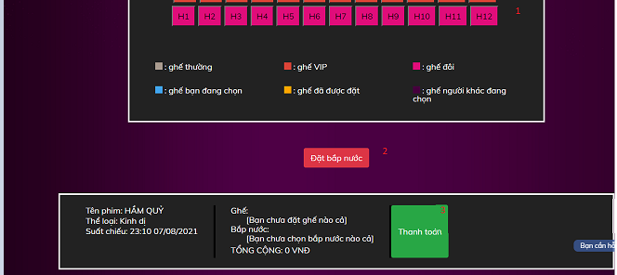

|  |  |  |  |  |  |  |
| --- | --- | --- | --- | --- | --- | --- |
| No | Name | Type | Validation | Event | Description | Status |
| 1 | Choose seat | button |  | click | Click to choose seat | Enable |
| 2 | Oder water corn | button |  | click | Click to open oder water corn | Enable |
| 3 | pay | button |  | click | Click to pay page | Enable |

### 7.Find nearest threater,find nearly threater

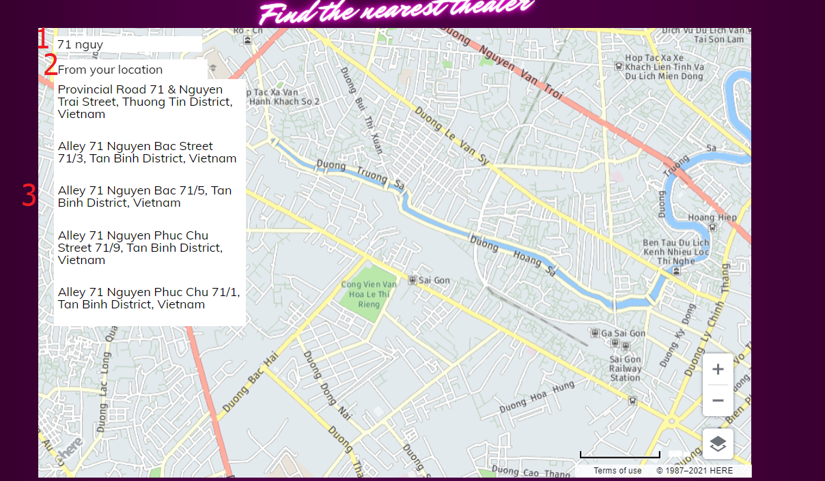

|  |  |  |  |  |  |  |
| --- | --- | --- | --- | --- | --- | --- |
| No | Name | Type | Validation | Event | Description | Status |
| 1 | Search | textbox |  | Key up | Input search | Enable |
| 2 | Location | p |  | click | Get location current | Enable |
| 2 | Panel | div |  | click | Choose address to see location in google | Enable |

### 8.Threater page

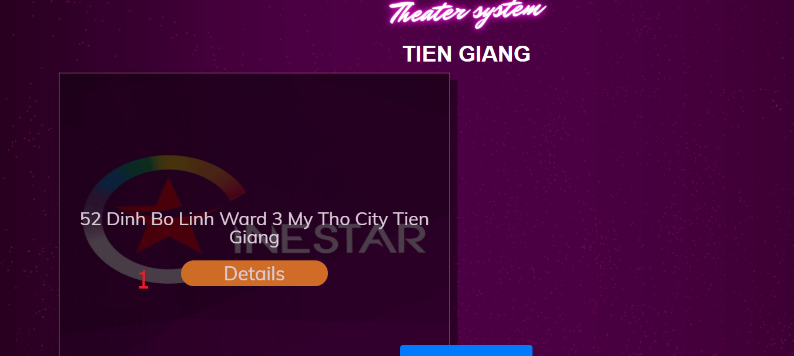

|  |  |  |  |  |  |  |
| --- | --- | --- | --- | --- | --- | --- |
| No | Name | Type | Validation | Event | Description | Status |
| 1 | Detail | anchor |  | click | Href to detail threat | Enable |

### 9.Threater detail page

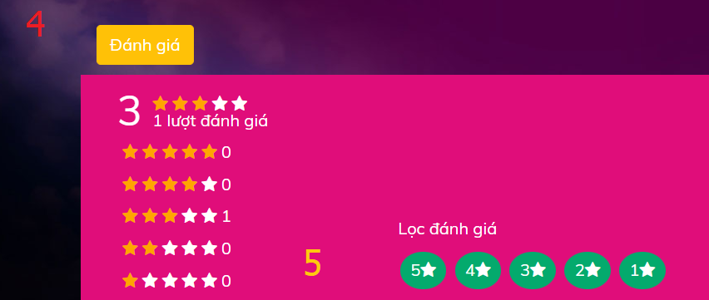

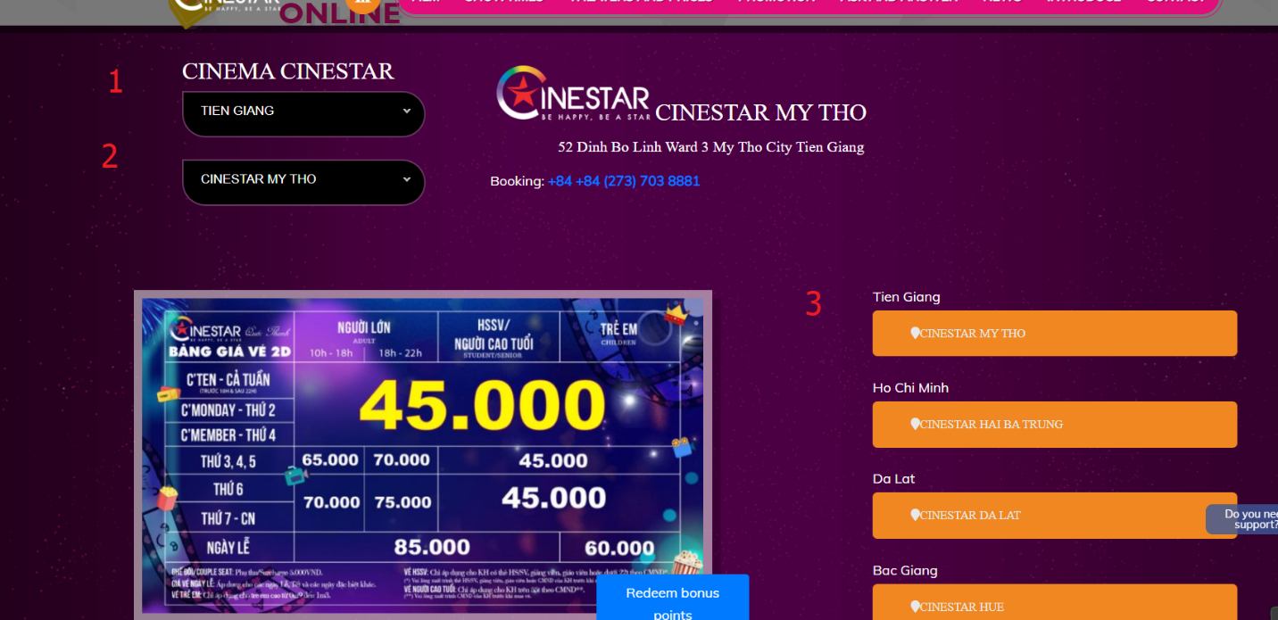

|  |  |  |  |  |  |  |
| --- | --- | --- | --- | --- | --- | --- |
| No | Name | Type | Validation | Event | Description | Status |
| 1 | province | combobox |  | select | Select province | Enable |
| 2 | Name threater | combobox |  | select | Select name threater | Enable |
| 3 | Link threater | anchor |  | click | Href to another threater | Enable |
| 4 | Rating | button |  | click | Click to show modal rating | Enable |
| 5 | Display | button |  | click | Click to choose show filter by rating number | Enable |

### 10.Mini game

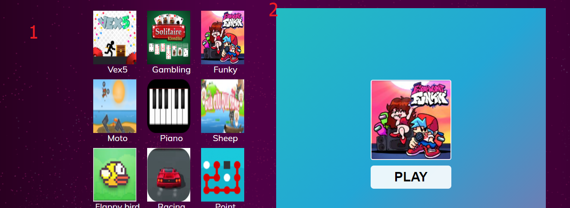

|  |  |  |  |  |  |  |
| --- | --- | --- | --- | --- | --- | --- |
| No | Name | Type | Validation | Event | Description | Status |
| 1 | Image game | image |  | Click | Click to choose game | Enable |
| 2 | Game | iframe |  |  |  | Enable |

### 11.Register receiver news

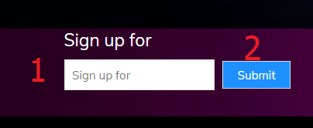

|  |  |  |  |  |  |  |
| --- | --- | --- | --- | --- | --- | --- |
| No | Name | Type | Validation | Event | Description | Status |
| 1 | Sign up | textbox | Not null,blank.valid email | input | Input email | Enable |
| 2 | submit | button |  | click | Click to send | Enable |

### 12.pop up fchat

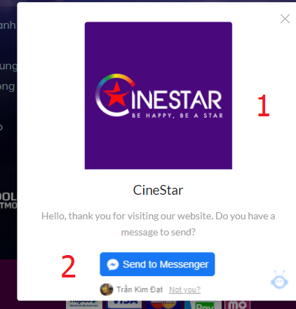

|  |  |  |  |  |  |  |
| --- | --- | --- | --- | --- | --- | --- |
| No | Name | Type | Validation | Event | Description | Status |
| 1 | Close | button |  | click | Close popup | Enable |
| 2 | Send | button |  | click | Click to send | Enable |

### 13.Login

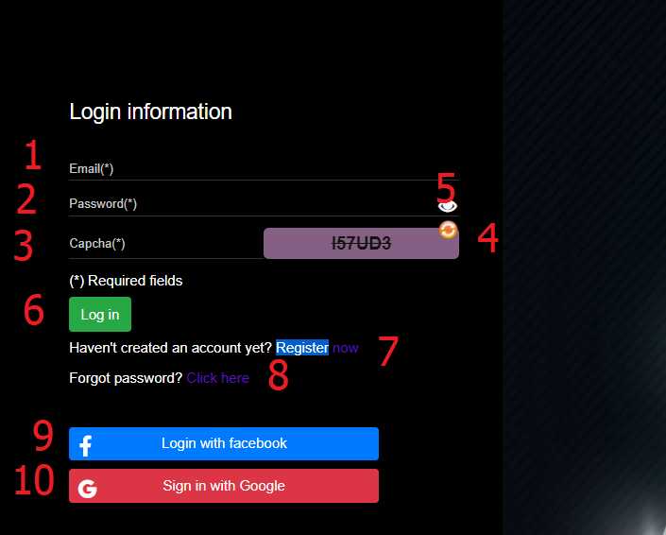

|  |  |  |  |  |  |  |
| --- | --- | --- | --- | --- | --- | --- |
| No | Name | Type | Validation | Event | Description | Status |
| 1 | Email | textbox | Not blank,not null | input | Input email | Enable |
| 2 | password | password | Not blank, not null,from 8 to 20 characters | input | Input password | Enable |
| 3 | Captcha | textbox | Not blank,match recapcha | input | Input capcha | Enable |
| 4 | Recapcha | icon |  | click | Click to change recapcha | Enable |
| 5 | password | icon |  | click | Show/hide password | Enable |
| 6 | login | button |  | click | Click to login | Enable |
| 7 | Register/login | checkbox |  | click | Slide to register | Enalble |
| 8 | Forgotpass | anchor |  | click | Click show modal forgotpass | Enable |
| 9 | Login facebook | button |  | click | Click to login facebook | Enable |
| 10 | Login google | button |  | click | Click to login google | Enable |

### 14.Register

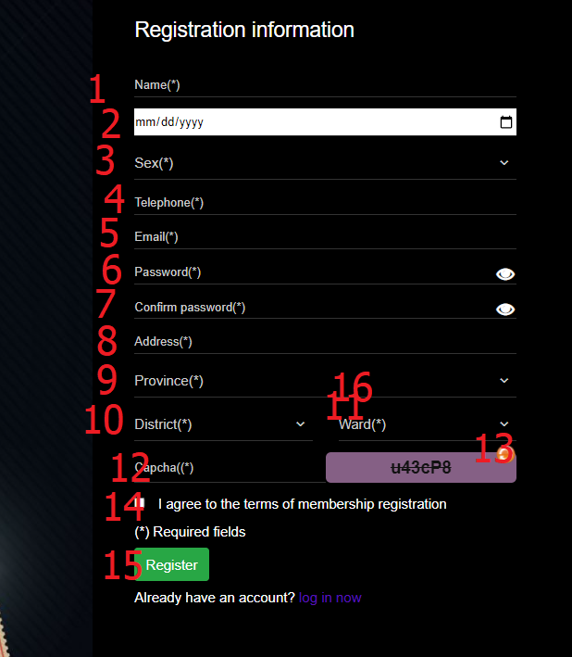

|  |  |  |  |  |  |  |
| --- | --- | --- | --- | --- | --- | --- |
| No | Name | Type | Validation | Event | Description | Status |
| 1 | Name | textbox | Not blank, not null,from 6 to 50 characters,not contains special characters and digit | input | Input name | Enable |
| 2 | Date of birth | datebox | Not null | select | Datebox date of birth | Enable |
| 3 | Sex | combobx | Not null | select | Select gender | Enable |
| 4 | phone | textbox | Not blank, not null | input | Input phone | Enable |
| 5 | email | textbox | Not blank,not unlively email.Exampleex@abc.xyz | click | Input email | Enable |
| 6 | password | password | Not blank,not null,from 8 to 20 character,must same confirm | input | Input pass | Enable |
| 7 | confirmpassword | password | Not blank,not null | input | Input confirm | Enalble |
| 8 | Address | textbox | Not blank,not null | input | Input address | Enable |
| 9 | Province | combobox | Not null | click | Select province | Enable |
| 10 | District | Combobox | Not null | click | Select district | Enable |
| 11 | Ward | Combobox | Not null | click | Select ward | Enable |
| 12 | Captcha | textbox | Not blank,match recapcha | input | Input capcha | Enable |
| 13 | Recapcha | icon |  | click | Click to change recapcha | Enable |
| 14 | agree | checkbox | Must true | click | Click to addgree | Enable |
| 15 | register | button |  | click | Click to register | Enable |
| 16 | Register/login | checkbox |  | click | Slide to login | Enalble |

### 15.forgot password

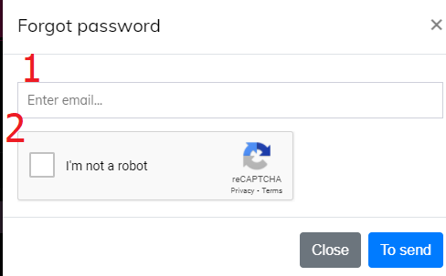

|  |  |  |  |  |  |  |
| --- | --- | --- | --- | --- | --- | --- |
| No | Name | Type | Validation | Event | Description | Status |
| 1 | email | textbox | Not blank, not null,email valid and exists in database | input | Input email | Enable |
| 2 | Not robot | Recapcha version 2 | Must true | click | Click to confirm I’m not a robot | Enable |

### 16.Reset password

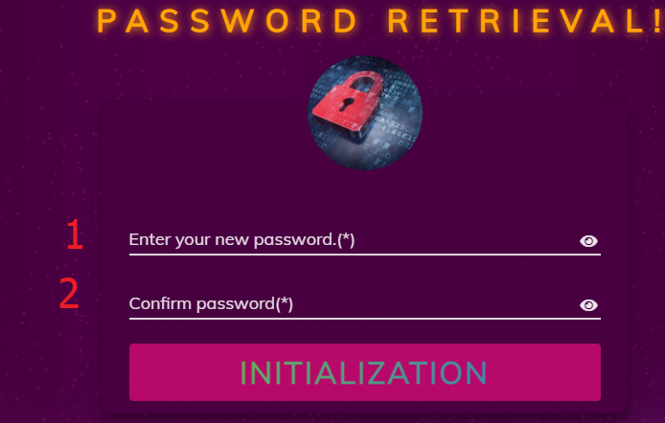

|  |  |  |  |  |  |  |
| --- | --- | --- | --- | --- | --- | --- |
| No | Name | Type | Validation | Event | Description | Status |
| 1 | password | password | Not blank,not null,from 8 to 20 character,must same confirm | input | Input pass | Enable |
| 2 | confirmpassword | textbox | Not blank,not null | input | Input confirm | Enalble |

### 17.Rating,add/remove this movie personal movie wishlist ,share link movie detail in zalo

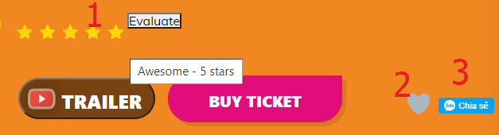

|  |  |  |  |  |  |  |
| --- | --- | --- | --- | --- | --- | --- |
| No | Name | Type | Validation | Event | Description | Status |
| 1 | rating | input |  | click | Click to rating | Enable |
| 2 | heart | div |  | click | Click to add/remove this movie personal movie wishlist | Enalble |
| 3 | Share zalo | button |  | click | Click to share link movie detail | Enalble |

### 18.Change coupon

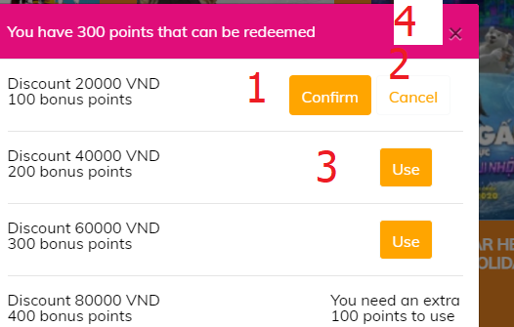

|  |  |  |  |  |  |  |
| --- | --- | --- | --- | --- | --- | --- |
| No | Name | Type | Validation | Event | Description | Status |
| 1 | use | button |  | click | Click to choose point want change | Enable |
| 2 | cancel | button |  | click | Click to cancel | Enalble |
| 3 | confirm | button |  | click | Click to confirm change | Enalble |
| 4 | close | button |  | click | Click to close modal | Enalble |

### 19.order history

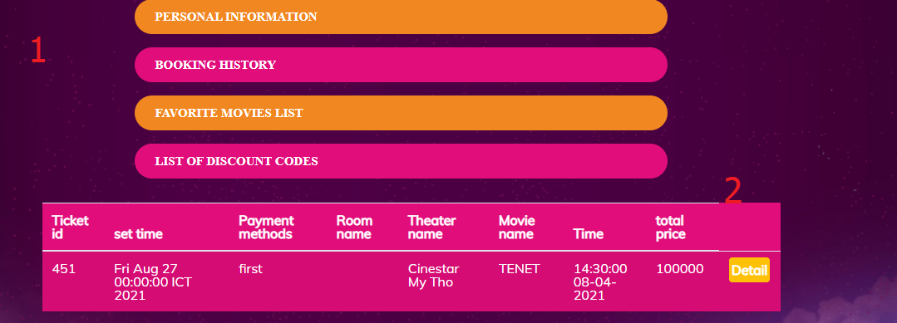

|  |  |  |  |  |  |  |
| --- | --- | --- | --- | --- | --- | --- |
| No | Name | Type | Validation | Event | Description | Status |
| 1 | About personal slide | anchor |  | click | Click to href | Enable |
| 2 | Detail | button |  | click | Click to see detail ticket | Enalble |

### 20.Detail ticket

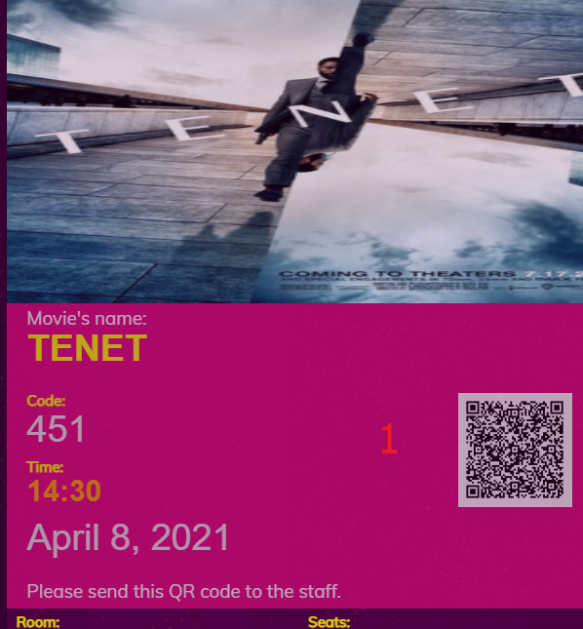

|  |  |  |  |  |  |  |
| --- | --- | --- | --- | --- | --- | --- |
| No | Name | Type | Validation | Event | Description | Status |
| 1 | qrcode | image |  |  | Show detail ticket | Enable |

### 21.List personal coupon

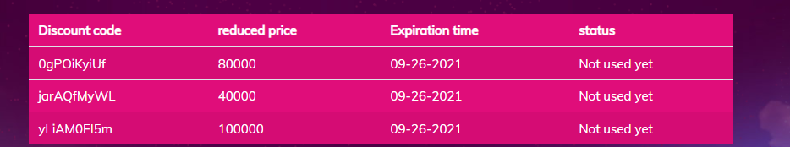

### 22.personal movie wishlist , personal watched movie

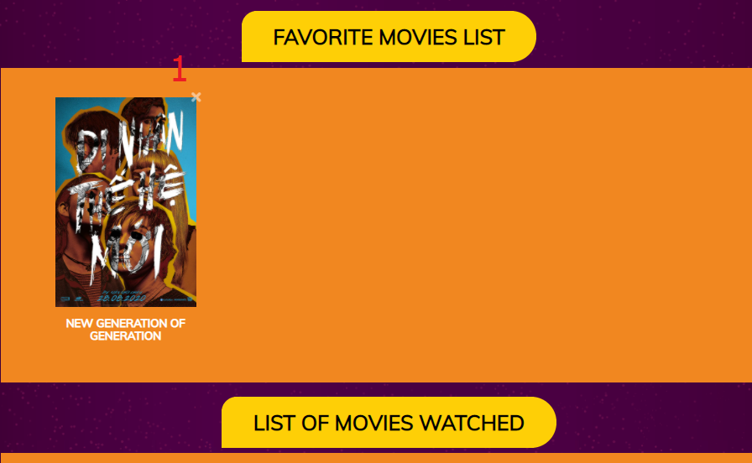

|  |  |  |  |  |  |  |
| --- | --- | --- | --- | --- | --- | --- |
| No | Name | Type | Validation | Event | Description | Status |
| 1 | remove | button |  |  | Click remove this movie out of personal movie wishlist | Enable |

### 23.personal information

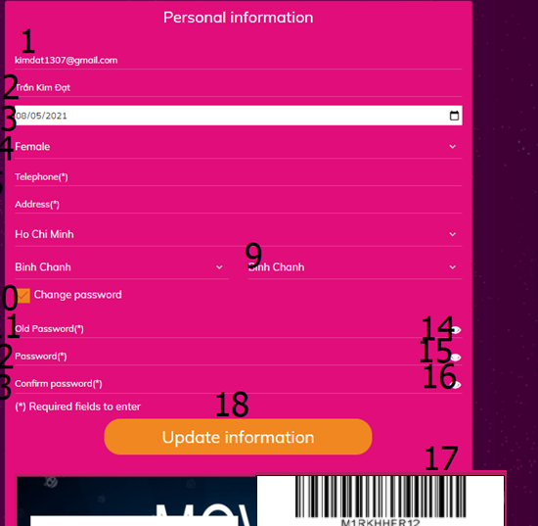

|  |  |  |  |  |  |  |
| --- | --- | --- | --- | --- | --- | --- |
| No | Name | Type | Validation | Event | Description | Status |
| 1 | email | textbox |  |  | Input email(Read only) | Enable |
| 2 | Name | textbox | Not blank, not null,from 6 to 50 characters,not contains special characters and digit | input | Input name | Enable |
| 3 | Date of birth | datebox | Not null | select | Datebox date of birth | Enable |
| 4 | Sex | combobx | Not null | select | Select gender | Enable |
| 5 | phone | textbox | Not blank, not null | input | Input phone | Enable |
| 6 | Address | textbox | Not blank,not null | input | Input address | Enable |
| 7 | Province | combobox | Not null | click | Select province | Enable |
| 8 | District | Combobox | Not null | click | Select district | Enable |
| 9 | Ward | Combobox | Not null | click | Select ward | Enable |
| 10 | changepass | checkbox |  | click | Click to show /hide div change password | Enable |
| 11 | oldpass | password | Not blank,not null,must correct old pass in database | input | Input old pass | Enable |
| 12 | password | password | Not blank,not null,from 8 to 20 character,must same confirm, don’t same old pass | Input | Intput password | Enable |
| 13 | confirm | password | Not blank,not null,must correct old pass in database | Input | Input confirm | Enable |
| 14,15,16 | Show/hide password | icon |  | click | Click to show/hide password | Enable |
| 17 | bacode | image |  |  | See bar code | Enable |
| 18 | update | button |  | click | Click to update personal information | Enable |

### 24.Rating threater

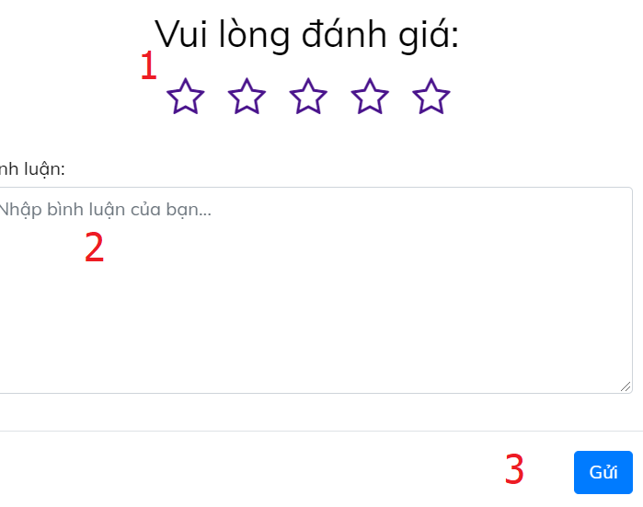

|  |  |  |  |  |  |  |
| --- | --- | --- | --- | --- | --- | --- |
| No | Name | Type | Validation | Event | Description | Status |
| 1 | rating | input | Must checked one of them | checked | Click to choose number rating | Enable |
| 2 | comment | input | Max 250 charactes | input | Input comment | Enable |

### 25.Notification



### 26. Payment page

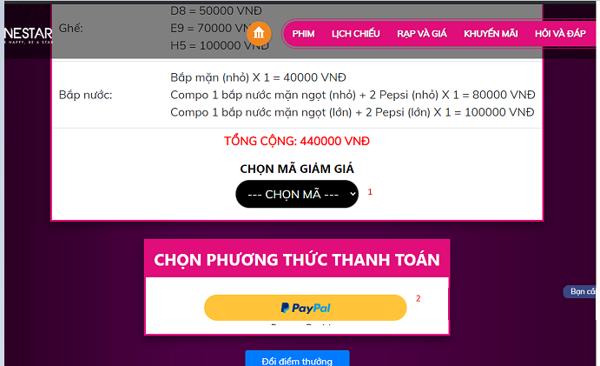

|  |  |  |  |  |  |  |
| --- | --- | --- | --- | --- | --- | --- |
| No | Name | Type | Validation | Event | Description | Status |
| 1 | Choose discount code | select |  | select | Select choose discountcode | Enable |
| 2 | paypal | button |  | click | Click to pay ticket | Enable |

### 27.Vchat

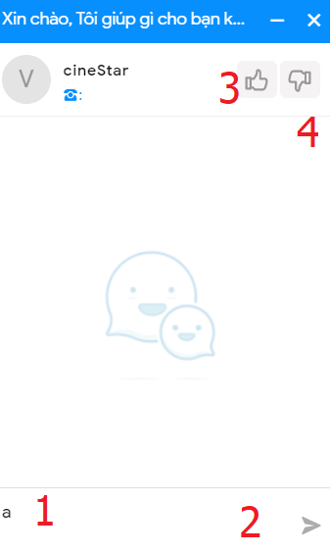

|  |  |  |  |  |  |  |
| --- | --- | --- | --- | --- | --- | --- |
| No | Name | Type | Validation | Event | Description | Status |
| 1 | textarea | input |  | Input | Input mess,Enter to send mess | Enable |
| 2 | send | button |  | click | Click to send mess | Enable |
| 3,4 | Like,dislike | button |  | click | Click to like/dislike | Enable |

### 28.Facebookchat

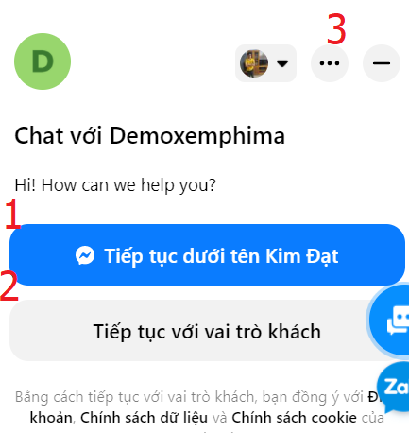

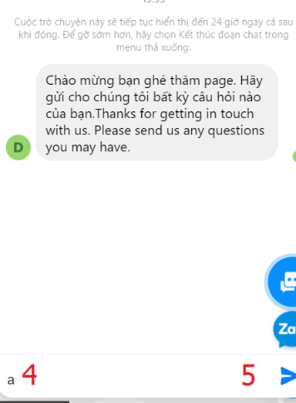

|  |  |  |  |  |  |  |
| --- | --- | --- | --- | --- | --- | --- |
| No | Name | Type | Validation | Event | Description | Status |
| 1 | facebookaccount | button |  | click | Click to continue chat as facebook account | Enable |
| 2 | guest | button |  | click | Click to continue chat as guest | Enable |
| 3 | close | button |  | click | Click to close box chat | Enable |
| 4 | textarea | input |  | input | Input mess | Enable |
| 5 | send | button |  | click | Click to send mess | Enable |

### 29.zalo chat

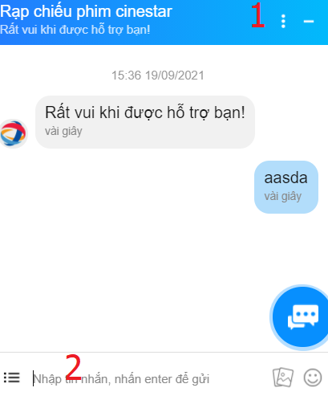

|  |  |  |  |  |  |  |
| --- | --- | --- | --- | --- | --- | --- |
| No | Name | Type | Validation | Event | Description | Status |
| 1 | close | button |  | click | Click to close box chat | Enable |
| 2 | textarea | input |  | Input | Input mess, enter to send mess | Enable |

### 30.Uhchat

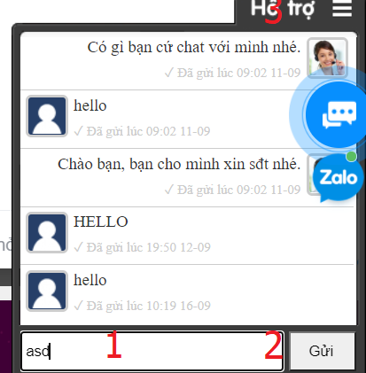

|  |  |  |  |  |  |  |
| --- | --- | --- | --- | --- | --- | --- |
| No | Name | Type | Validation | Event | Description | Status |
| 1 | textarea | input |  | Input | Input mess, enter to send mess | Enable |
| 2 | send | button |  | click | Click to send mess | Enable |
| 3 | close | button |  | click | Click to close box chat | Enable |

31. search movie page

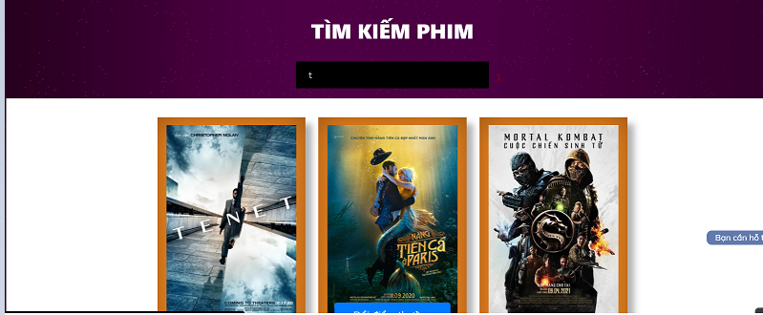

|  |  |  |  |  |  |  |
| --- | --- | --- | --- | --- | --- | --- |
| No | Name | Type | Validation | Event | Description | Status |
| 1 | Search | input |  | Input | Search movie | Enable |

32. Movie page

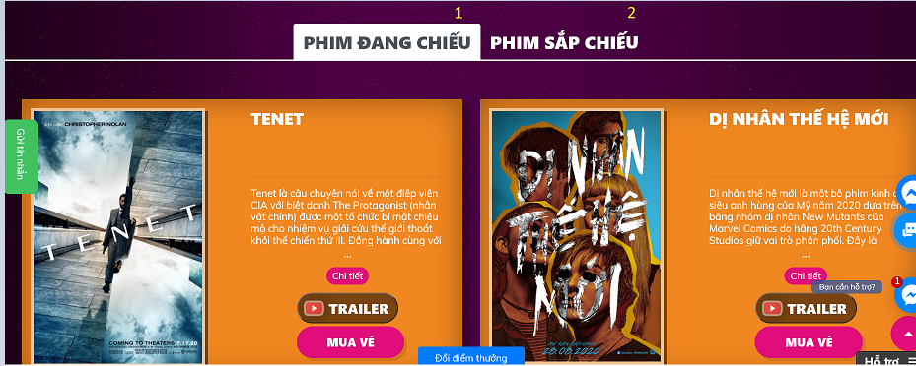

|  |  |  |  |  |  |  |
| --- | --- | --- | --- | --- | --- | --- |
| No | Name | Type | Validation | Event | Description | Status |
| 1 | Movies Showing | tab |  | click | Click to movies showing | Enable |
| 2 | Film coming soon | tab |  | click | Click to film coming soon | Enable |

IV.Android

1. Home page

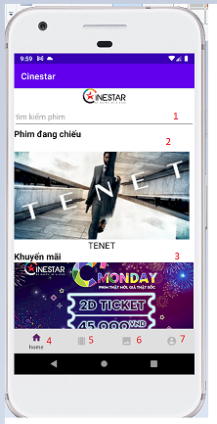

|  |  |  |  |  |  |  |
| --- | --- | --- | --- | --- | --- | --- |
| No | Name | Type | Validation | Event | Description | Status |
| 1 | Search movie | Textbox |  | input | Search movie | Enable |
| 2 | movie | button |  | click | Click to detail movie page | Enalble |
| 3 | Promotion | button |  | click | Click to detail promotion | Enalble |
| 4 | Home | button |  | click | Click to home page | Enalble |
| 5 | Movie | button |  | click | Click to movie page | Enalble |
| 6 | News | button |  | click | Click to news page | Enalble |
| 7 | Account | button |  | Click | Click to account page | Enalble |

1. News page

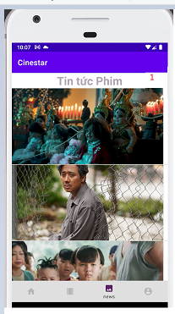

|  |  |  |  |  |  |  |
| --- | --- | --- | --- | --- | --- | --- |
| No | Name | Type | Validation | Event | Description | Status |
| 1 | news | button |  | click | Click to detail news page | Enable |

1. Movie page

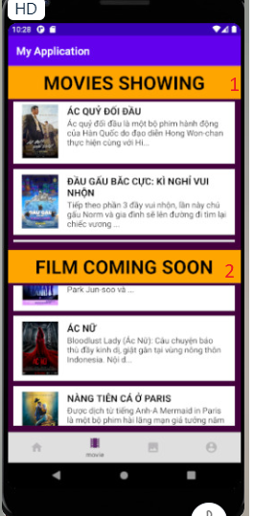

|  |  |  |  |  |  |  |
| --- | --- | --- | --- | --- | --- | --- |
| No | Name | Type | Validation | Event | Description | Status |
| 1 | Movie showing | button |  | click | Click to detail movie showing page | Enable |
| 1 | Film coming soon | button |  | click | Click to detail movie coming soon page | Enable |

1. Movie detail page

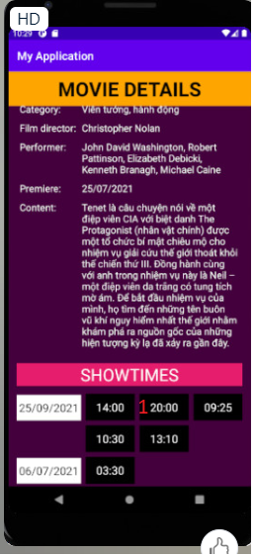

|  |  |  |  |  |  |  |
| --- | --- | --- | --- | --- | --- | --- |
| No | Name | Type | Validation | Event | Description | Status |
| 1 | Show time | button |  | click | Click to ticket page | Enable |

1. Ticket page

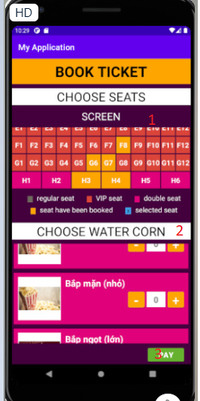

|  |  |  |  |  |  |  |
| --- | --- | --- | --- | --- | --- | --- |
| No | Name | Type | Validation | Event | Description | Status |
| 1 | Choose seats | button |  | click | Click to choose seats | Enable |
| 2 | Choose watercorn | Button |  | click | Click to choose water corn | Enable |
| 3 | pay | button |  | click | Click to pay page | Enable |

1. Pay page

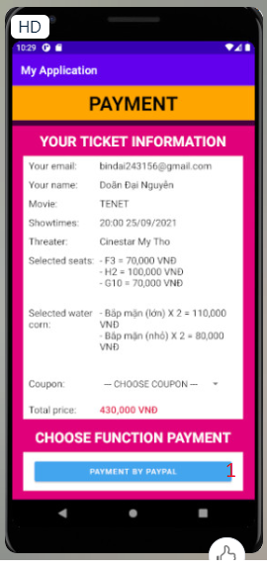

|  |  |  |  |  |  |  |
| --- | --- | --- | --- | --- | --- | --- |
| No | Name | Type | Validation | Event | Description | Status |
| 1 | Payment by paypal | button |  | click | Click to pay with paypal | Enable |

### 7.Wheel spin page

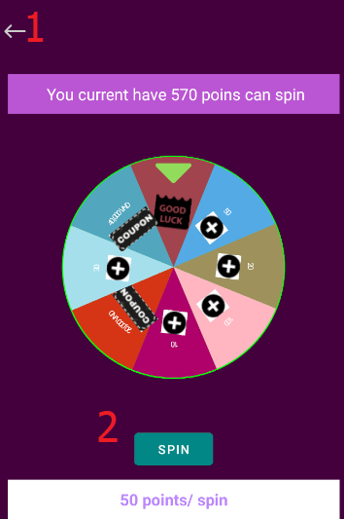

|  |  |  |  |  |  |  |
| --- | --- | --- | --- | --- | --- | --- |
| No | Name | Type | Validation | Event | Description | Status |
| 1 | Back | Toolbar |  | click | Back to profile page | Enable |
| 2 | Spin | Button |  | Click | Click to spin | Enable |

### 8.Profile page

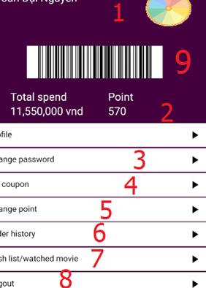

|  |  |  |  |  |  |  |
| --- | --- | --- | --- | --- | --- | --- |
| No | Name | Type | Validation | Event | Description | Status |
| 1 | LuckyWheel | Imageview |  | click | Click to go wheel spin page | Enable |
| 2 | Change Profile | Button |  | Click | Click to go to changeprofile page | Enable |
| 3 | Change Passowrd | Button |  | click | Click to go change password page | Enable |
| 4 | My coupon | Button |  | Click | Click to go to coupon page | Enable |

|  |  |  |  |  |  |  |
| --- | --- | --- | --- | --- | --- | --- |
| 5 | Change point | Button |  | Click | Click to go to change point page | Enable |
| 6 | Order hisotry | Button |  | Click | Click to go to order history page | Enable |
| 7 | Wishlist/watched listmovie | Button |  | Click | Click to go to Wishlist/watched listmovie page | Enable |
| 8 | Logout | Button |  | Click | Click to logout | Enable |
| 9 | Barcodemembershipcard | Imageview |  |  | Barcode(membershipcard) | Enable |

### 9.Coupon list page

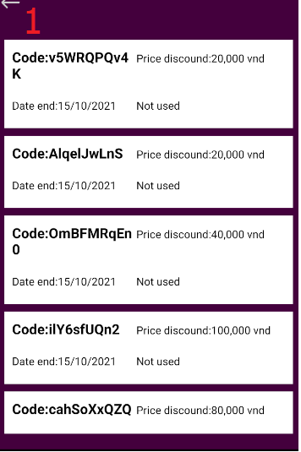

|  |  |  |  |  |  |  |
| --- | --- | --- | --- | --- | --- | --- |
| No | Name | Type | Validation | Event | Description | Status |
| 1 | Back | Toolbar |  | click | Back to profile page | Enable |

### 10.Change point page

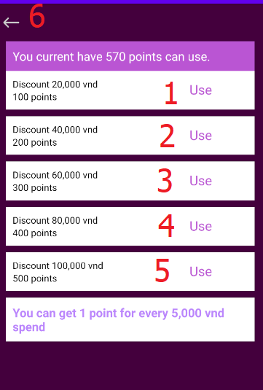

|  |  |  |  |  |  |  |
| --- | --- | --- | --- | --- | --- | --- |
| No | Name | Type | Validation | Event | Description | Status |
| 1,2,3,4,5 | Use | Button |  | click | Click to change point | Enable |
| 6 | Back | Toolbar |  | click | Back to profile page | Enable |

### 11.Order history

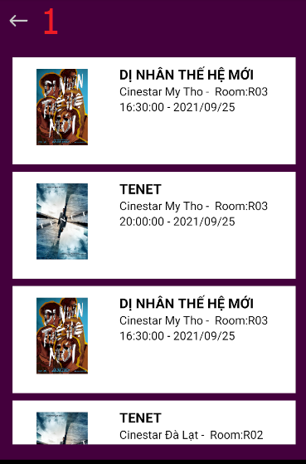

|  |  |  |  |  |  |  |
| --- | --- | --- | --- | --- | --- | --- |
| No | Name | Type | Validation | Event | Description | Status |
| 1 | Back | Toolbar |  | click | Back to profile page | Enable |

### 12.Ticket detail

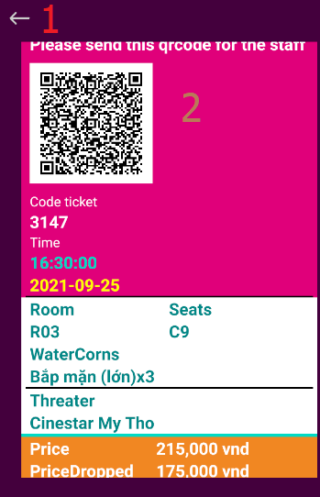

|  |  |  |  |  |  |  |
| --- | --- | --- | --- | --- | --- | --- |
| No | Name | Type | Validation | Event | Description | Status |
| 1 | Back | Toolbar |  | click | Back to order history page | Enable |
| 2 | Qrcode | Imageview |  |  |  | Enable |

### 13.Wishlist and watched list movie

#### 13.1 WishList

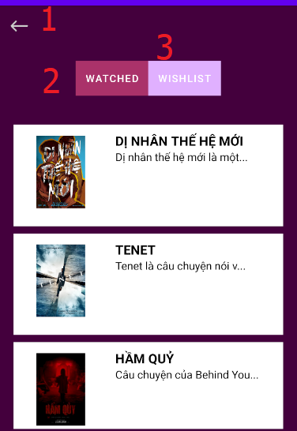

|  |  |  |  |  |  |  |
| --- | --- | --- | --- | --- | --- | --- |
| No | Name | Type | Validation | Event | Description | Status |
| 1 | Back | Toolbar |  | click | Back to profile page | Enable |
| 2,3 | Tablayout wishlist/watched | Tablayout |  | click | Click to go to fragment wishlist/watched list movie | Enable |

13.2 watched

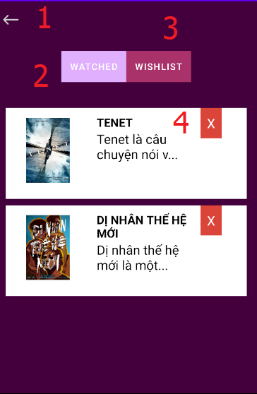

|  |  |  |  |  |  |  |
| --- | --- | --- | --- | --- | --- | --- |
| No | Name | Type | Validation | Event | Description | Status |
| 1 | Back | Toolbar |  | click | Back to profile page | Enable |
| 2,3 | Tablayout wishlist/watched | Tablayout |  | click | Click to go to fragment wishlist/watched list movie | Enable |
| 4 | Remove | Textview |  | click | Click to remove movie out of wishlist | Enable |

### 14.Change password

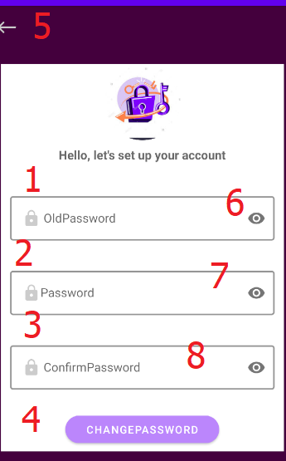

|  |  |  |  |  |  |  |
| --- | --- | --- | --- | --- | --- | --- |
| No | Name | Type | Validation | Event | Description | Status |
| 1 | oldpass | Textfield | Not blank,not null,must correct old pass in database | input | Input old pass | Enable |
| 2 | password | Textfield | Not blank,not null,from 8 character | input | Input pass | Enable |
| 3 | confirm | Textfield | Not blank,not null,must same password correct pass in database | Input | Input confirm | Enable |
| 4 | Changepassword | Button |  | Click | Click to change pass | Enable |
| 5 | Back | toolbar |  | Click | Click to back profile page | Enable |
| 6,7,8 | Show/hide password | icon |  | click | Click to show/hide password | Enable |

### 15.Login page

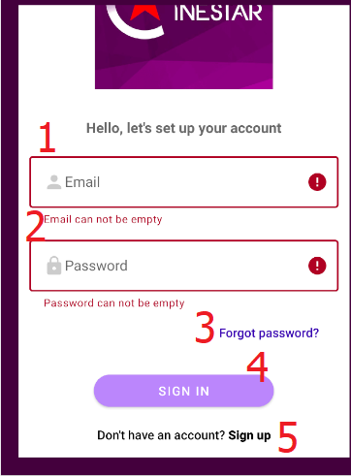

|  |  |  |  |  |  |  |
| --- | --- | --- | --- | --- | --- | --- |
| No | Name | Type | Validation | Event | Description | Status |
| 1 | Email | Textfield | Not blank,must valid.Example:kimmdat@gmail.com | input | Input email | Enable |
| 2 | Password | Textfield | Not blank,not null, | input | Input pass | Enable |
| 3 | Forgot | Button |  | click | Click to go to forgot page | Enable |
| 4 | Sign in | Button |  | click | Click to sign in | Enable |
| 5 | Sign up | Button |  | click | Click to go to sign up page | Enable |

### 16.Forgot page

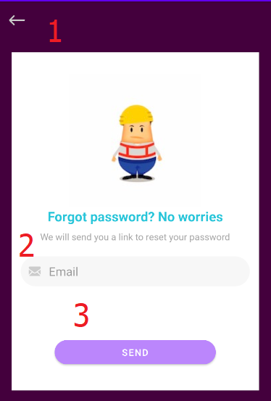

|  |  |  |  |  |  |  |
| --- | --- | --- | --- | --- | --- | --- |
| No | Name | Type | Validation | Event | Description | Status |
| 1 | Back | Toolbar |  | click | Click to back to signin page | Enable |
| 2 | Email | Textfield | Not blank,must valid.Example:kimmdat@gmail.com | input | Input email | Enable |
| 3 | Send | button |  | Click | Click to get link reset password | Enable |

### 17.Sign up page

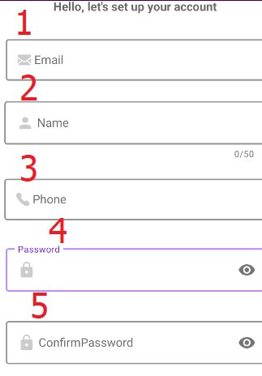

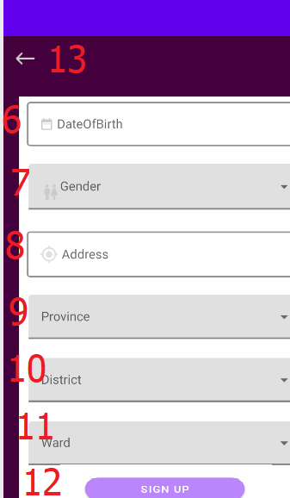

|  |  |  |  |  |  |  |
| --- | --- | --- | --- | --- | --- | --- |
| No | Name | Type | Validation | Event | Description | Status |
| 1 | Email | Textfield | Not blank,must valid.Example:kimmdat@gmail.com | input | Input email | Enable |
| 2 | Name | Textfield | Must character,not blank , not null,from 6 to 50 character | input | Input name | Enablee |
| 3 | Phone | Textfield | Notblank,not null | Phone | Input phone | Enable |
| 4 | password | Textfield | Not blank,not null,from 8 character | input | Input pass | Enable |
| 5 | confirm | Textfield | Not blank,not null,must same password | Input | Input confirm | Enable |
| 6 | Dateofbirth | Textfiled | Must choose | input | Input date of birth | Enable |
| 7 | Gender | AutocompleteTextview | Must choose | Input | Input gender | Enable |
| 8 | Location | Textfiled | Not blank,not null | input | Input location | Enable |
| 9 | Province | AutocompleteTextview | Must choose | Input | Input province | Enable |
| 10 | District | AutocompleteTextview | Must choose | Input | Input district | Enable |
| 11 | ward | AutocompleteTextview | Must choose | Input | Input ward | Enable |
| 12 | signup | button |  | click | Click to signup | Enable |
| 13 | Back | toolbar |  | click | Click to back signin page | Enable |

### 18. Profile page

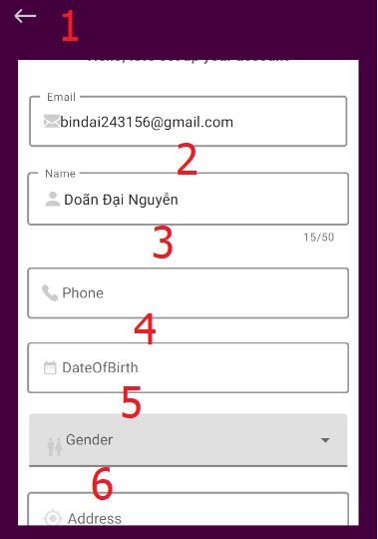

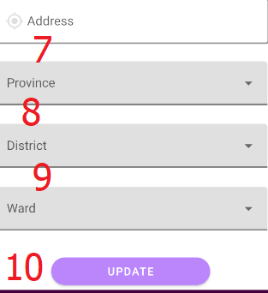

|  |  |  |  |  |  |  |
| --- | --- | --- | --- | --- | --- | --- |
| 1 | Back | toolbar |  | click | Click to back signin page | Enable |
| 2 | Name | Textfield | Must character,not blank , not null,from 6 to 50 character | input | Input name | Enablee |
| 3 | Phone | Textfield | Notblank,not null | Phone | Input phone | Enable |
| 4 | Dateofbirth | Textfiled | Must choose | input | Input date of birth | Enable |
| 5 | Gender | AutocompleteTextview | Must choose | Input | Input gender | Enable |
| 6 | Location | Textfiled | Not blank,not null | input | Input location | Enable |
| 7 | Province | AutocompleteTextview | Must choose | Input | Input province | Enable |
| 8 | District | AutocompleteTextview | Must choose | Input | Input district | Enable |
| 9 | ward | AutocompleteTextview | Must choose | Input | Input ward | Enable |
| 10 | update | button |  | click | Click to update | Enable |

# **TASK SHEET REVIEW 3**

|  |  |  |  |  |  |  |  |
| --- | --- | --- | --- | --- | --- | --- | --- |
| **Project Ref. No.:**  **CINESTAR** | | **Project Title:** | **Activity Plan Prepared By:** | **Date of Preparation of Activity Plan:** | | | |
| **Sr.No.** | **Task** | **Actual Start Date** | **Actual Days** | **Team Mate Names** | **Status** |
| 1 | Show data home page | **Cinestar** | TRAN KIM DAT | 27/8/2021 | 5 | Nguyen Doan Dai | done |
| 2 | Search showtimes on header (search by 4 combobox on header) | 27/8/2021 | 5 | done |
| 3 | Search movie by keyword (search on input search header and in search page). | 27/8/2021 | 5 | done |
| 4 | Movie page (Show all movie in database with 2 tab - movie is playing, movie is coming soon) | 27/8/2021 | 5 | done |
| 5 | Movie details page(Show all information of movie) | 27/8/2021 | 5 | done |
| 6 | Showtimes page (search showtimes by theater and by movie title) | 27/8/2021 | 5 | done |
| 7 | Payment page (show information ticket and payment) | 27/8/2021 | 5 | done |
| 8 | Realtime booking seat. | 27/8/2021 | 5 | done |
| 9 | Book ticket pages (book seat and book water corn) | 27/8/2021 | 5 | done |
| 10 | Admin ticket (show, details, update, search). | 30/8/2021 | 5 | Nguyen Doan Dai | Done |
| 11 | Admin Showtimes (Insert, update, show, search). | 30/8/2021 | 5 | Done |
| 12 | Report ticket, report revenue by theater | 30/8/2021 | 5 | Done |
| 13 | Client ,Admin website design | 27/8/2021 | 5 | Nguyen Thanh Huy | Done |
| 14 | Admin login | 27/8/2021 | Done |
| 15 | Manage contact(delete) | 27/8/2021 | Done |
| 16 | Promotion(add,updatedelete) | 27/8/2021 | Done |
| 17 | movie review  (add,update,delete) | 27/8/2021 | 5 | Done |
| 18 | Water corn  (add,update,delete) | 27/8/2021 | Done |
| 19 | Multi language admin | 27/8/2021 | Done |
| 20 | Manager admin | 27/8/2021 | Done |
| 21 | Client (contact ,promotion,news) | 27/8/2021 | Done |
| 22 | Search movie review client |  | Done |
| 23 | Chat zalo ,coment zalo | 27/8/2021 | 5 | Done |
| 24 | Report | 30/8/2021 | Done |
| 25 | Manage User (Show,search,view detail) |  |  | 27/8/2021 | 5 | Trần kim đạt | Done |
| 26 | Manage Coupon (Show,search) |  | 27/8/2021 | Done |
| 27 | Manager Membershipcard(Show,search) |  | 27/8/2021 | Done |
| 28 | Manager Threater(show,create,update) |  | 27/8/2021 | Done |
| 29 | Modal location ,choose address at here api at created threater(website) |  | 27/8/2021 | Done |
| 30 | Change language at client(website) |  | 27/8/2021 | Done |
| 31 | Register receiver news(website) |  | 27/8/2021 | Done |
| 32 | Popup fchat,Chatfacebook, chatvchat,uhchat(website) |  | 27/8/2021 | 5 | Trần kim đạt | Done |
| 33 | Redeem bonus point(website) |  | 27/8/2021 | Done |
| 34 | Comment facebook,share link movie detail in zalo(website) |  | 27/8/2021 | Done |
| 35 | Find neareset threater,nearly threater along calculator distance(website) |  | 27/8/2021 | Done |
| 36 | Show all distinct region of threater, show threater detail at threater detail (website) |  | 27/8/2021 | Done |
| 37 | Choose threater based on region at threater detail page(website) |  | 27/8/2021 | Done |
| 38 | Map location threater detail with here api(website) |  | 27/8/2021 | Done |
| 39 | Threater page,threaterdetail page(website) |  | 27/8/2021 | Done |
| 40 | Rating movie,real time rating movie((website) |  | 27/8/2021 | 5 | Trần kim đạt | Done |
| 41 | Add/remove movie wishlist users(website) |  | 27/8/2021 | Done |
| 42 | Login,register, login/register page, logout(website) |  | 27/8/2021 | Done |
| 43 | Forgot password(website) |  | 27/8/2021 | Done |
| 44 | Recapcha v2(website) |  | 27/8/2021 | Done |
| 45 | Loginfacebook, login google(website) |  | 27/8/2021 | Done |
| 46 | Profile page,update profile,change password(website) |  | 27/8/2021 | Done |
| 47 | Barcode membershipcard(website) |  | 27/8/2021 | Done |
| 48 | Show personal coupon, personal movie wishlist, personal movie watched,personal order history,personal coupon page,personal movie watched page,personalorderhistory page,personal coupon page (website),notification(website) |  | 27/8/2021 | Done |
| 49 | Qr code detail ticket and ticket detail ,ticket detail page (website) |  | 27/8/2021 | Done |
| 50 | Resetpassword,resetpassword page (website) |  | 27/8/2021 | Done |
| 51 | Admin send email to users registed receiver news |  | 27/8/2021 | Done |
| 52 | Report top 3 movies by threater,from date to date ,month,day,years,by wishlist |  | 30/8/2021 |  | Trần kim đạt | Done |
| 53 | Report detail spending of user from date to date |  | 10/9/2021 |  | Trần kim đạt | Done |
| 54 | Mini game |  | 10/9/2021 |  | Trần kim đạt | Done |
| 55 | Rating threater,filter by number rating threater |  | 10/9/2021 |  | Trần kim đạt | Done |
| 56 | Manage rating threater |  | 10/9/2021 |  | Trần kim đạt | Done |
| 57 | Logout(Android) |  | 10/9/2021 |  | Trần kim đạt | Done |
| 58 | Like/Dislike movie(Android) |  | 10/9/2021 |  | Trần kim đạt | Done |
| 59 | Wheel spin(Android) |  |  | 10/9/2021 |  | Trần kim đạt | Done |
| 60 | Barcode membership(Android) |  | 10/9/2021 |  | Trần kim đạt | Done |
| 61 | Change profile(Android) |  | 10/9/2021 |  | Trần kim đạt | Done |
| 62 | Change password(Android) |  | 10/9/2021 |  | Trần kim đạt | Done |
| 63 | Show coupon(Android) |  | 10/9/2021 |  | Trần kim đạt | Done |
| 64 | Change point(Android) |  | 10/9/2021 |  | Trần kim đạt | Done |
| 65 | Order history(Android) |  | 10/9/2021 |  | Trần kim đạt | Done |
| 66 | Detail ticket,qrcode detail ticket(Android) |  | 10/9/2021 |  | Trần kim đạt | Done |
| 67 | Wishlist/watched movie(Android) |  | 10/9/2021 |  | Trần kim đạt | Done |
| 68 | Signup,sign in,forgotpass(Android) |  | 10/9/2021 |  | Trần kim đạt | Done |
| 69 | Movie page(android) |  | 10/9/2021 |  | Nguyễn Doãn Đại | Done |
| 70 | Detail movie(android) |  | 10/9/2021 |  | Nguyễn Doãn Đại | Done |
| 71 | Book ticket(android) |  | 10/9/2021 |  | Nguyễn Doãn Đại | Done |
| 72 | Payment (android) |  | 10/9/2021 |  | Nguyễn Doãn Đại | Done |
| 73 | Home page(android) |  | 10/9/2021 |  | Nguyễn Thanh Huy | Done |
| 74 | News page(android) |  |  | 10/9/2021 |  | Nguyễn Thanh Huy | Done |
| 75 | Movie(add,update,search) |  |  | 10/9/2021 |  | Nguyễn Doan Đai | done |
| 76 | Search movie page |  |  | 10/9/2021 |  | Nguyễn Doan Đai | done |
| 77 | Pay by MoMo |  |  | 10/9/2021 |  | Nguyễn Doan Đai | done |
| 78 | Pay by paypal |  |  | 10/9/2021 |  | Nguyễn Doan Đai | done |
| 79 | Admin manage movie (insert, show, update, search) |  |  | 10/9/2021 |  | Nguyễn Doan Đai | done |
| 80 | Admin manage room (insert, show, update, search) |  |  | 10/9/2021 |  | Nguyễn Doan Đai | done |
| 81 | Send Mail information ticket (in website and android) |  |  | 10/9/2021 |  | Nguyễn Doan Đai | done |
| 82 | Time out book ticket (ticket holding time) |  |  | 10/9/2021 |  | Nguyễn Doan Đai | done |
| 83 | QR Code in send Mail |  |  | 10/9/2021 |  | Nguyễn Doan Đai | done |